Elizabeth I and the Elizabethan Period:
a Brief Introduction

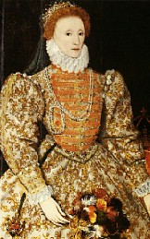
Elizabeth I was 25 years old when she became Queen of England in 1558. Her 45-year reign, which ended with her death in 1603, saw England's emergence as a nation of tremendous political power and unparalleled cultural achievement. Because so much of this English renaissance is directly attributable to Elizabeth's personal character and influence (as well as to the unprecedented length of her reign), it is appropriate that the last half of the sixteenth century in England is identified as the Elizabethan Period.
The very fact that Elizabeth became Queen at all almost indicates some predestination toward greatness and defiance of normal expectations. The daughter of Henry VIII and his second wife, Anne Boleyn (who later was executed for treason), Elizabeth was third in line of succession, following her younger half-brother Edward (son of Henry VIII and Jane Seymour) and her older half-sister Mary (daughter of Henry VIII and Catherine of Aragon). Under normal circumstances, it would be unlikely that she would ever assume the throne.
However, as has often happened throughout history, events did not follow their predicted course. The nine-year old Edward became King Edward VI on the death of Henry VIII in 1547, but he had little opportunity to establish himself as a monarch, dying at the age of 15. He was succeeded by Mary I (1553-1558), whose relentless efforts to return England to Catholicism brought about a true reign of terror and stifled any possibility of forward movement in the nation. When Mary died suddenly in 1558, Elizabeth I became Queen.
In both intellect and temperament, Elizabeth was well-suited for the role of monarch. She was exceptionally well-educated, having been tutored at her father's court by Roger Ascham, one of the most outstanding scholars and thinkers of the age. Her intellectual interests were broad, ranging from history and science to art, literature, and philosophy, and she was a remarkably astute political strategist.
Not only did she return the country to internal political and religious stability in the wake of "Bloody Mary's" reign, she directed England's course as it became a powerful force among European nations. Both Spain and France felt the effects of England's growing strength and audacity under Elizabeth's rule. Furthermore, Elizabeth shrewdly perceived that great political advantage could be gained from her status as an unmarried monarch, and throughout her reign various political alliances via marriage were hinted at but never finalized.
Sir Francis Drake's circumnavigation of the globe (1577-1580) added to the nation's prestige and competitiveness in navigation and exploration. However, the pinnacle of England's power at sea was the triumphant defeat of the mighty Spanish Armada in 1588, which secured the nation's position as a world power. Eleven years later, in 1599, England entered the arena of world trade and colonization, which it would dominate for the next three centuries, with the chartering of the East India Company.
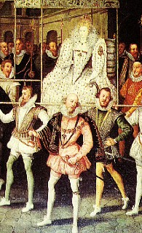
Elizabeth was an enormously popular monarch, one of western civilization's first true cult figures. The following of "The Virgin Queen," or "Gloriana," as she was called, was extensive; according to many historians, every public appearance became an occasion for grand spectacle, great pageantry, and huge crowds.
The Queen's tastes in fashion set the standard for the aristocracy and the rest of society; her love of music, drama, and poetry fostered an atmosphere in which many of England's greatest writers found encouragement and financial patronage. Under Elizabeth's leadership, England experienced the true cultural reawakening or renaissance of thought, art, and vision which had begun in Italy a century earlier. Elizabeth's court was a magnet which attracted the most talented individuals of the era, and, at the Queen's direction, Oxford and Cambridge universities were reorganized and chartered as centers for learning and scholarly endeavor.
The prosperity, confidence, optimism, and vigor which characterized Elizabeth's court and reign carried over into many aspects of life. The foremost example of this influence can be seen in what scholar E.M.W. Tillyard terms "The Elizabethan World Picture," a widely-held set of assumptions about the inherently ordered nature of the universe. Belief in this "Great Chain of Being," in which every single element has its own prescribed place and function in a hierarchical universe, spilled over into a general love of structure, intricate design, and elaborate ornamentation which can be seen in the fashion, music, architecture, and literature of the period.
The greatest literature created during the Elizabethan Period falls into two categories: poetry and drama. Influenced by the Italian sonnets, which had been introduced into the English language by Sir Thomas Wyatt (1503-1542) during the reign of Henry VIII, English poets began to construct their own variations on the intricate, highly structured poetic form. Others, such as Edmund Spenser (1552-1599) in his extraordinarily ambitious poem of homage to Elizabeth,The Faerie Queen, adapted sonnet patterns into forms of their own invention.
Even William Shakespeare, who is more commonly associated with drama, varied the rhyme scheme and patterns of the sonnet form to suit his own purposes in an elaborate sequence or "cycle" of over one hundred sonnets. The pursuit of a literary life was viewed as an admirable and worthy endeavor, and poets shared their work with each other and at court, vying for the praise and patronage of the Queen and aristocracy. The Queen herself wrote both poetry and music.
The other great literary achievement of the Elizabethan Period was the drama, a form which was rooted in centuries of popular folk entertainment and which had been adapted into the religious plays of the middle ages. As the sixteenth century progressed, playwrights increasingly moved their plots from the simplistically religious to the secular, weaving into their dramas such diverse elements as legend and myth, classical dramatic forms, intense exploration of character, and familiar conventions freely adapted from works of their contemporaries. The dramatic form allowed playwrights to simultaneously develop plot, theme, complex characters, and poetic language which, at its best, as in the tragedies of Shakespeare, soared gloriously and memorably, pushing the English language to new heights of imaginative achievement.
In an era in which the lives of varied social classes rarely intersected, the theatre was a true common denominator. Everyone, regardless of social class, enjoyed the spectacle of the Elizabethan theatre, and playwrights found themselves writing for highly diverse audiences which reflected the ever-changing makeup and energy of society. It was not unusual for a crowd to take in a morning of public executions, bear-baiting, street carnivals, and fairs before settling down for an afternoon performance at one of the public theatres in London such as The Globe. The most successful playwrights of the day, such as Shakespeare, made certain that their dramas included "something for everybody," whether it be bawdy jokes and physical sight gags for the peasant "groundlings" who stood at the foot of the stage, scenes of action and intrigue for the middle class spectators, or elevated language and characters to appeal to the more educated upper class citizens who sat in the tiered galleries around the outdoor stage.
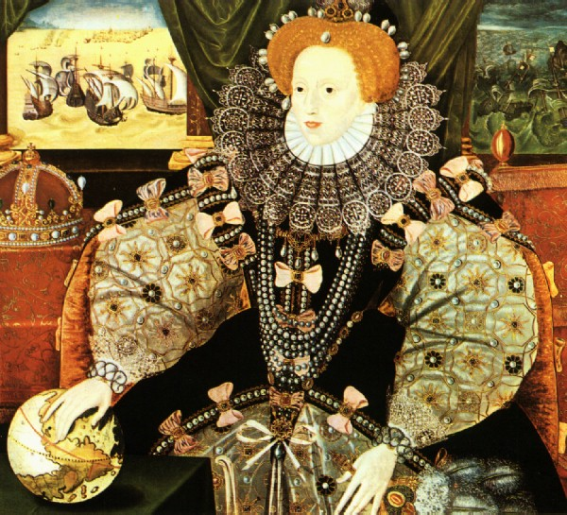
The last years of Elizabeth's reign were not always politically smooth; in fact, by the 1590's there was at least one serious threat of rebellion, as well as a series of bitter Parliamentary conflicts. But Elizabeth was steadfast as a monarch and held things firmly in control until her death in 1603. She was succeeded by her cousin, King James VI of Scotland, who united the two nations as King James I.
England during the reign of Elizabeth I was a country of tremendous ambition, achievement, promise, and gusto. The accomplishments and spirit of the age are traceable to many sociological and cultural factors, but foremost among these is the leadership of the forceful, resourceful, and shrewd Queen Elizabeth I. Her death marked not only the end of the Tudor line, but of a glorious era in English history.

Works Consulted
Adventures in English Literature. Annotated Teacher's Edition. Ed. William C. Bassell. Orlando: Harcourt Brace Jovanovich, Publishers, 1989.
Briggs, Asa. A Social History of England. New York: Viking Penguin, 1985.
English Literature. Signature Edition. Teacher's Annotated Edition. New York: Scribner Laidlaw, 1989.
Morgan, Kenneth O., ed.The Oxford Illustrated History of Britain. Oxford: Oxford University Press,1984.
*Scott, Jack Cassin.Costume and Fashion 1550-1920. New York: Sterling Publishing Co., 1986.
Tillyard, E.M.W. The Elizabethan World Picture. New York: Vintage Books, 1942.
Trevelyan, George Macaulay. A Shortened History of England. New York: Viking Penguin, 1942.
*Woodward, G.W. O. Queen Elizabeth I. London: Pitkin Pictorials Ltd., 1975.


