Halloween
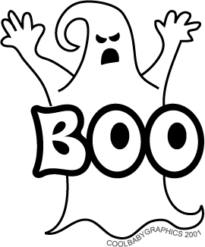

Halloween is one of the oldest holidays with origins going back thousands of years. The holiday we know as Halloween has had many influences from many cultures over the centuries. The holiday originally comes from the Celts, who celebrated New Year on November the 1st and they had to store all the crops from October the 30th, and prepare the for a cold winter. Then came the Druids, who used to dress like animals using animals’ skins and heads. That was really the first Halloween celebration. Afterwards it spread all across the Roman Empire and finally throughout Christianity. It was first named Hallow E’en, which meant Evening of the Saints, and later on it got its original name. Nowadays it is celebrated mostly in North America, but also in some South-American countries.
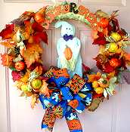

Every late November, people in every house hang at lest one ornament on their doors, to get in the spirit of the holiday. There are more than one ornamentation options, and everybody decorates his house just as he pleases. The most “notorious” ornaments is the candle-pumpkin. It’s practically a pumpkin emptied on the inside, and two eyes and a mouth are cut on its shell, and a candle is placed inside so it can brighten the whole holiday. Another way of decoration is the ghost and crown on the door. It’s a ghost, standing in the middle of a crown made out of synthetic grass and small Halloween Pumpkins.
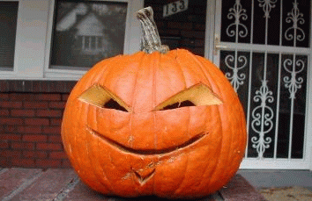

Another Halloween habit is trick-or-treating. It’s a game for the kids, which goes like this. Kids put on masks of ghosts, witches, zombies, or scary monsters, and go from door to door yelling out “Trick or Treat”. It means that either you give them a treat or they play a trick on you. The trick could be letting the air out of the person’s car’s tires, filling their windows with soap, throwing toilet paper rolls over their house’s roof, or anything else that makes them pay for not giving them a treat. The most preferred treats are candy, chocolate, or any other kinds of sweets, and sometimes pumpkin pie and fruit salad.

But, no mater what they do, people always find a way to get into the spirit of the holiday, like everyone else should.



