Absolutely Halloween
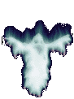

It's absolutely Halloween. And, Halloween is absolutely the best holiday of the year. It is the favorite for many as there is no stress, no overload, and no "Holiday Depression" . It's just absolutely fun.
Bats Bizarre Dracula Ghosts Witches Graveyards Ghouls Haunted Houses Movies Paranormal Parties Pumpkins Skeletons Scarecrows Vampires You name it, we'll take you to it.
This Holiday is celebrated by all the creatures of the undead and they will turn over in their graves when they here the living speak of this day. The living feel safe and secure until the demons reveal their horrid faces. For thousands of years, this has been the night for the spirits and the undead to rule the land. Beware of ghostly images on the Night of October 31st.

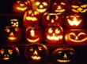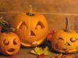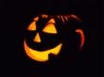

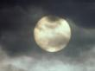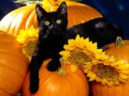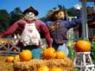

The Origin of Halloween
The origin of Halloween dates back 2000 years ago to the Celtic celebration of the dead. A Celtic festival was held on November 1, the first day of the celtic New Year, honoring the Samhain, the Lord of the Dead. Celtic ritual believed that the souls of the dead returned on the evening before November 1. The celebration included burning sacrifices and costumes. These early events began as both a celebration of the harvest and an honoring of dead ancestors.
Halloween spread throughout Europe in the seventh century. It began with "All Hallows Eve", the "Night of the Dead". It is immediately followed by "All Souls Day", a christian holy day.
The first lighted fruit was really carved out of gourds and turnips. European custom also included carving scary faces into the gourds and placing embers inside to light them. This was believed to ward of evil spirits, especially spirits who roamed the streets and countryside during All Hallows Eve.
The Irish brought the tradition of carving turnips and even potatoes with them to America. They quickly discovered that pumpkins were bigger and easier to carve.
Halloween is the evening of October 31 which is All Saints Day. In American Halloween came to be observed by children by dressing up in scarry or other costumes and play trick or treat.
We am not sure about the origins of Haloween. The first references date to about 1550. It has apparently evolved from the feast of Allhallows or All Saints Day on November 1. This celebration dates from the 14th or 15th Centuries. Allhallows was a shortened form of Allhallowsmas.

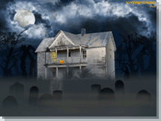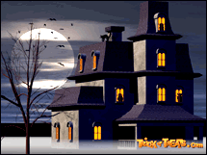

Halloween as celebrated in America has Celtic anf English origins. Haloween or comparable holidays is celebrated in many different countries.
On October 31st, you will likely see witches, ghosts, goblins, skeletons, demons, and other evil characters knocking at your door and hollering "trick or treat", and they will expect a treat or you will be tricked. There will be parties where kids (and even adults) bob for apples, tell fortunes, or go through haunted houses. There will be decorations of jack-o-lanterns, witches on brooms, and black cats. It is the only day of the year when we give free food to strangers and display carved vegetables on our front porches. . . .when you really think about it, October 31st is a very strange day . . .Where did we get this celebration called Halloween?
Halloween celebrations (of any kind or form) did not become popular in the United States until the late 1800s. It appears to have arrived after 1840, when large numbers of immigrants arrived from Ireland and Scotland and introduced elements like Mischief Night, beliefs about elves and fairies, and practices such as jack-o'-lanterns. (Many of the Halloween customs that they brought to America probably did not enter Irish and Scottish culture until after 1750.) The practice does not come from ancient times, but modern. It must be said that "Halloween" as we know it in America, with all the folk stories and urban legends attached to it, is a distinctly American phenomenon, with the "Trick or Treat" bits occurring after 1930.
Halloween is celebrated in many countries today, but this is actually a result of secular American influence:
Halloween has become one of the most important and widely celebrated festivals on the contemporary American calendar, and it is not even officially a holiday. No day off is given for Halloween, no federal decree is proclaimed establishing it as a national holiday. People simply do it.
Unlike many other holidays, the children didn't dress up for Halloween, there is of course a good deal of dressing down. Children used to make their costumes using much imagination. Now costumes are generally massed produced and brought in discount stores. Trick or treat had declined in popularity because of saftey concerns. Fundamentalists groups have asailed this once rather innocent child's celebration as satantic. (These are of course the same people who see the Teletubbies as subverting innocent minds.) In recent years Halloween has become mpre popular as an adult holiday.
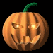
Halloween celebrations date back over two thousand years, originally descending from the Celtic festival "Samhain" -- a harvest festival marking the death of the old year and the beginning of the new one. While the festival itself was one of joy, the Celts believed "Samhain" to be the "Lord of Death" who allowed spirits to return to their former homes on earth, only on October 31.
Halloween traditions have evolved some over the years, but today the only spirits have evolved some over the years, but today the only spirits returning home will be children toting the bounty of their own "trick or treat" harvest!

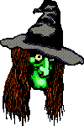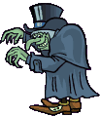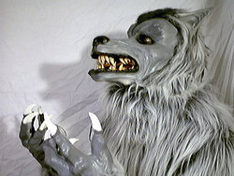

Halloween customs
Observance of Halloween faded in the South of England from the 17th century onwards, being replaced by the commemoration of the Gunpowder Plot on November 5. However it remained popular in Scotland, Ireland and the North of England. It is only in the last decade that it again became popular in the South of England, but as an entirely Americanized version.
The custom survives most accurately in Ireland, where the last Monday of October is a public holiday. All schools close for the following week for mid-term, commonly called the Halloween Break. As a result Ireland is the only country where children never have school on Halloween and are therefore free to celebrate it in the ancient and time-honored fashion.
Halloween has become one of the most important and widely celebrated festivals on the contemporary American calendar, and it is not even officially a holiday. No day off is given for Halloween, no federal decree is proclaimed establishing it as a national holiday. People simply do it.

