ANIMALS IN DANGER

According to the European branch of WWF, the brown bear is in danger in all the world. Its population is about 100-150 persons. We find her in Central and Northern Pindos and also in Western Rodopi.
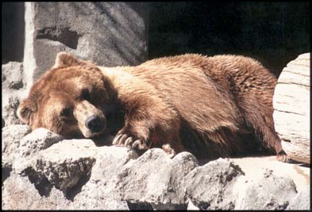
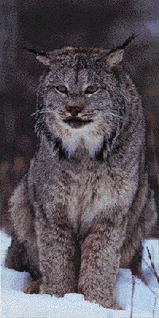Another species in danger in all over Europe is lynx, the biggest European feline. Very few lynxes live now in Greece because of the hunting for their fur and because of the damages they cause in stockbreeding. We find them in the mountain range of Pindos and in forests in the Northern borders of our country.
The Mediterranean seal is the most threatened mammal in Europe. It has disappeared from the European coasts of the Mediterranean Sea and that's why Greece is very important for its protection. The main reasons for its disappearance are the damage of her living areas, the killing by the fishermen because of the damages she does to their nets, the luck of food and the pollution of the sea.
Animal in danger in Europe is also the wolf. Greece is one of the European countries were the wolf seems to be found in a satisfying amount. But still, they are not more than 500. The wolf lives in almost the whole mainland, except Peloponnisos from where he was disappeared during the 40's decade. He also lives in the mountains of Sterea Hellas, but there isn't a permanent population there. 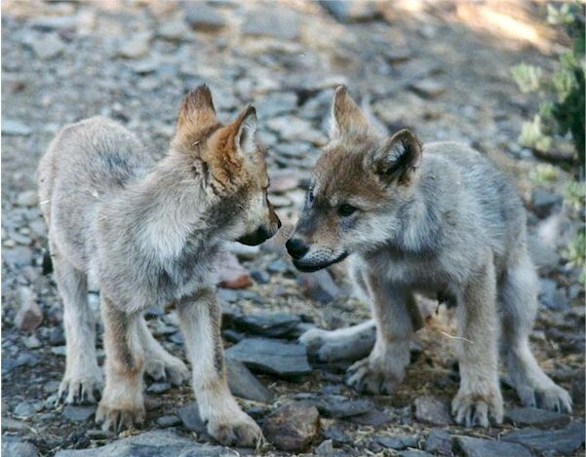
The jackal is found in almost all the areas of the mainland. The only island where the jackal lives is Samos. We don't have an exact number of the population but all the facts show that there is a wane of it. 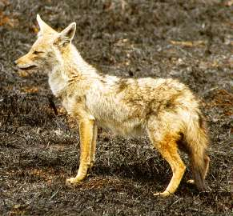
The deer, the biggest vegetarian animal in Greece, is under an immediate danger. Because of the exaggerated hunting its populations are minimized and today there are very few left only in the peninsula of Sithonia, the mountain range of Rodopi and Parnassos.
In the Mediterranean Sea, the sea turtle caretta-caretta is reproduced only in Greece, Cyprus and Turkey. The density of the nests in Zakynthos is the higher all over the world.

Extract from the project "Animal in Danger "
by the student Plesa Claudiu Georgian
IX-D.

