Atractions
of America

Detroit
From the steely heights of wartime manufacturing, to the explosion of the post-war years, Detroit has seen its share of surges. Now Motor City's cultural renaissance throttles ahead at full speed. Downtown is being reborn, Detroit's architectural history, from art deco to neo-gothic, is being revamped, the artsy Necklace District shines again and roulette wheels keep turning in the nation's most populated gaming city.
Forget the tired cliches about Detroit's demise. Remember that Motown began here in 1958 and changed America's music charts for all time. In the early-'80s, the intrepid beginnings of techno happened in the warehouses of downtown Detroit and the present-day success of Eminem continues to shine a provocative light on this city's cultural world. Museums abound, the Hydroplane Thunderfest draws thousands every year and Detroit's People Mover keeps the city in motion.
From the native Anishnabe tribe to early French colonials to present day Motowners, something about the banks on the placid waters of the Detroit River have always drawn, and kept, a loyal crowd.
Downtown Detroit Hotels
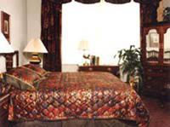
Hotel Pontchartrain
2 Washington Boulevard Detroit, MI 48226
Around so long it's been dubbed the "Pontch" by Motowners, the Hotel Pontchartrain stands on the site of Detroit's first French fort of the same name. The 25-floor Pontchartrain recently underwent renovations to bring its rooms into the new millennium. Rooms overlooking the Detroit River recall the fascination the French must have felt, while back rooms peek into Detroit's fire station. All rooms are softly classic and since Detroit grew up around this very spot, be certain you're central.
Luxury speed cruisers dock in front of this red brick ode to European prestige, set in Detroit's quaint and quieter River Town district. Inside in the lobby, chandeliers, rich carpeting and crimson color schemes prove this French hotelier's hold on one of Detroit's more abundant addresses. In a word, the guestrooms, from deluxe doubles to presidential suites, are lavish; the services, from meeting rooms to tanning beds, span the gamut of extravagance.

The City That Was
When you click on points of interest in the panoramic photo of 1906 Detroit in the right frame, text and images will appear in this frame. Each picture within the pages can also be clicked on to provide more-detailed, higher-resolution photos.
The Detroit pictured here has been washed away in a tide of technological and social change more rapid, perhaps, than any in human history. Click on the photo at right, read the text below, and witness the transformation of Campus Martius from grand civic plaza to post-Industrial urban backwater.

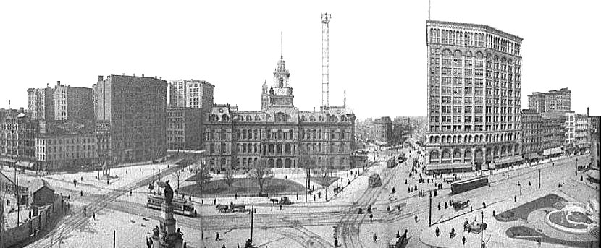
Campus Martius, Detroit, Michigan, 1906
This is downtown Detroit, 1906, on the eve of the automobile explosion. There are no automobiles in the three-picture perspective at right, even though Henry Ford had driven his first model through the streets of Detroit ten years earlier. People and cargo travel by horse or electric streetcar, and pedestrians roam freely through the streets. Detroit City Hall (1871) is in the center with its wide lawn sloping to Woodward, Detroit's main street. The scene has an aura of civic idealism, equal parts bustling metropolis and manicured garden; the dusty streets, striped by vehicle tracks, lend a rural air.
Detroit's major roads radiate from this public square known as Campus Martius. (Ironically, the city had been laid out in the shape of a spoked-wheel nearly one hundred years before Henry Ford manufactured the first Model T.) All distances in Detroit were once measured from this point, including the "Mile Roads" that march into Detroit's northern suburbs. Woodward Avenue, Fort Street, and Michigan Avenue meet here, and Gratiot and Grand River start only a few blocks away. These are main arteries along which Detroit is still developing in the outer suburbs.
As the automobile transformed the country, Detroit quadrupled in population (1900-1930). Concrete was poured, skyscrapers soared, and the retail district, seen in the right panel of the panorama, expanded to world class status. Increasingly prosperous Detroiters bought more and more of their own product, and downtown overflowed with cars.
By 1928, Campus Martius was the busiest intersection in the country according to a contemporary visitor's guide.
As early as 1920, civic leaders made plans to relieve the congestion around Campus Martius. Streets were widened, traffic signals installed, and subway schemes studied. The Great Depression put an end to the subway plans, and the city's growth slowed.
After the war, Detroiters, like most Americans, were far more interested in the open spaces of their suburbs than in the grimy confines of the central city. Despite well-intentioned (yet often clumsy) attempts at urban renewal, the central city and Campus Martius slowly withered as families left the city to raise baby boomers in the clean air of suburban tract housing.
The City Hall in the center of this picture was torn down in 1961, leaving an open public space. New buildings were set back from the street, and the streets were widened, but by the late 60's, the number of people in downtown was declining. The closing of the huge Hudson's department store in 1982 signaled the end of retail in downtown, and only government and financial institutions hang on today, awash in a sea of unused office space and boarded storefronts. General Motors' recent purchase of the Renaissance Center for a bargain basement price ($72 million for a complex that cost $350 million to build twenty years ago) is an indication of how far the decline has gone.
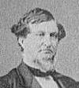
Campus Martius is still a relatively busy intersection, but no more so than dozens of other places across town and probably less so than many rural interstate exit ramps.
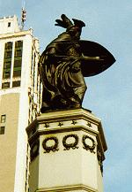
In the photographs at right, scattered pedestrians walk at random slants across the open space. Today, they cling together at crosswalks or huddle at bus stops, numbed by the thrum of tires and the dull grinding of laboring motors.
Detroiters have a bittersweet nostalgia for their downtown, and some still go back for sporting events, parades, and the like; but none of them would give up their strip malls and cineplexes to go back to 1906. The collective psychology that built civic plazas like Campus Martius no longer exists, dissipated in the march of technology, time, and social turmoil that goes by the name of Progress.
The average Detroiter walking across Campus Martius in 1906 probably had a pretty good opinion of Progress; the frontier days were still in living memory, and the technological and material improvements in daily life were manifest.
The average Detroiter today wouldn't walk across Campus Martius at all, though he may drive through it on the way to a Red Wings game. He may even have a fair opinion of Progress, but It probably doesn't cross his mind as he waits at just another stoplight at what was once "the busiest intersection in the country, by actual count!"

Soldiers & Sailors Monument
At the top of this 1871 monument to Civil War veterans is "a colossal personification of Mich igan as a semi-civilized Indian queen menacingly brandishing a sword with her right hand and clutching a shield with the left." (From an 1870's Michigan History.) Michigan was indeed a menacing presence during the Civil War,providing 90,000 troops (8th in the Union, despite ranking 10th in population) for the Federal cause. The 24th Michigan Infantry (part of the famous Black Hats) fought at Gettysburg where they helped stop Lee's numerically superior forces on the first day then faced the Pickett's famous Charge on the third day, suffering eighty-percent casualties. Other Michigan units served with equal distinction.
The 24th was born at Campus Martius; at the request of the President, Governor Austin Blair called for six new regiments of volunteers on July 15, 1862. The next day, Detroit civic leaders held a rally in Campus Martius to recruit voluteers. Some in the crowd, mistaking the call for the imposition of a draft, began to protest, and the rally turned into a riot. Rally leaders, including the octagenerian Lewis Cass, (former governor, Secretary of War, and Indian fighter) were escorted into the nearby Russell House hotel under the protection of the Wayne County sheriff. The riot was seen as a black mark upon the patriotism of Detroit, Wayne County, and Michigan. To remedy this, the governor called for a special regiment of volunteers outside the six requested by Lincoln; potential enlistees were encouraged to "rescue the honor of Detroit." Another rally was held at Campus Martius, this time things went smoothly, and, after finishing their training in camp at Woodward and Eight Mile Road in late August, the 24th Michigan Infantry paraded through the city to the riverfront where they embarked on an Eastern-bound steamer.
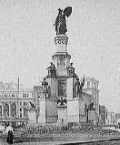
Before the Civil War, Detroit was a hotbed of the populist, mercantile politics that fueled Northern opposition to Southern aristocrats and the plantation economy. The city's merchant class and newly prosperous immigrants saw the future of the United States patterned after their own recent successes which had been the product of freely-available land, protectionist trade/open immigration, and growth in transportation.
From a contemporary Detroiter's point of view, the South, with its slave-based economy and concentration of power in the hands of a few, threatened the foundations of his recently-realized dream. Further, the New England ancestry of most Detroiters made abolition a popular political cause.
Detroit wholesale merchant Zachariah Chandler was elected in 1857 to the U.S. Senate where he was regarded as the most radical of all Republicans, opposing compromise before the war, urging full military effort during the war, and taking vengeance on Southern leaders during Reconstruction. Upon the death of Abraham Lincoln, while the rest of the nation mourned, Chandler was privately pleased with the possibilities posed by Lincoln's assassination. "Had Mr. Lincoln's policy been carried out, we should have Jeff Davis, Toombs, etc. back in the Senate at the next session of Congress, but now their chances to stretch hemp are better.... So mote it be."
After the War, Detroit finally outgrew its identity as a frontier outpost. The city center moved 1/4 mile from the waterfront to the high ground formerly occupied by the colonial-era fortifications and military parade grounds. (Hence the name Campus Martius, Latin for "Grounds Military.") The new City Hall, begun before the war, opened on Campus Martius in 1871 on the west side of Woodward, and the Soldiers and Sailors Monument, directly across the street, was formally dedicated a year later. These two were the anchors upon which Campus Martius and Detroit grew during the post-War period.
The Union victory (which came at the cost of 15,000 Michigan lives) was at least partly responsible for Detroit's growth. Detroit was a leading supplier of war materiel.
Further, the economic expansion of the West that followed the War came on Northern terms, which meant free settlers on small farms rather than slaves and planters on large plantations. It meant a large influx of immigrants to settle the vast expanses. Together, the increase in population and the economies of small farms created a tremendous demand for manufactured goods that Detroit was ideally suited to provide.
At the bottom of the granite monument roost four bronze eagles. On the next tier are four figures representing the miltary services: Infantry, Artillery, Cavalry, and Marine. Bronzed medallions of Lincoln, Grant, Sherman, and Farragut are spaced between. And, just below the figure of Michigan are four allegorical figures representing Victory, Union, Emancipation, and History.
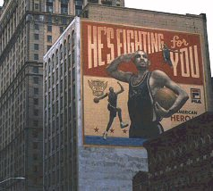
Today, Detroiters still glorify their heroes in civic artwork, but the themes are commercial, not allegorical. Their heroes are not patriots but professional athletes, and their media are not bronze and granite but high-tech paints and computer-controlled airbrushes. The 1993 mural on the building behind the Soldiers and Sailors Monument is of Barry Saunders, star running back for the Detroit Lions. The Swoosh© logo in the upper right-hand corner of the mural proclaims the patronage of shoe-giant Nike who paid for the artwork.
On the other side of Campus Martius, Detroit Piston Grant Hill promotes FILA shoes in a mock-military mural done in 1996.

The Majestic Building
As fortunes were made in the booming American economy of the 1880's, American businessmen and entrepeneurs turned to the new architecture of the skyscaper to express their wealth and importance. Detroit's first skyscaper, the Hammond Building, was built in 1890 by George Hammond, a Detroit-born meat packing magnate who made his fortune as a pioneer in refrigerated shipping.
Not to be outdone, department store owner Christopher Mabley began planning an even taller structure to display his merchandise. Like Hammond, Mabley died before the structure could be completed, but, unlike Hammond, no one completed his dream. The bui lding never housed his department store, nor did it bear his name. The letter "M" had been carved into the capstone and at other places in the building's stonework to signify Mabley, so the developers who continued the project christened the orphaned skyscaper the Majestic Building.
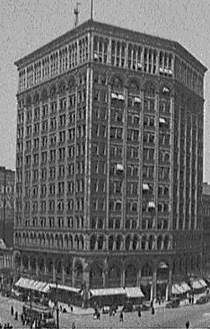
Designed by noted skyscaperist Daniel Burnham of Chicago, the Majestic was modern in more than just its soaring form. The entire structure was proclaimed fireproof, a claim that was tested by a 1915 fire on the top floor. The fire burned for more than two hours before firefighters could contain it, but it never spread beyond its origin. The terra-cotta walls and floors contained the blaze and gave proof to Detroiters that Progress could indeed make their lives better, happier, and safer.
At fourteen stories, it reigned as the king of Detroit skyscrapers from 1896 until 1909. The photo at left shows the expansive view from the roof, with the County Building standing in the middleground.
Though built as a store, the Majestic served its entire life as an office building. It fell to the wrecking ball in 1962 and was replaced by the black granite First Federal Building in 1965.
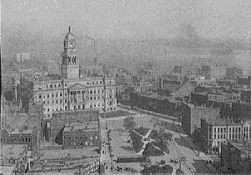
In the days before the Majestic, this corner housed Fred Sanders's ice cream parlor where he invented the ice cream soda. Sanders's concoction became famous across America, giving Sanders the means to start a chain of ice cream parlors that spread across the Detroit area. Cherished by generations of Detroiters, Sanders Ice Cream gradually succumbed to 31 Flavors, Dairy Queen, TCBY, et al. The last store closed in 1995. In the panorama photo, the building to the right of the Majestic is the home of the flagship Sanders store.

The Merrill Fountain
Lizzie Merrill Palmer dedicated this Italian Renaissance fountain to her father, robber baron-lumberman Charles Merrill in 1901. His fortune, like that of many 19th-century Detroit families, was made on Michigan's raw materials. Detroit's access to raw materials from the Great Lakes' wilderness made it an ideal site for manufacturing even before the rise of the automobile industry.
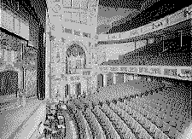
At the dedication, Mrs. Palmer's husband, Senator Thomas W. Palmer, orated on the need for fountains: "As men were crowded into great cities and denied the frequent sight or contact with water in agitation or repose, a craving for it, as a feature of the landscape, has led to the construction of artificial lakes, cascades and fountains to cool the air, please the eye and soothe the ear, as well as supply the physical wants of the people. For Palmer and his audience, the agrarian past was a fresh memory. Speeches and editorials frequently invoked the same kind of romantic pastoral nostalgia that Palmer elicits with the word craving. At the same time, the answer to this craving is not a return to Nature, but a further reduction of it into "artificial lakes, cascades and fountains".

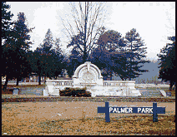
Glistening white on a sunny summer day, the fountain is only a few years old in this photo. Behind it is the Detroit Opera House, the focus of Detroit culture for half a century.
The Opera House would soon be converted to expand the burgeoning retail trade. The improved efficiency in manufacturing techniques that put automobiles within the reach of millions of Americans also made retail goods more plentiful and cheaper than ever before. Shopping, the American cultural institution, was only in its infancy.
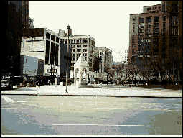
The fountain itself would be removed in the twenties to relieve traffic congestion. It now sits in Palmer Park, six miles up Woodward, in northern Detroit, on land donated by Senator and Mrs. Palmer.

Today, the Bagley Fountain, moved from Fort and Woodward in a 1930's widening of Campus Martius, occupies more or less the same ground.

San Francisco Attractions
Alcatraz Island and Prison
Board the ferry to Alcatraz Island at Fisherman's Wharf and enjoy spectacular views of the San Francisco skyline on the way to this must-see San Francisco attraction -- once home to notorious prisoners like Al Capone. Alcatraz Tour tickets can be purchased at the ticket booth at Pier 41, San Francisco Fisherman's Wharf.
Baker Beach
San Francisco's most popular and locally beloved nude beach is nestled in the western shadow of the Golden Gate Bridge. Aside from being the birth place of Burning Man, the great qualities of Baker Beach are its size, close shore breaks, tide pools, steep bluffs, and climbable rocks, and a totally nude north end that rubs friendly elbows with a decidedly family-style south side, complete with barbeque grills and picnic tables. While this stretch of the Pacific makes for rough swimming, it bodes well for panoramic sun bathing and excellent shore fishing.
Cable Cars
The Powell-Hyde line begins at Powell and Market streets, terminating at Victorian Park near the Maritime Museum and Aquatic Park; the Powell-Mason line also begins at Powell and Market, but ends at Bay and Taylor near Fisherman's Wharf; the California Street line runs from California and Market streets to Van Ness Avenue.
Chinatown
Enter at "Dragon's Gate" at Grant Avenue and Bush Street.
San Francisco's bustling Chinatown is a tightly-packed warren of Chinese restaurants, shops, temples and street vendors. Great for gifts, and fireworks on Chinese New Year.
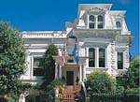
Cliff House
The third Cliff House, which was built in 1909, after its two predecessors burned, is considerably more modest than the eight-story French chateau built by Adolph Sutro in 1896. This newest one, built in 1909 by Sutro's daughter, is operated by the National Park Service as a restaurant and boast commanding views of the Pacific Ocean and Ocean Beach.
Coit Tower
The wild local heiress Lillie Hitchcock donated the money for her posthumous tribute the San Francisco fire department, the 180-foot tall Coit Tower which overlooks an impressive 360 degree panorama view of the Embarcadero, Pier 39, the Golden Gate Bridge, Mt. Sutro, and the Financial District all in one dizzying sweep. Work up an appetite for North Beach's Italian flair by trekking your way up Telegraph Hill to peruse the view and the Diego Rivera style frescoes housed inside the Tower.
Exploratorium
Founded in 1969 by noted physicist and educator Dr. Frank Oppenheimer, the Exploratorium houses a playful array of over 650 hands-on science, art, and human perception exhibits. From salt volcanos and bubble bombs to fault lines and frogs, the line up tests imaginations young and old. Just the building itself, a palatial domed structure left from the San Francisco Pan Pacific Exhibition of 1916, is worth a visit.
Fisherman's Wharf
Popular with tourists and sea lions, Fisherman's Wharf is full of shops, silly museums and family fun. Still a working wharf, its vendors sell thousands of tons of fish and shellfish. Take an early morning walk down "Fish Alley" to see fisherman at work. Later, the Wharf is boardwalk-style family entertainment with decidedly tourist attractions such as Ripley's Believe It or Not! Museum, the Red & White Fleet, a the Wax Museum. For maritime-lovers and WWII buffs, the San Francisco Maritime Musuem is at the foot of Polk St. and massive USS Pampanito is docked right at Pier 45
Ghirardelli Square
Shopping and waterfront dining at fine restaurants and shops in historic San Francisco Ghirardelli Chocolate Factory near San Francisco Fisherman's Wharf. The building was saved from destruction in one of the U.S.'s first examples of adaptive reuse.Ghirardelli Square Chocolate Festival takes place in early September.
Golden Gate Park
Larger than Central Park, the 1,000-acre Golden Gate Park;s treasure trove of attractions includes Stybing Arboretum and Botanical Gardens, a biodiversity hub where 6,000 plant species, including a towering display of California redwoods, thrive; the ethereal Japanese Tea Garden; a children's playground; the Asian Art Museum; MH de Young Memorial Museum; and the California Academy of Sciences, with its aquarium, Morrison Planetarium and laserium. Even more, the open tennis courts, horse stables, baseball diamonds, polo grounds, croquet and lawn-bowling greens, an archery field, a golf course and a fly-fishing pool draw an outdoorsy crowd year-round. For a full experience, follow the green panhandle between Fell and Oak streets straight into the park.
Grace Cathedral
The gothic landmark of the west coast, the ornate beauty of Grace Cathedral is home to hidden gardens, curling dragon statues, and a redwood pulpit that has seen the likes of Dr. Martin Luther King Jr., Archbishop Desmond Tutu, and the Dalai Lama. The Grace hosts glorious concerts year round and its Columbarium is the only sacred landmark in San Francisco where freshly cremated remains may be laid to rest.
Mission District
The heart of San Francisco's predominantly Latino neighborhood is 24th Street, a colorful collection of authentic restaurants, taquerias, Mexican bakeries, produce markets, specialty shops and murals. Mission Dolores at 16th and Dolores streets is the oldest structure in San Francisco (many of San Francisco's Spanish pioneers are buried on the site). Two blocks away on Dolores and 18th St., the palm tree studded Dolores Park still has a Spanish flavor.
Union Square
A lone Corinthian column surrounded by newly installed palm trees marks SF's mecca for shopaholics. Ringed by Macy's, Saks, Neiman Marcus, Nike Town and Levi's stores along with colorful flower stands and street performers. Surrounding streets feature superstores like Virgin Megastore, FAO Schwarz, Gump's and Britex Fabrics along with boutiques for Coach, Bulgari, Cartier, Thomas Pink, Louis Vuitton, MaxMara, Emporio Armani, Diesel, Prada, Celine, Escada, Gucci, Guess, Hermes, Agnes B., Betsey Johnson and Wilkes Bashford.
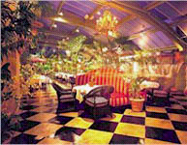
Yerba Buena Center for the Arts
Fumihiko Maki's daring architecture is home to eclectic exhibitions, performances and films. The lawn of Yerba Buena Gardens above is great for frisbee throwing. The nearby Sony Metreon, which opened in 1999 has become a major South of Market destination with 350,000 square feet of shopping, restaurants, movie theaters, interactive arcades and attractions.

