Aztec Events
Aztecs lived in Mexico in the sixteenth century. The Aztec people, led by their Lord Montezuma, ruled over a huge, rich empire. Their capital, Tenochtitlan, was one of the worlds largest cities. In 1519 the Spanish attacked and destroyed the Aztec Empire.
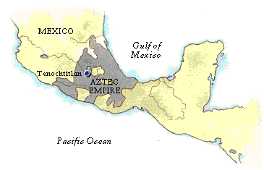
We know something about how Aztecs lived from ruins of buildings, and remains of pottery, jewellery, and other artefacts which have been found. Archaeologists are people who piece together history from this sort of evidence. Often evidence is buried deep under the ground.
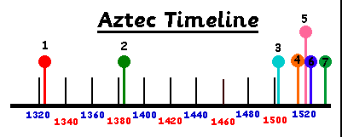
Choose a number from the list below . . .
1, 2, 3, 4, 5, 6, 7
1. 1325 Aztecs found Tenochtitlan on a marshy island in Lake Texcoco.
2. 1485-1547 Life of Hernando Cortez
3. 1502 Montezuma crowned Emperor of the Aztecs
4. 1519 Cortez follows Coloumbus' route to the Americas and lands in Mexico.
5. 1520 Death of Montezuma
6. 1521 Tenochtitlan conquered by Spaniards led by Cortez.
7. 1528 Cortez returns to Spain

