Beauty spots
Danube delta
At the end of the great river Danube's 2,860 km ( 1788 miles) journey from the Black Forest mountains in Germany to Romania's Black Sea coast, a natural paradise with spectacular wiews spreads out in front of you. Over countless centuries the silt brought down by the river has enlarged the Delta into a network of channels, lakes, reed isles, tropical woods, pastures and sand dunes that now cover nearly 5,640 sq km. This amazing wetland shelters over 300 species of birds, countless species of fish and, 1,150 kinds of plants It is no wonder that UNESCO designated the Delta a "Reservation of the Biosphere.”
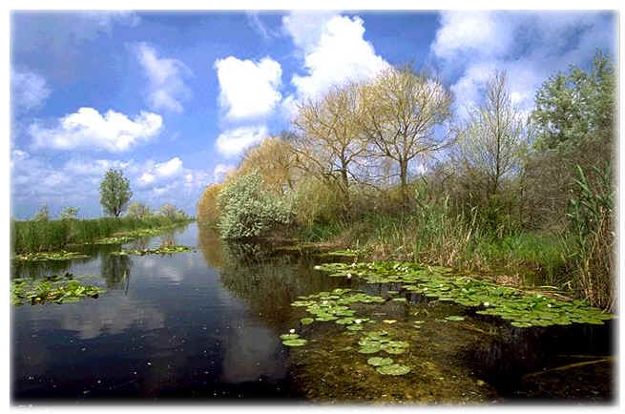

The Danube Delta is one, in Europe unique landscape which distinguishes itself by the indescribable wealth of animal species and botanical species which can be found here.
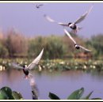
Therefore the Danube Delta is considered to be one of the biggest bird paradieses of the earth. The Danube main canals are connected with channels and tributaries together. In between numerous lakes, as well as the lagoon landscape situated in the south. 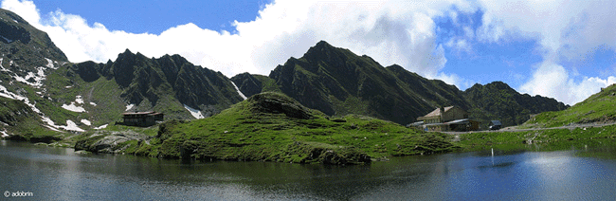
Experience this unrestrained nature which has developed with reed, wild apple trees and pear trees, meadows and creepers like a jungle.

