GENERAL PRESENTATION OF THE CAPITAL PUNISHMENT

I INTRODUCTION
Capital Punishment, legal infliction of death as a penalty for violating criminal law. Throughout history people have been put to death for various forms of wrongdoing. Methods of execution have included such practices as crucifixion, stoning, drowning, burning at the stake, impaling, and beheading. Today capital punishment is typically accomplished by lethal gas or injection, electrocution, hanging, or shooting.
The death penalty is the most controversial penal practice in the modern world. Other harsh, physical forms of criminal punishment—referred to as corporal punishment—have generally been eliminated in modern times as uncivilized and unnecessary. In the majority of countries, contemporary methods of punishment—such as imprisonment or fines—no longer involve the infliction of physical pain (see Corporal Punishment). Although imprisonment and fines are universally recognized as necessary to the control of crime, the nations of the world are split on the issue of capital punishment. About 80 nations have abolished the death penalty and an almost equal number of nations (most of which are developing countries) retain it.
The trend in most industrialized nations has been to first stop executing prisoners and then to substitute long terms of imprisonment for death as the most severe of all criminal penalties. The United States is an important exception to this trend. The federal government and a majority of U.S. states provide for the death penalty, and from 50 to 75 executions occur each year throughout the United States.
II THE DEATH PENALTY DEBATE
The practice of capital punishment is as old as government itself. For most of history, it has not been considered controversial. Since ancient times most governments have punished a wide variety of crimes by death and have conducted executions as a routine part of the administration of criminal law. However, in the mid-18th century, social commentators in Europe began to emphasize the worth of the individual and to criticize government practices they considered unjust, including capital punishment. The controversy and debate over whether governments should utilize the death penalty continue today.
The first significant movement to abolish the death penalty began during the era known as the Age of Enlightenment. In 1764 Italian jurist and philosopher Cesare Beccaria published Tratto dei delitti e delle pene (1764; translated as Essay on Crimes and Punishments, 1880). Many consider this influential work the leading document in the early campaign against capital punishment. Other individuals who campaigned against executions during this period include French authors Voltaire and Denis Diderot, British philosophers David Hume and Adam Smith, and political theorist Thomas Paine in the United States.
Critics of capital punishment contend that it is brutal and degrading, while supporters consider it a necessary form of retribution (revenge) for terrible crimes. Those who advocate the death penalty assert that it is a uniquely effective punishment that deters crime. However, advocates and opponents of the death penalty dispute the proper interpretation of statistical analyses of its deterrent effect. Opponents of capital punishment see the death penalty as a human rights issue involving the proper limits of governmental power. In contrast, those who want governments to continue to execute tend to regard capital punishment as an issue of criminal justice policy. Because of these alternative viewpoints, there is a profound difference of opinion not only about what is the right answer on capital punishment, but about what type of question is being asked when the death penalty becomes a public issue.
A Brutality
Early opponents of capital punishment objected to its brutality. Executions were public spectacles involving cruel methods. In addition, capital punishment was not reserved solely for the most serious crimes. Death was the penalty for a variety of minor offenses.
The allegations of brutality inspired two different responses by those who supported executions. First, advocates contended that capital punishment was necessary for the safety of other citizens and therefore not gratuitous. Second, death penalty supporters sought to remove some of the most visibly gruesome aspects of execution. Executions that had been open to the public were relocated behind closed doors. Later, governments replaced traditional methods of causing death—such as hanging—with what were regarded as more modern methods, such as electrocution and poison gas.
The search for less brutal means of inflicting death continues to recent times. In 1977 Oklahoma became the first U.S. state to authorize execution by lethal injection—the administration of fatal amounts of fast-acting drugs and chemicals. Lethal injection is now the preferred method of execution in the majority of U.S. states. However, modern opponents of capital punishment contend that sterilized and depersonalized methods of execution do not eliminate the brutality of the penalty.
B Dignity
In the debate about execution and human dignity, supporters and opponents of the death penalty have found very little common ground. Opponents of capital punishment assert that it is degrading to the humanity of the person punished. Since the 18th century, those who wish to abolish the death penalty have stressed the significance of requiring governments to recognize the importance of each individual. However, supporters of capital punishment see nothing wrong with governments deliberately killing terrible people who commit terrible crimes. Therefore, they see no need to limit governmental power in this area.
C Effectiveness
Early opponents of capital punishment also argued that inflicting death was not necessary to control crime and properly punish wrongdoers. Instead, alternative punishment—such as imprisonment—could effectively isolate criminals from the community, deter other potential offenders from committing offenses, and express the community's condemnation of those who break its laws. In his Essay on Crimes and Punishments, Beccaria asserted that the certainty of punishment, rather than its severity, was a more effective deterrent.
Supporters of capital punishment countered that the ultimate penalty of death was necessary for the punishment of terrible crimes because it provided the most complete retribution and condemnation. Furthermore, they argued that the threat of execution was a unique deterrent. Death penalty supporters contended that capital punishment self-evidently prevents more crime because death is so much more feared than mere restrictions on one’s liberty.
Supporters and opponents of capital punishment still debate its effectiveness. Social scientists have collected statistical data on trends in homicide before and after jurisdictions have abolished capital punishment. They have also compared homicide rates in places with and without the death penalty. The great majority of these statistical comparisons indicate that the presence or absence of capital punishment or executions does not visibly influence the rate of homicide.
Opponents of capital punishment maintain that these studies refute the argument that the death penalty deters crime. Many capital punishment opponents consider the deterrence argument fully negated and no longer part of the debate. However, supporters of the death penalty dispute that interpretation of the statistical analyses of deterrent effect. Capital punishment advocates note that because the death penalty is reserved for the most aggravated murders, the deterrent effect of capital punishment on such crimes may not be apparent in data on homicide rates in general. Supporters also urge that the conflicting results of various studies indicate that the deterrent effect of the death penalty cannot not be proven or disproven with any certainty. They maintain that in the absence of conclusive proof that the threat of execution might not save some people from being killed, capital punishment should be retained.
D Human Rights
A unique facet of the modern debate about capital punishment is the characterization of the death penalty as a human rights issue, rather than a debate about the proper punishment of criminals. Modern opposition to the death penalty is seen as a reaction to the political history of the 20th century, most notably the Holocaust—the systematic mass killing of Jews and others during World War II (1939-1945). All the major nations in Western Europe utilized capital punishment prior to World War II. After the defeat of the National Socialist (Nazi) and Fascist governments of Germany and Italy, those two nations became the first major powers in Europe to abolish capital punishment. The postwar movement to end capital punishment, beginning in Italy and Germany and then spreading, represented a reaction to totalitarian forms of government that systematically violated the rights of the individual (see Totalitarianism).
The human rights focus on the death penalty has continued, especially in settings of dramatic political change. When people view capital punishment as a human rights issue, countries that are becoming more democratic have been eager to abolish the death penalty, which they associate with the former regime and its abuses of power. For example, a number of former Communist nations abolished capital punishment shortly after the dissolution of the Union of Soviet Socialist Republics in 1991. Similarly, the multiracial government of South Africa formed in 1994 quickly outlawed a death penalty many associated with apartheid, the official policy of racial segregation that had been in place since the late 1940s.
III WORLD TRENDS
For most of recorded history, capital punishment was available to every government for especially serious crimes and often for a great variety of less serious offenses. The term felony, which today signifies all serious crime, was the traditional classification in England for crimes punishable by death. Since the 18th century, the long-term trend in nations of Western Europe and North and South America has been a reduction of the number of capital crimes (criminal offenses punishable by death) and the execution of fewer criminals.
A Early Efforts
Against the Death Penalty Some distinctive doctrines in criminal law originated in efforts to restrict the number of capital crimes and executions. For instance, in the late 18th century, when all murder in the United States was punishable by death, Pennsylvania pioneered in dividing murder into two categories. The state enacted laws that authorized punishment of first-degree murder by death, while second-degree murder was punishable by imprisonment only. Elsewhere, penal codes uniformly required death for certain serious crimes. In these jurisdictions, discretionary powers to commute death sentences gradually expanded. (A commutation substitutes a lesser penalty for a more severe one—for example, replacing execution with a life sentence.) Today in many nations, including Turkey and Japan, the death penalty remains legal but the number of executions has declined over time.
Although many jurisdictions limited imposition of the death penalty, no government had formally abolished capital punishment until Michigan did so in 1846. Within 20 years Venezuela (1863) and Portugal (1867) had formally eliminated the practice as well. By the beginning of the 20th century the death sentence had been abolished in a handful of nations, such as Colombia, Costa Rica, Ecuador, Norway, and The Netherlands. Although not formally eliminated, it had fallen into disuse in many others, including Brazil, Cape Verde, Iceland, Monaco, and Panama.
B After World War II
The defeat of the Axis powers provided a foundation for the elimination of the death penalty in Western Europe. Some of the nations involved in the war saw abolition of capital punishment as a way to disassociate themselves from the atrocities that had taken place. Italy formally abolished the death penalty in 1947 and the Federal Republic of Germany did so in 1949. The British government instituted a Royal Commission to study capital punishment in 1950 and abolished the death penalty in 1965. (Northern Ireland did not abolish capital punishment until 1973.) By the early 1980s every major country in Europe had stopped executing criminals.
Coincident with this trend in Western Europe, many countries belonging to the Commonwealth of Nations, an association of countries formerly affiliated with the British Empire, eliminated capital punishment. For instance, Canada conducted its last execution in 1962 and abolished the death penalty in 1976. New Zealand held its last execution in 1957 and Australia stopped executing criminals ten years later.
A similar burst of abolitionist activity coincided with the breakup of the Soviet Union. East Germany, the Czech Republic, and Romania all outlawed capital punishment between 1987 and 1990. Throughout the former Communist countries, abolition of the death penalty was a political act far removed from the usual domain of criminal justice policy-making. Eliminating the death penalty was one of many ways the citizens of these countries rejected unlimited state power over individual life. For example, in Romania the overthrow of dictator Nicolae Ceauºescu was followed by his execution and that of members of his family. Shortly thereafter, the new government abolished capital punishment, which was associated with Ceauºescu’s brutal, tyrannical rule.
C Current Status
By the late 1990s, for the first time in history, the world’s nations were almost evenly divided with respect to capital punishment. As of 2000, 72 countries no longer authorized the penalty of death for any crimes. Another 13 countries authorized capital punishment only for exceptional crimes, such as crimes under military law and crimes committed in exceptional circumstances, such as during wartime. Amnesty International, a private organization working to abolish the death penalty, characterizes 23 other nations as “de facto abolitionist” because they have not conducted an execution in at least a decade or have made an international commitment not to carry out executions.
In 2000, 87 nations authorized the death penalty for some crimes. Typically, capital punishment is reserved for individuals who commit the most violent or serious crimes, such as murder and treason. However, some governments authorize capital punishment for nonviolent or nonfatal crimes. For example, in Libya importing alcohol and trading in foreign currency are capital crimes, and in the United States large-scale drug trafficking is punishable by death.
Although the number of nations with and without capital punishment is almost equal, there are definite patterns by region and by level of economic development. None of the countries in Western Europe utilize capital punishment, nor do most countries in South America. Asian countries and Islamic nations tend to practice capital punishment. The majority of countries in Africa also authorize the death penalty.
In general, industrial democracies have abolished the death penalty, while nonindustrialized nations are much more likely to retain capital punishment. Only two advanced industrial democracies, the United States and Japan, retain the death penalty. A number of newly industrialized Asian nations, such as South Korea, also practice capital punishment. Dictatorships and other forms of totalitarian governments tend to be highly active in conducting executions.
Although the trend has been that fewer countries allow executions, the worldwide trend in the number of executions conducted cannot be reliably established. According to Amnesty International, a total of 1,813 prisoners were executed in 31 countries in 1999. Five nations—China, Iran, Saudi Arabia, the Democratic Republic of the Congo, and the United States—conducted 85 percent of all these executions. However, information about executions is somewhat unreliable because not all executions are reported and not all reported executions can be confirmed.
The worldwide trend toward abolition of capital punishment will likely continue. Among industrialized nations, those that have abolished the death penalty have shown no tendency to reverse this policy, and transnational agreements in Western Europe now support abolition of capital punishment. Only major political instability could be expected to reverse the trend in Europe, Canada, and South America. Among nations that have retained capital punishment, pressure to reduce or eliminate the death penalty appears to be increasing. China and the Islamic nations of Asia and the Middle East are likely to continue executions.
IV CAPITAL PUNISHMENT IN THE UNITED STATES
The United States stands apart from the general trends on capital punishment. It is the only Western industrialized nation where executions still take place. Furthermore, it is the only nation that combines frequent executions with a highly developed legal system characterized by respect for individual rights.
Many public opinion polls indicate that capital punishment enjoys significant support in the United States. Nonetheless, it remains a highly controversial and hotly contested issue. Opponents even question whether a high level of support actually exists for the death penalty. They note that public-approval ratings of capital punishment as a preferred penalty decline when the alternative punishment is a “true” life sentence—that is, life imprisonment with no possibility of release.
A Distribution of Authority
The United States has a federal system of government, in which power is divided between a central (national) authority and smaller local units of government (see Federalism). Federal law provides the death penalty for more than 40 crimes, including treason, various forms of aggravated murder, and large-scale drug trafficking. However, the federal government has conducted no executions since 1963. Fewer than 1 percent of the persons presently sentenced to death are under the jurisdiction of the federal government. Capital punishment in the United States, therefore, is primarily a matter of state law and practice.
In the U.S. system, the states possess the primary responsibility for defining crimes and enforcing criminal law. The federal government provides basic rules, including rights guaranteed by the Constitution of the United States, but each state chooses its own criminal penalties. This basic arrangement holds for the death penalty as well.
Both law and practice regarding the death penalty vary widely in the 50 states. Twelve states do not have a death penalty. The most serious form of punishment in such states is life imprisonment, sometimes without the possibility of parole. The other 38 states all provide that some forms of aggravated murder can be punished with death. Several states also authorize capital punishment for the nonlethal offenses of drug trafficking, hijacking, treason, and sexual assault. However, in 1999 all persons under sentence of death in the United States had been convicted of some form of murder.
B Capital Punishment and the Constitution
For the first 150 years of U.S. history, the federal government played a minor role in setting policy toward the death penalty. The majority of states provided capital punishment and executions were common until the late 1950s. Some states abolished capital punishment at their own initiative, beginning with Michigan in the late 1840s. By 1965, 13 states had no death penalty, and the number of executions in those states that retained capital punishment laws had drifted downward from 199 in 1935 to 7. The reduction in executions in the United States during the 1940s and 1950s paralleled declines that were taking place in Europe and countries formerly affiliated with Britain.
By the mid-1960s, a growing debate over abolition of capital punishment had shifted from state legislatures to the federal courts. Opponents of the death penalty initiated a series of lawsuits contending that the death penalty as administered in the United States violated several amendments to the U.S. Constitution. These cases alleged that capital punishment violated the 14th Amendment, which prohibits the government from depriving citizens of life, liberty, or property without “due process of law,” as well as the 8th Amendment, which forbids cruel and unusual punishments.
In the 1972 decision of Furman v. Georgia, the Supreme Court of the United States ruled that allowing a jury unlimited discretion to choose between a death sentence and a prison sentence for a convicted criminal constituted cruel and unusual punishment. This ruling invalidated every state death penalty statute, because all of the states that retained capital punishment in 1972 used a standardless system, in which the jury received no guidance in deciding sentences. As a result, an official moratorium on executions was initiated that year and continued until 1976.
Following the Furman decision, states quickly passed new death penalty legislation. The new statutes still gave juries discretion to choose between prison and the death sentence. However, the laws also restricted the types of murder for which the death penalty could be imposed. In addition, the new statutes provided instructions on factors that judges and juries should take into account when deciding between prison and death. In the 1976 case of Gregg v. Georgia the U.S. Supreme Court ruled that such systems of guided discretion did not violate the constitutional prohibition against cruel and unusual punishment. Soon after that case was decided, 35 states had passed laws providing systems of guided discretion in death penalty cases. The first execution under these laws was that of Gary Gilmore by firing squad in Utah in 1977. Gilmore’s execution launched the modern era of capital punishment in the United States.
C Current Conditions
The current U.S. system of capital punishment differs from that of the pre-1972 era because many federal constitutional standards must now be obeyed in death penalty cases. For example, the Supreme Court has ruled that the Eighth Amendment forbids the execution of defendants who, due to mental illness, are not capable of understanding the meaning of their pending execution. In the 1988 case of Thompson v. Oklahoma, the Court rejected an attempt to impose the death penalty on an individual who was under the age of 16 at the time he committed his crime. The Court has also indicated that only individuals convicted of crimes that result in a death are eligible for the death penalty. Contemporary laws that authorize capital punishment for individuals who commit offenses that do not result in death have not yet been challenged and reviewed by the Court.
Since reinstatement of the death penalty in 1976, more than 600 executions have taken place in the United States. Of the 38 states that allowed capital punishment in 1999, only 29 had actually conducted an execution in the previous two decades. Very few states make executions a regular practice. Six of the 29 states that had executed criminals since 1977—Florida, Louisiana, Missouri, Texas, Virginia, and Georgia—conducted 70 percent of all the executions. Geographically, executions are highly concentrated in Southern states. In 1997 Texas put to death 37 prisoners, as many as all the rest of the states combined.
Every year in the United States juries sentence between 200 and 300 criminals to death. The number of death sentences is a tiny fraction of the total number of murders that occur each year—about 1 percent. However, the number of death sentences far exceeds the number of executions. The result of this steady supply of condemned prisoners is a huge and ever-growing death row population. In 1998 about 3,500 prisoners were under death sentence in the United States.
Between reinstatement of the death penalty in 1976 and the end of 1998, three women have been executed in the United States. In July 1998, 48 women remained on death row. The 74 individuals sentenced to death for crimes they committed while juveniles made up about 2 percent of the U.S. death row population in July 1998. Between 1976 and 1998, U.S. jurisdictions executed 13 offenders who were under the age of 18 when they committed their capital crimes. In February 1999 Oklahoma executed a prisoner who had committed his crimes at the age of 16, becoming the first U.S. jurisdiction to execute such an individual since 1940.
D Delay, Efficiency, and Fairness
When executions do happen in the United States, they are usually conducted a decade or more after the condemned prisoner has been convicted of the capital crime. There are two reasons why a gap of many years exists between a state death penalty and an actual execution. The first is the obvious point that all legal appeals of the death sentence must be finished before an execution can take place; otherwise, the defendant's appeal would be meaningless. Consequently, imposition of the preferred punishment for the crime—death—is postponed during the appeal process. By contrast, punishment for individuals sentenced to prison rather than death need not be postponed during the appeal process. Criminals who serve their sentences while the appeal continues are subjected to their punishment simultaneously.
A second factor contributing to delay between sentencing and execution is the procedural rule known as exhaustion of remedies. Under the U.S. federal system, defendants must finish all appeals in state courts before they can even begin to seek review of their convictions in the federal courts. This requirement that a prisoner first "exhaust state remedies" provides states with the opportunity to correct errors in their own courts before the federal courts step in. However, as a result of this doctrine, a defendant may wait many years before the case even begins in a federal court. Yet if the federal courts did not scrutinize cases where a defendant alleges a violation of constitutional rights, the states could enforce only those constitutional rights they wish to uphold. If the federal courts wait their turn and then provide a full inquiry, a long delay between conviction and execution will result.
This long gap between crime and punishment frustrates supporters of capital punishment. In recent years the Congress of the United States has passed two separate federal laws intended to reduce the delay between sentencing and execution. These laws limit the authority of federal courts to hear appeals in death penalty cases. Critics of this attempt to curtail appellate review include the nation’s largest organization of attorneys, the American Bar Association (ABA). In 1997 the ABA adopted a resolution calling upon all jurisdictions that utilize capital punishment to refrain from conducting executions until those jurisdictions had implemented certain policies to ensure that death penalty cases are administered fairly and impartially. One of the ABA’s recommended policies focused on “preserving, enhancing, and streamlining state and federal courts’ authority and responsibility” regarding appeals.
A basic conflict between the efficiency of a criminal justice system and its fairness to accused persons lurks behind the problem of delay. Providing procedural safeguards to avoid punishment of innocent persons and ensure that even guilty persons have every chance to demonstrate errors in the process of their conviction is not the swiftest way to run a criminal justice system. Ensuring due process of law is time-consuming and expensive. Widespread public support always exists for cutting back on defendants’ rights in criminal cases. After all, these rights make it more difficult to protect the community from criminals. Limiting federal court authority to hear appeals reduces delay. However, this increased efficiency comes at a price. The chance of unjust executions increases when federal judges cannot hear all claims of legal error. Reducing access to courts saves time and money but increases the likelihood of significant error. For death penalty convictions, the consequence of error is the ultimate punishment of death.
E Disparity in Application Critics of capital punishment in the United States object to perceived arbitrariness and discrepancies in its administration. Numerous studies have documented the influence of race on sentencing decisions. However, supporters and opponents provide varying opinions on the meaning of the disparity in treatment of offenders as a result of race.
Those who believe the states administer the death penalty in a racially biased manner emphasize the disproportionate numbers of African Americans on death row. Critics of the application of the death penalty also note that the race of the victim provides a statistically clear determinant of whether or not a defendant receives a sentence of death or imprisonment. Thus, although about half of all murder victims in the United States are nonwhite, 80 percent of all death sentences are imposed for murders of whites. Supporters of capital punishment attribute statistical disparities in sentencing to the different circumstances surrounding the offenses. For example, supporters claim that murders of white victims more often involve a killing during the course of a robbery or other felony, an aggravating factor that makes the murderer eligible for a death sentence.
Legal challenges to imposition of the death penalty based on allegations of racial discrimination have achieved little success. In the 1987 decision of McCleskey v. Kemp, the Supreme Court affirmed the death sentence of an African American man convicted in Georgia of killing a white police officer during the course of a robbery. The defendant had submitted data to the Supreme Court indicating that defendants in Georgia charged with killing white victims were more than four times as likely to receive a death sentence than those convicted of killing a nonwhite victim. In a 5-to-4 vote, the Court concluded that while the study indicated “a discrepancy that appears to correlate with race,” the defendant had not clearly demonstrated that the jury in his particular case acted with discriminatory purpose. While not rejecting the validity of the statistical analysis, the Court refused to overturn a particular death sentence without evidence that the issue of race had influenced the jury in that specific case.

The most recently executed offenders in the U.S.A

Each of their records contains information about the crime they commited,their victims as well as life facts such as level of education or age at the time of the offense.I have chosen to include this part in my presentation of the subject because the executions are extremely recent and each of us should stop and think for a moment what they were doing on a particular day while a man,a human being, was preparing to die, or better said to be killed, in order to pay for his crime.

The offenders are placed in a cronological order :

- 20th October 2005 – Luis Ramirez
- 3rd November 2005 – Melvin White
- 9th November 2005 – Charles Daniel Thacker
- 15th November 2005 – Robert Dale Rowell
- 16th November 2005 – Shannon Charles Thomas

Name | TDCJ Number | Date of Birth
Rowell, Robert Dale | 999104 | 04/08/1955
Date Received | Age (when Received) | Education Level (Highest Grade Completed)
06/03/1994 | 44 | 9
Date of Offense | Age (at the time of Offense) | County
05/10/1993 | 38 | Harris
Race | Gender | Hair Color
White | Male | Brown
Height | Weight | Eye Color
5' 08" | 168 | Blue
Native County | Native State | Prior Occupation
Harris | Texas | Laborer
Prior Prison Record
TDCJ-ID #237420 on a 12 year sentence from Harris Co. for Robbery by Assault, TDCJ-ID #314202 on a 30 year sentence for 3 counts of Aggravated Robbery.
Summary of incident
On 05/10/1993 in Houston, Texas, Rowell entered a crack house in an attempt to rob Irving Wright of drugs and money. Rowell started shooting with a 25 caliber pistol striking all three victims, killing Wright and Mata, Perez was shot in the left arm and leg and paralyzed. Rowell then robbed the victim of unknown money and fled the scene by car.
Co-defendants
None
Race and Gender of Victim
Unknown males
Photograph of Offender


Date of Execution:
November 15, 2005
Offender:
Rowell, Robert Dale
Last Statement:
Yes sir. I would like to apologize to the victim's family and all the grief I have caused them. I would like to say I love the girls next to them. Praise the Lord. Let's go, Warden. That's it.

Name | TDCJ Number | Date of Birth
White, Melvin Wayne | 999317 | 1/25/1950
Date Received | Age (when Received) | Education Level (Highest Grade Completed)
6/21/1999 | 49 | 9 years
Date of Offense | Age (at the time of Offense) | County
8/5/1997 | 47 | Pecos
Race | Gender | Hair Color
White | Male | Brown
Height | Weight | Eye Color
5-9 | 205 | Brown
Native County | Native State | Prior Occupation
Howard | Texas | Mechanic/Laborer
Prior Prison Record
None
Summary of incident
On August 4, 1997, the subject kidnapped a 9-year-old white female in Ozona, Texas, during the nighttime hours. He then took her to a roadside park out of the city limits and attempted to have sexual intercourse with her. The victim resisted, but he taped her hands behind her back with black electrical tape and continued to sexually assault her. During this time, a vehicle pulled up behind him and he left the location. He then he took the victim to another location, hit her several times on the head with a tire tool, and left the scene. Authorities were given the location of the body by the subject. The victim was found with her hands tied behind her back, deceased.
Co-defendants
None
Race and Gender of Victim
White female
Photograph of Offender


Date of Execution:
November 03, 2005
Offender:
White, Melvin
Last Statement:
Tell Beth and them I am sorry, truly sorry for the pain that I caused your family. I truly mean that too. She was a friend of mine and I betrayed her trust. I love you all. Tell momma I love her.
The Lord is my shepherd; I shall not want, He maketh me to lie down in green pastures; he leadeth me beside the still waters. He restoreth my soul; he leadeth me in the paths of righeousness for his name's sake. Yea, though I walk through the valley of the shadow of death, I will fear no evil; for thou art with me. Thou preparest a table before me in the presence of mine enemies; thou anointest my head with oil; my cup runneth over. Surely goodness and mercy shall follow me all the days of my life; and I will dwell in the house of the Lord for ever.
Our Father, who are in heaven, Hallowed be thy Name. Thy kingdom come. Thy will be done, On earth as it is in heaven. Give us this day our daily bread. And forgive us our trespasses, As we forgive those who trespass against us. And lead us not into temptation, But deliver us from evil. For thine is the kingdom, and the power, and the glory, for ever and ever. Amen
All right Warden, let's give them what they want.

Name | TDCJ Number | Date of Birth
Ramirez, Luis | 999309 | 06/19/1963
Date Received | Age (when Received) | Education Level (Highest Grade Completed)
05/18/1999 | 35 | 12
Date of Offense | Age (at the time of Offense) | County
04/08/1998 | 34 | Tom Green
Race | Gender | Hair Color
Hispanic | Male | Black
Height | Weight | Eye Color
5' 5" | 148 | Brown
Native County | Native State | Prior Occupation
Tom Green | Texas | carpenter, laborer
Prior Prison Record
None
Summary of incident
On 04/08/99 in San Angelo, Texas, co-defendant Edward Bell fatally shot a Hispanic male. The victim was lured to a secluded area in San Angelo, Texas, under the pretext of fixing a washing machine. (The victim fixed appliances in his spare time.) He was handcuffed and walked to a shallow grave, which had been previously dug, and fatally shot. Ramirez had hired the co-defendant to carry out the shooting.
Co-defendants
Bell, Edward
Race and Gender of Victim
Hispanic male
Photograph of Offender
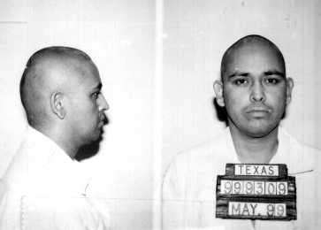

Date of Execution:
October 20, 2005
Offender:
Ramirez, Luis
Last Statement:
Yes I do. I would like to address you first. I did not kill your loved one, but I hope that one day you find out who did. I wish I could tell you the reason why, or give some kind of solace; you lost someone you love very much. The same as my family and friends are going to lose in a few minutes. I am sure he died unjustly, just like I am. I did not murder him; I did not have anything to do with his death. And to you my family and friends, I love you dearly. Even though I die, that love for you will never die. Into Your hands, Lord, I commit my spirit. Thank you. Thank you all.

Date of Execution:
November 16, 2005
Offender:
Thomas, Shannon Charles
Last Statement:
Yes. Man, I just want you to know how much I love them. I want you to be strong and get through this time. Do not fall back. Keep going forward. Don't let this hinder you. Let everybody know I love them (several names listed), Kevin - as well as everyone else in the family. Tell them that I love them and stay strong. This is kind of hard to put words together; I am nervous and it is hard to put my thoughts together. Sometimes you don't know what to say; I hope these words give you comfort. I don't know what to say. I want you to know I love you; just stay strong and don't give up. Let everybody know I love them...and love is unconditional, as Mama has always told us. I may be gone in the flesh, but I am always with you in spirit. I love you.
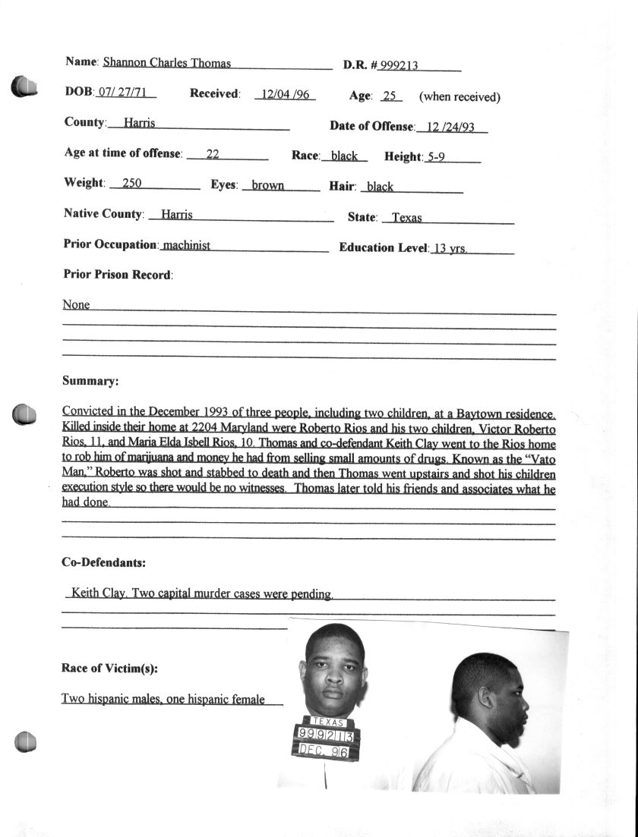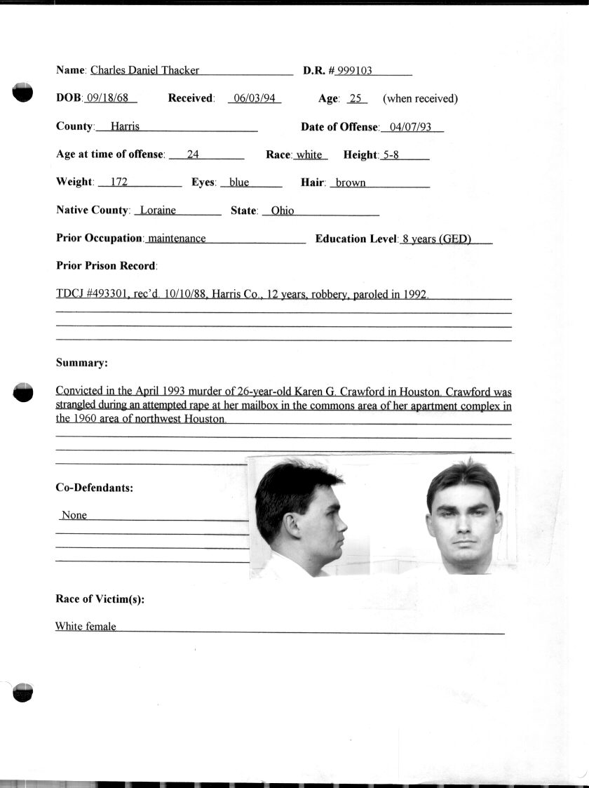

Date of Execution:
November 09, 2005
Offender:
Thacker, Charles Daniel
Last Statement:
Jack and Irene, I love you guys. Tell my family I love them. I am sorry for the things I have done. I know God will forgive me. Keep track of Danielle for me. I will miss you guys. I love you. I guess that's all.

