Nervous System

Central nervous system
The brain and spinal cord comprise the central nervous system. The vertebrate brain is divided into three main sections: the fore-, mid- and hind-brains. Invertebrate brains are different, and in segmented animals, large ganglia may be largely responsible for the actions of the segment in which they reside, the brain being merely the large ganglion at the head end of the animal.
The hind-brain is evolutionarily the oldest of the vertebrate brain structures, and consists (from the back forwards) of the medulla oblongata (the site of cardiac control), the pons (breathing control), and the cerebellum, two paired hemispheres controlling proprioception, balance and coordination. The midbrain (mostly consisting of the tectum) was originally responsible for sight, but this has been subverted in vertebrates. The hind and mid-brains are collectively termed the brainstem.
The forebrain consists of the thalamus (principally wiring), the pineal gland (involved in sleep responses and circadian rhythms), the hypothalamus (involved in homoeostasis, via its effects on psychological drives, neurosecretion and releasing factors aimed at the pituitary and control of autonomic nerves) and the pituitary, the 'master' endocrine gland. The hypothalamus, pituitary, and other parts (e.g. the hippocampus) are collectively termed the limbic system and are the seat of drives such as thirst, hunger, libido and aggression.
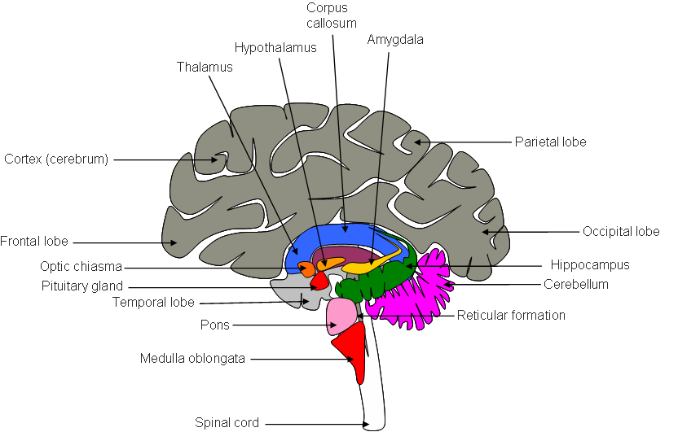
The front most section of the brain is the cortex, primitively an olfactory centre, but in vertebrates, subverted to receive other sensory inputs (sight, hearing), generate motor outputs (including speech) and is responsible for 'thought' in general. The cortex consists of two hemispheres, which in humans are massively expanded, deeply furrowed with sulci, and hide most of the underlying structures. Many areas have been identified with particular functions, such as Warnicke's and Broca's areas, involved in speech. There is heavy bias between the hemispheres in humans in that the right is involved in analytical, mathematical and such functions, whilst the left is involved in speech, sensory synthesis, etc. The retina of the eye is also technically a part of the brain, and is the only part of the brain visible without hacking someone's head open :)
The whole brain and spinal cord consist of canals and ventricles containing cerebrospinal fluid, surrounded by a core of grey matter (neurone bodies), surrounded by white matter (axon 'wiring'), surrounded by meninges. The meninges consist of a soft inner layer, the pia mater, a spongy middle layer, the arachnoid, and a tough outer layer, the dura mater. In the cortex, the grey matter unusually grows out over the white matter.

Peripheral nervous system and neurones
There are many sorts of nerve: reflex arcs through the spinal cord serve to connect stimuli from afferent nerves thru intermediary neurones with rapid motor responses via efferent nerves. The autonomic nervous system controls involuntary physiological changes: the sympathetic system serves to 'stimulate' (it uses adrenaline as a neurotransmitter), the parasympathetic system 'inhibits' via acetylcholine. Higher level voluntary actions involve intermediate neurones of the cortex.
Nerve cells (neurons or neurones) generally consist of short afferent dendrites, a cell body, and an efferent axon, which may be microns to metres in length. The axon may be insulated by fatty myelin sheaths, formed by the wrapping of Schwann cells around the axon. In the brain, other cells are present besides neurones; these include astrocytes ('glue'), oligodendrocytes (insulation, similar to Schwann cells), microglia (immune cells), and ependema ('tiling').
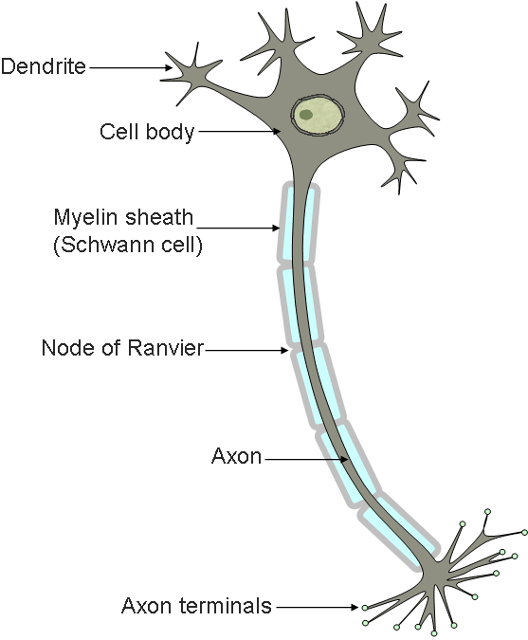
The transmission of information by neurones is both electrical and chemical. The electrical transmission occurs via changes in membrane potential: in the resting state; sodium and potassium pumps maintain a potential across the membrane (positive on the outside). When a dendrite is stimulated by a neurotransmitter (see below), ligand gated Na and K channels open in the dendrite, causing an influx of Na and an efflux of K. This causes depolarisation of the membrane (it becomes negative on the outside). The change in potential opens voltage gated Na and K channels, which serve to propagate the change across the neurone surface. In myelinated neurones, the voltage change 'jumps' along the axon via discontinuities in the myelin sheath (nodes of Ranvier). After this action potential passes, the neurone restores its resting potential, usually entering a refractory period, during which it is insensitive to further stimulation. Hyperpolarisation also occurs. The action potential is an 'all or nothing' event: increased intensity of stimulation causes an increase in the rate of neurone firing, rather than in the amplitude of the change in membrane potential.
At synapses, junctions between nerve cells, neurotransmission is achieved by the diffusion of chemical neurotransmitters. Action potentials cause vesicles of neurotransmitter in the axon 'knob' to dump their contents into the synaptic space, where they diffuse to ligand gated ion channels on the body or dendrites of the recipient neurone. Neurotransmitters are removed by active uptake or degradation. Some of the more important neurotransmitters are...
- Acetylcholine (ACh). This is involved in neuromuscular junctions and the parasympathetic nervous system. In the parasympathetic nervous system, two receptors are identified. These are muscarinic junctions (the alkaloid muscarine mimics ACh; this effect is blocked by atropine), which are responsible for responses such as depression of heart-rate, and nicotinic junctions (nicotine mimics, curare inhibits), which are exploited during surgery: curare allows patients to be paralysed, without adversely affecting the heart. ACh is destroyed by ACh esterase, which is inhibited by Sarin, Tabun and organophosphates, hence their use as pesticides and nerve gases.
- Gamma-aminobutyrate (GABA). GABA receptors are 'generally inhibitory', benzodiazepines and barbiturates make GABA receptors hypersensitive, hence their use as tranquillisers. GABA and the gaseous transmitter nitric oxide (NO) interact, and the use of nitroglycerine/amyl nitrite in producing vasodilation for angina treatment is due to this.
- Serotonin. The 'happy' neurotransmitter: Prozac prevents the reuptake of this chemical from synapses, ecstasy (MDMA), causes massive oversecretion, and LSD and mescaline mimic its effects.
Psilocybin, LSD and Prozac act at serotonin synapses. [psilocybin non chime version] [LSD non chime version] [Prozac non chime version]
- Adrenaline (epinephrine) and noradrenaline (norepinephrine). Involved in the sympathetic nervous system, which has much the same effects on the body as adrenaline itself (sweating, increased heart rate, bowel voiding, etc.).
- Anandamine. The putative neurotransmitter involved in cannabinoid intoxication.
- Tetrahydrocannabinol acts at anandamine receptors. [non chime version]
- Nitric oxide (NO). A short lived (strangely stable free radical) recently found to be involved in a large number of physiological responses, not least in (penile/clitoral) erection.
- Dopamine. Involved in muscular coordination, the use of its precursor L-dopa in the treatment of Parkinson's (and the associated dyskinesia) is well know, if not well understood. Acetylcholine, dopamine, serotonin, adrenaline, tyramine and a number of other transmitters are all monoamines, i.e. aminoacids less the acid group. Some of these transmitters are also involved in neuromodulation and immune responses ( e.g. histamine). Other aminoacids are also important in insect and vertebrate neurotransmission, e.g. glutamic acid and glycine.
MDMA (Ecstasy) and cocaine act at dopamine synapses. MDMA also acts at serotonin receptors. [cocaine non chime version] [Ecstasy non chime version]
- Peptides. By far the largest group, these mini-proteins are less well known than their smaller cousins. Enkephalins and endorphins modulate pain responses in the brain (morphine and other opiates mimic these chemicals), releasing factors (local hormones) secreted by the hypothalamus cause the pituitary gland to secrete other true hormones, and other neuropeptides may interact with the immune system.

Emergent properties
All this understanding of the brain and its effects on the body have led to some understanding of the brains emergent properties: those you wouldn't expect a priori from a few kilos of grey sparky sludge. Such properties include memory, which is probably due to the reinforcement of some synaptic connections at the expense of others, imagination, cultural transmission, the illusion of free-will, self-awareness and consciousness. Some insight into these properties may be given by certain forms of selective brain damage (including that caused purposively by doctors in treatment of epilepsy), but the study of consciousness is not easy, not least because it is extremely difficult to define it!

