p.s. : this is how drift is written in Japanese

Some things about it to make it easier to understand
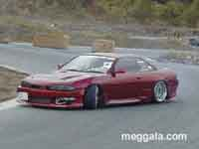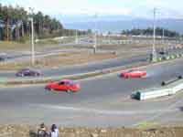
What is drifting?
Drifting is a high-skill level motor-sport in which drivers control a car while it slides from side to side at high speed (approx. 80 to 100mph) through a fixed course. It is similar to Rally racing on ice barn, but is done on a tarmac (paved course) and judged on speed, angle of attack, execution and style rather than just who finishes the fastest. Drift cars are typically compact to midsized, rear-wheel-drive sport cars. The goal is to apply enough power to the rear wheels to break the tires' traction and initiate a slide while accelerating the vehicle forward, or "drift" Once a drift is initiated, it must be maintained through the turn using nearly a full power, a tap of braking and precise counter steering. Drift racing as all about style and control the better you are the faster you go and the longer you can drift. Time and speed don't play a part really it the skill of the driver, his level of control.
The cars are often not the most popular models and are generally older types because parts cost less and the initial purchase price isn't so high the reason is accidents /crashes yes they happen in drifting no one is perfect and when you get good you just push it harder and faster.

History of Drifting

The Japanese towns of Rokkosan, Hakone, Irohazaka, and various hill climbs in Nagano are all steeped in legends of the origins of drifting. No one can really pinpoint drifting's actual birthplace but the movement started in the mid 1960s. Like many forms of professional racing today, the modern interpretation of drifting evolved from a form of illegal street racing held on windy mountain roads called touge (pronounced toe-geh). Touge was practiced by extremely dedicated enthusiasts known as rolling zoku (pronounced zoe-koo) whose only goal was to trim precious milliseconds off their time between two points. Eventually, some of these rolling zoku began to adopt driving techniques used by rally drivers, techniques to clear a corner quickly without sacrificing too much momentum. As touge drivers started to emulate the rally racers techniques, they discovered that not only did their driving performance and times improve, the rush was much more intense. From touge, drifting was born.

How is drifting judged?

Because professional drifting events are judged on execution and style, it is mandatory that the judges are intimately familiar with the capabilities of the cars and the advanced driving techniques employed by the competitors. D1 Grand Prix judges are usually former professional drifters or racing drivers. These expert D1 judges evaluate speed, angle of attack, showmanship and vehicle control. All drivers make solo runs before Best 16 heads-up eliminations start. The competitors who make it to the Best 16 run door handle-to-door handle, going against one other car on the circuit at the same time. As fun as the solo runs are, these drift showdowns really ignite the crowd and bring them to their feet.
Factors like slowing to the point of hindering the other driver, running into another car or spinning out mean an automatic loss of the run. To advance to the next round, drivers use tactics such as putting pressure on an opponent through a more aggressive drift angle, carrying a higher speed through a corner, and showing good strategy. Judges are thoroughly familiar with the capabilities of each competitor's car and if the driver is not pushing the car to the limit, they will be eliminated from the round.
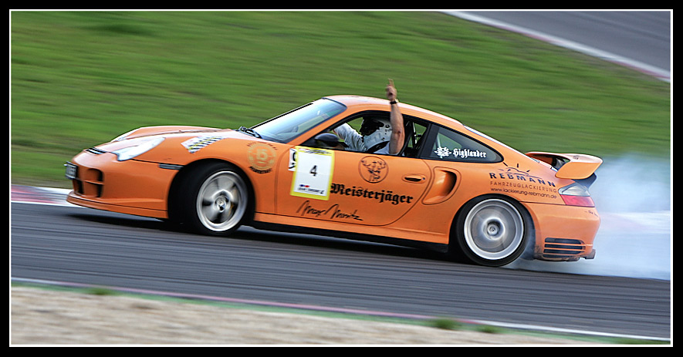
How the cars are set up
The suspension in a drift car is very tight and unforgiving even the chassis is tightened with roll cages and strut brace. The die hard followers of drift also alter the geometry of the suspension this is to allow the car to slide a lot better.. The differentials aren't your standard limited slip type they are semi lockers to ensure there is more wheel spin. The cars quite often have different wheels front and back cause the owner has quite a few sets cause one afternoon of drifting can destroy a set of tires. As a rule the good tires and I mean very good tires go on the front on the back they fit hard compound tires quite often second hand ones as they tend to end up in a cloud of smoke. Also they stretch the tires over a wide rim to give an example fitting 205 50 16 tires to an 8" rim or 235 45 17 to a 9" rim this reduces the chance of the tire rolling off the rim and enables the car to side better. The clutches on these cars ( don’t bother drifting with an auto it is quite dangerous.. you can pretend in the wet though) tend to be very tough ceramic brass button or multiple plate varieties. Why? well a lot of drifter use their clutch to commence wheel spin and hence the slide by either using compression lock or a clutch dump at high revs.
Power is not a requirement but helps in the learning stages. the most popular car for drifting is the Toyota Tureno or sprinter this is a non turbo 1.6L 4 cylinder car that is quite light and twitchy. the cars I will talk about are the Nissan Skyline and silvia/180-240 platform. as I know a bit about these
The Silvia/180/240sx s13 platform .

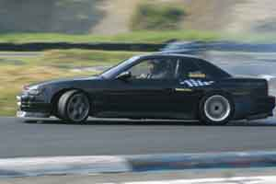 | 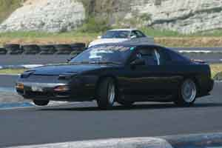
Silvia | 180/240SX

These are some of the most popular drifter in Japan Australia and the US.
Japan and the US were fortunate to get these cars new, in Australia these cars have only been coming in as second hand imports for the last few years. They come with a range of engines from 1.8 L non turbo to 2.0 L turbo in the US they only get the 2.4 ka engine non turbo.
The 2 turbo engines both lend themselves to modification and are great for drifting as they like to rev and with a few simple bolt on moods can make 300 hp. Basically these cars in turbo form come from the factory with manual or auto transmissions manual is the choice to go for LSD is fitted as standard as well. then you would change the suspension for some thing harder. and proceed from there. as for the engines 300-350 hp should be ample power.
here are some pictures of drift cars a bit closer up.
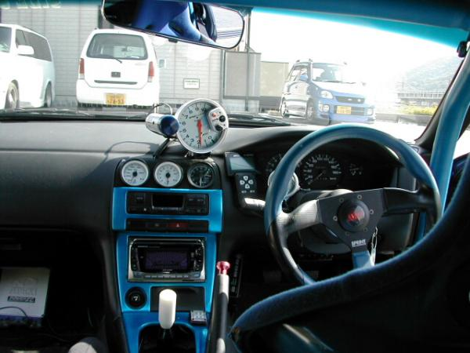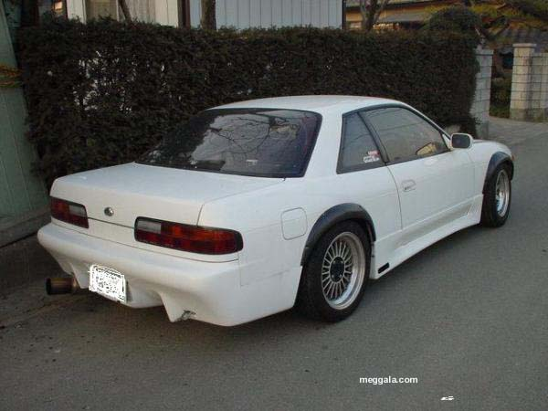

The Drifting Movement Evolves

About the same time touge evolved into drifting, some of the rolling zoku came off the mountains to bring their new sport to the urban jungles of Japan. The urban drifters added their own flavor to the sport with their flamboyant driving style and outrageous vehicles. Eventually, word of the spectacle spread and fans began showing up to witness drifting's amazing drivers and machines. But as popular as drifting had become, it was relegated to underground status by the risks and image associated with illegal street contests.
Eventually, the popularity of drifting propelled the sport into the mainstream and competitors started to organize and take their home-grown trials to the track. The gatherings were originally just for fun until the cars and driving skills became so refined that things started to get competitive. From the initial organized trials, regional drift contest open to the public and professionally judged, known as ikaten (pronounced ee-kah-ten) created by Video-OPTION, were began all major cities of Japan. The Drivers Search events let local drivers of all backgrounds show off their skills and compete with each other.

A Visionary

It was the vision of a car enthusiast and magazine publisher that brought drifting to mainstream motorsports in Japan.
Daijiro Inada (pronounced dye-jee-ro ee-na-da) , founder of Option Magazine and the Tokyo Auto Salon, knew drifting and the Drivers Search events represented only a fraction of the potential of drifting to the global motorsport subculture. Daijiro felt a strong need to bring drifting to a professional level.
In 2001, with the help of longtime friend Keiichi Tsuchiya (pronounced kay-ee-chee soo-chee-ya) , a professional Touring Car driver and the person considered to be the father of modern competitive drifting, Daijiro created the D1 Grand Prix. Today, the D1 Grand Prix is so popular in Japan that D1 drivers are celebrities. True to Mr. Inada's vision, the D1 Grand Prix represents the highest level of competition in the sport and provides the best-of-the-best to fans throughout Japan. Now he brings that passion and innovation to North America. Through D1 Drivers Search events, the D1 Grand Prix series and D1 Grand Prix in the United States, and with events planned for Europe and Korea in 2005, drifting is poised to take the world by storm.
Since its humble beginnings only a short time ago, the D1 Grand Prix events have grown from relatively small contests with 50 or so teams and 3,000 to 4,000 spectators to today's shows that
typically host over 100 teams and, by the end of the 2003 season, were attracting upward of 20,000 spectators.
Prior to 2001, relatively few tuners specialized in drifting set-ups. With the incredible success of the D1 drifting series in Japan, the number of drifting-specific shops jumped to over 200, revitalizing
the tuning industry in Japan.

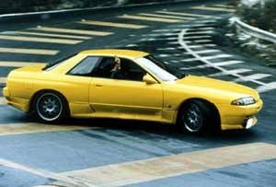 | 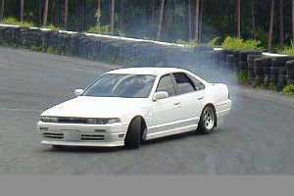
R32 drifting | Cefiro drifting

