Easter symbols: eggs, bunnies, hot-cross-buns, spring flowers

Easter food: eggs, hot-cross-buns, roast lamb, sweet- cheese-cream-cake, fresh vegetables, ham, cookies
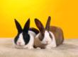

Easter flowers: daffodils, tulips, lilies, liliac, pussy willow brunches
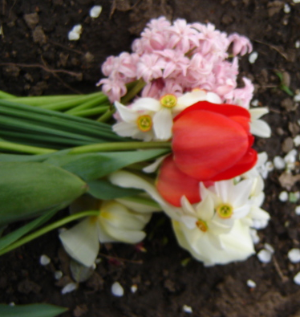

Easter games: Easter egg hunt, Easter egg roll, Egg Bowling, Egg Toss, Eggs and spoon Races, Egg knocking Game, Edible Eggs, Rabbit Mask, Baskets

E.greetings: May the peace of Easter fill your heart,
May the joy of Easter, fill your home,
May the blessings of Easter, fill your days!

E. poems. Bunnies are brown,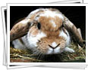
Bunnies are white,
Bunnies are always
An Easter delight.

Bunnies are cuddly,
The large and the small.
But I like chocolate ones
The best of all.
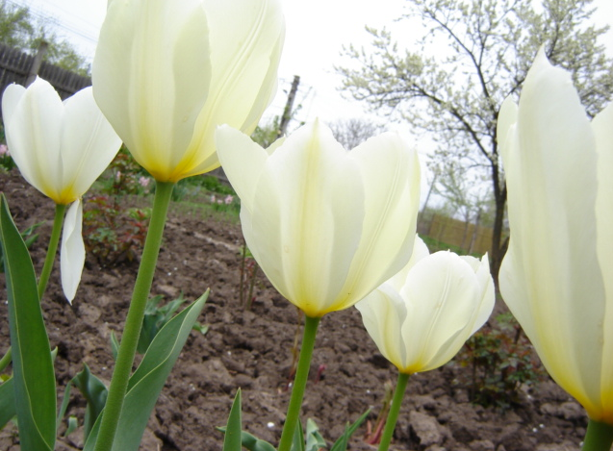
E. jokes: What did a soggy Easter Bunny dry himself?
With a Hare dryer.

How do bunnies stay healthy?
Eggsercise and hareobics.

E. presents:clothes, shoes,eggs, etc.

