Extreme Sports

Have you ever done something so extreme, that you've actually risked your life for it maybe? If so, why did you do it? Maybe to prove a point, but to who? Many people actually feel like they must make that impact in the world and prove a point to everyone else about being able to accomplish something maybe no one else could. It seems like a way to get attention possibly. Or maybe this just proves what people will actually do for money if it in fact was involved. It's actually said some people with personal experience to be more of a mental and spiritual thing to do, as opposed to a physical challenge, but there's no denying that you do work your legs, lung and ligaments.
Everyday, daring people all over the world are participating in extreme sports like adventure racing, bull-fighting, in-line skating, bungee jumping, snow boarding and skateboarding. All of these sports involve a serious risk, and that's why they are called Extreme Sports (Now also known as action sports)wich is a general, somewhat hazily-defined term for a collection of newer sports involving adrenaline-inducing action.
Starting with one of the most vigorous and growing sport in North America, adventure racing in 1999 will see up to 80 competitions for the sport alone. This means that tens of thousands of people will be participating, while many millions will be watching it on their very own televisions at home. Adventure racing includes completing extreme activities before other teams including mountain climbing, bike riding, and even canoeing.
A type of adventure racing that is fueling up is the solo competitions. This type of racing is safe, but it simply means that you do not have teammates to look out for you anymore. You must also push it to your best, and be a quick and fast. To keep the racing environment safe as possible, an association was formed called the Adventure Racing Association. The first meeting was in Australia on August 22nd, 1997. About 50 people of different nations gathered to discuss the highly important topics of safety in the racing environment. It is also a place for these people to learn more about the events, and discuss the sport.
A man named Dugard wrote during his initial experience in the Raid in 1992: "What I really wanted to do was quit. I've had enough of this foolishness - this suffering. The temperature is 120 degrees. I've hiked, rafted, canoed and climbed over 350 miles. I have definitely lived the promise that race organizer and founder Gerard Fusil made when I implored him to let me compete. 'You will suffer."
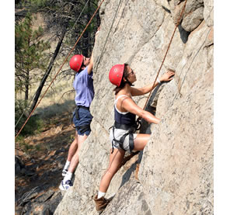
Rock climbing is an International sport that many people do for fun. They chose a site to basically "climb", and that's exactly what they do! Climbing is a very dangerous and risking sport, and is very similar to something you'd do in Adventure Racing. Only,usually rock climbers and mountain climbers do it mainly for fun, and it's usually not a race when it's on its own. It can even be for a family vacation to go rock climbing!
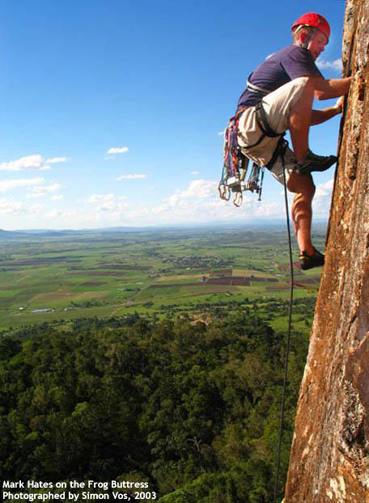
For people who rock climb often, it is essential that you buy your own equipment for your journeys. "What equipment would that be?" you ask? Well, you need climbing shoes. "Can these be regular tennis shoes?" is a popular asked question. The answer is, No, they must be special tightly fitting around your foot with a sticky rubber sole that provides the friction that you need for climbing. The laces of the shoes usually extend all of the way to the toe, and all the way to the top of the shoe making them very adjustable. The lace shoe also has a sole that wraps around the heel and up the sides of the shoe. Another type of shoe that is used is the slipper.
Experienced climbers only use the slipper however though, because it doesn't provide as much grip as the laced up ones. Another important thing that you'll need is chalk. Surprising enough, the chalk is needed to put on your hands when they get very sweaty. This makes them, so that they aren't as sweaty, and you have a better grip. Obviously the last most important thing you'll need is a rope. How would you plan on climbing that huge rock without a rope?!
Yet another extreme sport that is enjoyed by many people worldwide is Bungee jumping. Bungee jumping was started in England by Oxford Dangerous Sports club. They were the ones who named it Bungee. There are two different types of bungee jumping. Those two types are spelled a little differently. This first type is Bungy jumping. Bungy jumping has a lower velocity, smoother ride, and higher rebounds. It is commonly something that can be found as a priced ride at the fair or amusement parks all around the world. Then, there is another type of bungee jumping, which is spelled Bungee jumping. Bungee jumping is the official, real bungee experience. It has way more freefall than the generic Bungy jumping experience, and is not intended for people who are timid or undurable for the ride. Bungee jumping is another dangerous sport that does include a huge self risk for the jumper.
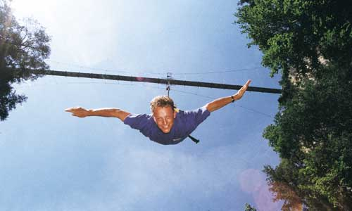
Many accidents have been reported about Bungee jumping, and sadly enough, the individuals themselves aren't always the ones who have control over their safety. Sometimes the people who work at the clubs of Bungee jumping may accidentally do something wrong to cause an accident. This is why you must go to a club that you trust.
One of the many incidents include the most recent, this year, when a 16-year-old girl jumped from a 15 m high platform on a very chilly cold evening in Korea. A support wire which was used to allow the cord to drop was frozen, so the girl ended up getting stuck 10 m from the ground in freezing weather until a fire rescue team came to get her, which ended up being a chilly 4 hours!
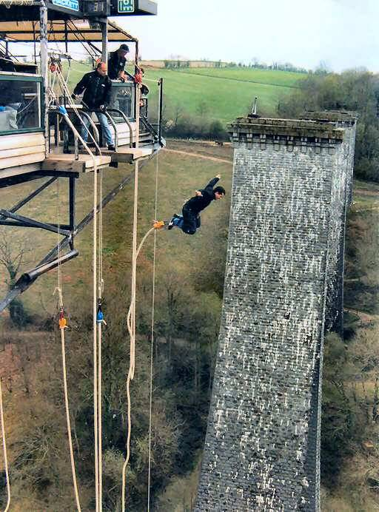
An accident that happened in Greece was caused by the jumper instead of a club worker this time. The jumper was quite nervous and was waiting to jump off of the platform. After hearing the jumpmaster (which is the person who goes up with the jumper to insure correct jumping procedures) count down to one, the jumper leaned forward to do the jump. After looking at the distance from him to the ground, he decided maybe it wasn't such a cool idea, and turned around to grab the jumpmaster to return to the platform. As a mistake on the jumpmaster's part, he himself was not secured and strapped in, so when the jumper grabbed a hold of him, he ended up flying off the platform along with the jumper. The jumpmaster died, but the jumper didn't since he was the one strapped on to the Bungee cord.
As you can see, bungee jumping is an added extreme to life that many people are surprisingly willing to go through with. All of these sports involve a serious risk in your everyday human functions. Even though most of these sporty activities that people engage in are meant to be fun, there are chances that something may go wrong if procedures aren't followed correctly. That's why it is important to always make sure you are going through with your sports under safe hands.
Sometimes clubs and sites that offer such amusement may not be completely trustworthy as far as following the correct directions of how they should properly go about such extreme sports. You must also be responsible for making sure if you are in good health and are able to withstand such events like coarse mountain climbing, quick pace vigorous racing, and jumping free-fall off of a 15 m high off the ground platform. You should definitely not engage in such sports if you have certain health problems such as back pains, or shoulder pains. You certainly should not do them if you are pregnant.
So, play it safe, and make the right decisions and you can be off to have an experience of a lifetime! Now you know why they call it Extreme, don't you?

