The Fashions
of
La Belle Epoque

1890 - 1899
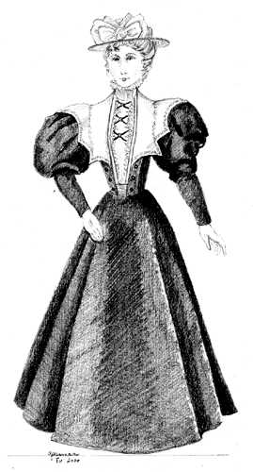
The lady on the left is dressed in the height of fashion from 1893. Her bodice gives the illusion of several layers but in reality is all one piece.
The wide collar and bretelles serve to heighten the impact of the very full leg of mutton sleeves.
Her tall, fitted collar is finished with a narrow frill. The skirt is the cone shape and is slightly stiffened. On her head she wears a flat hat trimmed with bows.
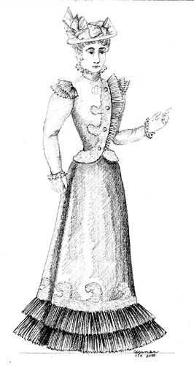
The lady on the right is dressed in the fashions at the end of the decade.
Her fitted jacket has an asymmetrical opening with a knife pleated ruffle and 4 buttons.
There is a double row of matching ruffles at the sleeve cap to emphasize the slight puff to the sleeves.
Her skirt has narrowed in size and is beginning to acquire the "morning glory" shape. While still stiff in silhouette, it is easy to see the transition to the next silhouette.

The gentleman is wearing a Morning Coat also known as the Cutaway.
The coat has 3 buttons and worn closed nearly obscures the waistcoat of white under it.
He wears striped grey trousers that are narrow and without creases.
His shirt is white and has a standing, rigid collar. He is wearing an ascot. On his feet he is wearing spats. A top hat and gloves complete his ensemble.

