FRANCE

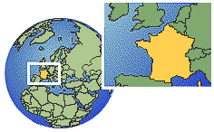

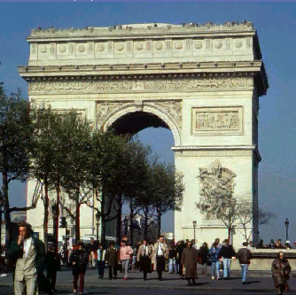
France (in French, République Française), country in western Europe, bounded on the north by the English Channel, the Strait of Dover, and the North Sea (which separate it from Great Britain); on the north-east by Belgium, Luxembourg, and Germany; on the east by Germany, Switzerland, and Italy; on the south-east by the Mediterranean Sea; on the south by Spain; and on the west by the Bay of Biscay (an arm of the Atlantic Ocean). France is approximately hexagonal in shape, with an extreme length from north to south of about 965 km (600 mi) and a maximum width of about 935 km (580 mi). The capital and largest city is Paris. The republic of France includes ten overseas possessions. These include the overseas departments of French Guiana, in South America; Martinique and Guadeloupe, in the Caribbean; and Réunion, in the Indian Ocean. Territorial collectivities and dependencies include St Pierre and Miquelon, Mayotte, New Caledonia, French Polynesia, the French Southern and Antarctic Territories, and Wallis and Futuna Islands. The total area of metropolitan France, which also includes the island of Corsica in the Mediterranean, is 543,965 sq km (210,026 sq mi).

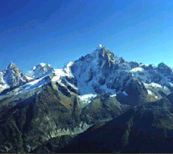
The chief physiographic features of France are its natural eastern and southern boundaries, a south-central plateau, and, contiguous to the plateau, a vast region of rolling plains. A series of massive mountain ranges, including a number of ranges of the Alps and the Jura, form natural boundaries at the Franco-Italian and most of the Franco-Swiss borders. With flanking chains and foothills, these ranges dominate the area east of the south-central plateau. Many of the Alpine mountains extending across and along the French border are more than 3,962 m (13,000 ft) above sea level; Mont Blanc (4,807 m/15,771 ft) is the second highest peak on the continent. The Jura, which have a maximum elevation, on the Franco-Swiss boundary, of about 1,710 m (5,600 ft), delineate the eastern frontier of France from the eastern extension of the Rhône Valley to the Belfort Gap, the broad depression linking the basins of the Rhine and the Saône rivers. From the edge of the Belfort Gap to the north-eastern corner of France, the Franco-German border is formed by the River Rhine. The Vosges mountains, extending north from the Belfort Gap, dominate the region between the Moselle and the Rhine. The highest elevations in the Vosges Mountains reach about 1,435 m (4,700 ft). The Pyrenees, which extend along the Franco-Spanish frontier from the Mediterranean Sea to the Bay of Biscay, form the other mountain boundary of France. Pic de Vignemale (3,298 m/10,820 ft) is the highest French peak in the Pyrenees. The Pyrenees are traversed by few passes, a circumstance that has traditionally hampered commerce between France and Spain. The Alpine and other ranges in the east are, however, broken by gaps and passes, notably the passes of St Bernard.
The south-central plateau, known as the Massif Central, is separated from the eastern highland region by the valley of the River Rhône. This elevated region has an irregular relief and conformation. The plateau, rising gradually from the plains region on the north and west, is characterized by volcanic outcroppings; by deeply eroded limestone tablelands to the south of the region of extinct volcanoes; and, farther to the south, by the Cévennes, a series of highlands rising from the Mediterranean coastal depressions.
The plains region, by far the most extensive section of the terrain of France, is a projection of the Great Plain of Europe. Except for a few hilly outcroppings, chiefly in the west-central portion, the French plains consist of gently undulating lowlands, with an elevation of about 200 m (650 ft) above sea level. The outstanding features of the plains region, the most fertile in France, are the valleys of the Seine, Loire, and Garonne rivers. Together with numerous tributaries, these rivers drain the Atlantic watershed of France. The River Rhône is the largest in the country in terms of volume of discharge. With its tributaries, particularly the Saône, Isère, and Durance, it drains the French Alpine region. Among the principal tributaries of the River Seine, which is the main artery of the national inland waterway system, are the Aube, Marne, Oise, and Yonne. France has only a few lakes. Lake Geneva, situated on the Franco-Swiss frontier, lies mainly in Switzerland.
The coastline of France, about 3,140 km (1,950 mi) long, has relatively few natural harbours. The northern coast, along the English Channel and the North Sea, is about 1,130 km (700 mi) long and is broken by a number of promontories, river estuaries, and minor indentations, few of which provide safe anchorages. Le Havre is the outstanding exception. As at Cherbourg, a number of harbours have been formed in this region by the construction of breakwaters. The western coastline of France along the Atlantic, including the Bay of Biscay, is about 1,390 km (865 mi) long. From the Brittany peninsula to the Gironde, the Atlantic coastline of France is irregular in outline, and, except in Brittany, is low and sandy. The principal harbours on this part of the coast are those of Brest, Lorient, and Saint-Nazaire. Bordeaux is inland on the Gironde. South of the Gironde, the coastline consists of an almost continuous stretch of dunes, bordered by arid moors. The best natural harbours of France, including those of Marseille, Toulon, and Nice, are on the Mediterranean. A major part of the French Mediterranean coast, which is about 620 km (385 mi) long, is bounded, however, by rocks or shallow water.
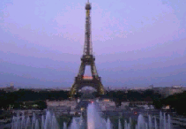

Bibliography:

Microsoft Encarta 98 CD

