Germany, Federal Republic of

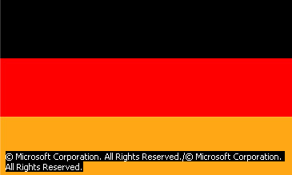

I |  | INTRODUCTION
Germany, Federal Republic of (German Bundesrepublik Deutschland), major industrialized nation in central Europe, a federal union of 16 states (Länder). Germany has a long, complex history and rich culture, but it did not become a unified nation until 1871. Before that time, Germany had been a confederacy (1815-1867) and, before 1806, a collection of separate and quite different principalities.
Germany is the seventh largest country in area in Europe, with a total area of 356,970 sq km (137,827 sq mi). The country has a varied terrain that ranges from low-lying coastal flats along the North and Baltic seas, to a central area of rolling hills and river valleys, to heavily forested mountains and snow-covered Alps in the south. Several major rivers and canals traverse the country and have helped make it a transportation center.
The country has a total of 82,398,326 people (2003 estimate). Germany is overwhelmingly urban, and most people lead a prosperous, comfortable lifestyle, with adequate leisure time and comprehensive social welfare benefits. Berlin is the capital and largest city, although Bonn, which was the provisional capital of West Germany, is still home to some government offices. The principal language is German, and two-thirds of the people are either Roman Catholic or Protestant.
Germans have made numerous noteworthy contributions to culture. Among the many outstanding German authors, artists, architects, musicians, and philosophers, the composers Johann Sebastian Bach and Ludwig van Beethoven are probably the best known the world over. German literary greats include Johann Wolfgang von Goethe, Friedrich Nietzsche, and Thomas Mann.
Germany has a large and modern industrial economy and is a leading producer of products such as iron and steel, machinery and machine tools, and automobiles. Germany is an economic powerhouse in the European Union (EU), and a driving force behind greater economic integration and cooperation throughout Europe.
Its central location in Europe has made Germany a crossroads for many peoples, ideas, and armies throughout history. Present-day Germany originated from the ad 843 division of the Carolingian empire, which also included France and a middle section stretching from the North Sea to northern Italy. For centuries, Germany was a collection of states mostly held together as a loose feudal association. From the 16th century on, the German states became increasingly involved in European wars and religious struggles. In the early 19th century, French conquest of the German states started a movement toward German national unification, and in 1815, led by the state of Prussia, the German states formed a confederacy that lasted until 1867.
Once unified under Otto von Bismarck in 1871, Germany experienced rapid industrialization and economic growth. During the early 20th century it embarked on a quest for European dominance, leading it into World War I. Germany’s defeat in 1918 triggered political and economic chaos. An ultranationalist reaction gave rise to the National Socialist (Nazi) Party, which gained power in the 1930s and was led by Adolf Hitler. In 1939 Nazi Germany plunged the world into a new global conflict, World War II.
In 1945 the Allied Powers of Britain, the United States, France, and the Union of Soviet Socialist Republics (USSR) defeated Germany in World War II. The Allies agreed to divide the country into four zones of occupation: the British, American, French, and Soviet zones. When the wartime alliance between the Western powers and the Soviet Union broke up in the late 1940s, the Soviet zone became the Communist-led German Democratic Republic (GDR), or East Germany. The three Western zones formed the Federal Republic of Germany (FRG), or West Germany. Control of Germany's historic capital, Berlin, was also divided between the two German states, despite its location deep within East Germany. In 1961 East Germany built the Berlin Wall and elaborate border fortifications to stop the exodus of millions of East Germans to the more prosperous and democratic West Germany. In 1989 the collapse of Communist rule in Eastern Europe was marked by the breaching of the Berlin Wall and the beginning of German reunification, which was governed under the West German Basic Law, or constitution. The two Germanys were reunited on October 3, 1990, as the Federal Republic of Germany. Despite its joy at unification, Germany faced a variety of social and economic problems as it tried to absorb millions of new citizens and to blend disparate cultures and institutions.

II |  | LAND AND RESOURCES
Germany ranks as the seventh largest country in Europe, after European Russia (the part of Russia west of the Ural Mountains), France, and Spain. Germany is bounded on the north by the North Sea, Denmark, and the Baltic Sea; on the east by Poland and the Czech Republic; on the south by Austria and Switzerland; and on the west by France, Luxembourg, Belgium, and The Netherlands. Stretching from the Baltic and North seas to the Alps, Germany measures 800 km (500 mi) from north to south; the country extends 600 km (400 mi) from west to east. In addition to coastline and mountains, the varied terrain includes forests, hills, plains, and river valleys. Several navigable rivers traverse the uplands, and canals connect the river systems of the Elbe, Rhine, see Main, and Danube rivers and link the North Sea with the Baltic. 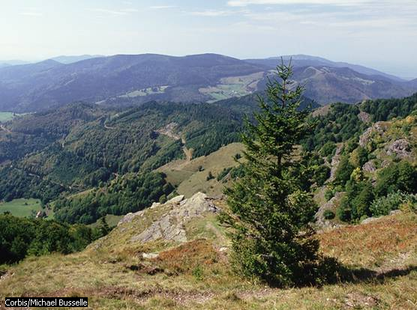

A |  | Natural Regions
Germany has three major natural regions: a lowland plain in the north, an area of uplands in the center, and a mountainous area in the south. The northern lowlands, called the North German Plain, lie along and between the North Sea and the Baltic Sea and extend southward into eastern Germany. The lowest point in Germany is sea level along the coast, where there are areas of dunes and marshland. Off the coast are several islands, including the Frisian Islands, Helgoland, and Rügen. The flat area was originally formed by glacial action during the Ice Age and includes an alluvial belt, southwest of Berlin, which is Germany’s richest farming area. Farther west, this belt supported the development of the coal and steel industries of the Ruhr Valley in cities such as Essen and Dortmund. Historically, the north German lowlands have been wide open to invasions, migrations, and trade with Scandinavia and Eastern Europe. East of the Elbe River, they also sustained large-scale agriculture and huge feudal estates once owned by the Prussian aristocratic elite.
The central uplands feature mountain ranges of modest height, separated by river valleys. Navigable rivers facilitated economic development by providing inexpensive transportation before the age of railroads and trucking. This region is located between the latitude of the city of Nürnberg and the Main River in the south and the latitude of Hannover in the north. Much of it is heavily forested and exploited for its timber. The region is marked by an abundance of waterpower. Intense cultivation and industrial development has occurred in cities such as Dresden and Kassel, located in the river valleys.
The mountainous region, or Alpine zone, in the south includes the Swabian and Franconian mountains, the foothills of the Alps, and two large forests, the Black Forest in the southwest and the Bavarian and Bohemian Forest in the east. Germany’s highest point is Zugspitze (2,962 m/9,718 ft) in the Bavarian Alps. Major cities in this area include Stuttgart and Munich. The region has traditionally relied on small-scale agriculture and tourism, but many high-technology industries began to develop there during the 1970s.

B |  | Rivers and Lakes
Rivers have played a major role in German development. The Rhine River flows in a northwesterly direction from Switzerland through much of western Germany and The Netherlands into the North Sea. It is a major European waterway and a pillar of economic development. Its main German tributaries include the Main, Mosel, Neckar, and Ruhr rivers. The Oder River, along the border between Poland and Germany, runs northward and empties into the Baltic; it provides another important path for waterborne freight. The Elbe River originates in the Czech mountains and traverses eastern and western Germany toward the northwest until it empties into the North Sea at the large seaport of Hamburg. The Danube River connects southern Germany with Austria and Eastern Europe. Since the recent construction of the Rhine-Danube Canal, freight can be transported by barge from the North Sea to the Black Sea. Smaller rivers such as the Neisse and Weser also play a significant role as transport routes. There are several large lakes, including the Lake of Constance (Bodensee) in extreme southwest Germany and the glacial moraine lakes of Bavaria, but none of them have rivaled the importance of rivers in German economic development.
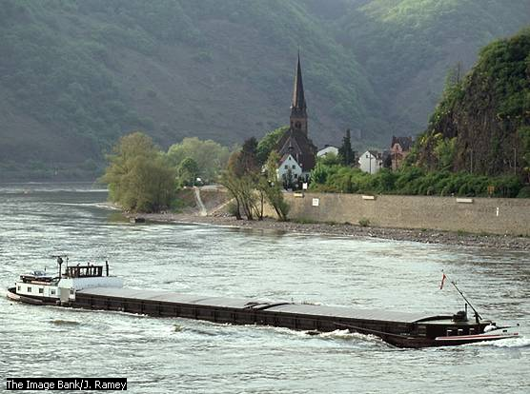
C |  | Coastline
Germany’s coastline along the North Sea is characterized by vast stretches of tidal flats and several important seaports, including Hamburg, Bremerhaven, and Emden. Schleswig-Holstein, Germany’s northernmost state, is traversed by the vital Kiel Canal, which carries freight between the Baltic and North seas, eliminating the need for a shipping route around Denmark. Major seaports of the German Baltic coast include Kiel and Rostock. The coastline also features recreation areas, some on small islands off both coasts.
D |  | Plant and Animal Life
Once a country of deep forests, Germany today includes mostly areas that have long been cleared. However, forest conservation since the 18th century has preserved large areas of oak, ash, elm, beech, birch, pine, fir, and larch. About one-third of the country is woodland. Of the many animals that once roamed the forests, deer, red foxes, hares, and weasels are still common, but these animals and wilder game such as wild boars, wildcats, and badgers depend increasingly on conservation efforts. Private hunting licenses are extremely expensive, and even fishing in the streams and lakes where edible species abound is not encouraged. Instead, there is a good deal of fish farming, including trout and carp; deer are also commercially produced to satisfy the demand for venison. Many species of songbirds migrate to Germany every year, as do storks, geese, and other larger fowl that fly in over the Mediterranean Sea from Africa. Herring, flounder, cod, and ocean perch are found in coastal waters.
E |  | Natural Resources
The presence of coal and iron ore encouraged German industrial development in the late 19th century. Most of the deposits were found in close proximity to one another, allowing for the convenient use of coal as fuel first to process the iron into steel and then to manufacture products from the steel. The availability of inexpensive transport by water, and later by land, facilitated the growth of manufacturing and encouraged exports. The presence of certain minerals in great quantity, such as potash and salt, permitted the development of a chemical industry, including the production of fertilizers and pharmaceuticals. The availability of wood, petroleum, natural gas, brown coal (also known as lignite), and hydroelectric power further smoothed the path of German industrial progress.
F |  | Climate
Germany has a mostly moderate climate, characterized by cool winters and warm summers. River valleys such as that of the Rhine tend to be humid and somewhat warmer in both winter and summer, whereas mountain areas can be much colder. Precipitation on the average is much heavier in the south, especially along the Alpine slopes, which force incoming weather fronts to rise and shed their moisture in the form of rain and snow.
G |  | Environmental Issues
Germany is located in the middle of other industrial nations whose air and water pollution come into the country with the wind and rain, and in the rivers. Also every summer many automobiles, including those from other European countries, drive across Germany’s autobahn on their way to vacations in southern Europe. Among Germany’s homegrown environmental problems, the most important are probably those connected with industrial overdevelopment and automobile traffic.
A densely settled country, Germany has limited land, air, and water in which to bury and dissipate all the unhealthful and toxic wastes produced by its ever more intensive industrial development. Factory and automobile exhaust pollution is blamed for the widespread death of the forests from acid rain. Agricultural development has produced fertilizer and pesticide runoff into lakes and streams, burdening the groundwater supply. Germany also received some nuclear fallout at the time of the 1986 Chernobyl’ reactor meltdown in Ukraine (Chernobyl’ Accident). Public resistance halted the development of nuclear energy in Germany as people objected to the proposed sites of nuclear plants.
With unification, West Germany inherited the enormous pollution problems of East Germany, whose government had not dealt with serious environmental damage. Among the worst problems were the open remnants from strip mining and the legacy of the chemical industry, both located in southern East Germany. The poisoning of soil and groundwater by uncontrolled industrial and agricultural development required enormous expenditures for cleanup. The burning of brown coal, the only kind of coal abundant in East Germany, has led to health problems, including respiratory ailments and lung and heart disease.
Germany has developed a number of measures to address environmental problems of various sorts, ranging from controls on industrial emissions to identification of additives in food to smog control devices on vehicles. In the 1970s an environmental protest movement developed, and the Green Party—a political party that focuses on environmental issues—was formed. These two events led the major political parties to devote more attention to the environment because they felt they had to compete with the Green Party. The most remarkable result of this increased environmental awareness was the development of an “eco-industry,” a new manufacturing sector that makes pollution-control devices and other environmentally useful equipment. This industry has also produced new jobs, helping counter the fears of both trade unions and existing industries that environmental controls would cost jobs and handicap business. In addition, Germany has ratified various international environmental agreements on air pollution, biodiversity, climate change, endangered species, oceans, the ozone layer, wetlands, and whaling.

