History of Bistrita

Bistrita Nasaud county is situated in northern Romania and bordered by Maramures (north), Suceava (east), Mures (south) and Cluj (west).
The county measures 5.355 sqkm and is the meeting place of Oriental Carpathians, Transilvaniei Plateau and Somesul Mare river plateau and part of Muresul river plateau.
The capital city is Bistrita with a population of 83,000 as of January 1, 2004.
At the time Christopher Columbus discovered America, people of Bistrita were in the process of building the evangelic church, a 246ft tall building. 700 years ago Bistrita was already one of the most important
cities in Transilvania.
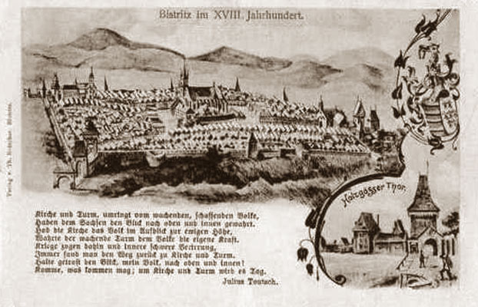
Bistrita City is located on the Bistrita Valley, at the foot of the Borgo Mountains, not far away from Borgo Pass, at important trade routes.
Archeological diggings in the area have revealed the existence of some prehistoric dwellings, but Bistrita was first mentioned in a document in 1244 and was officially mentioned as a city in 1264. Towards the end of the 13th century Bistrita's economy develops and flourishes, but it is broken off at times by troubles and wars. In 1241 - 1242, the Tatars, on their way to Central Europe, devastate the town and surroundings.
In 1353, Bistritareceived the right to organize an annual 15-days fair and to have its own seal (a crowned ostrich head holding a gold lucky horseshoe in its beak), representing town's most important trades: crafts and commerce.
Because of unsettling times the city builds defense walls and Bistrita become a fortress. By 1465 the city has 18 defense towers and bastions defended by the city's traders organized in guilds. This is the time Bistrita becomes one of the most important cities in Transylvania along with Sighisoara and Sibiu.
Proof of the strong economical development are some of the city's architectural structures, some of which can still be seen today :
- The Gothic Cathedral and its 75-meters (246 ft.) steeple overlooking the city. The construction started in 1470 and finalized almost 100 years later (1564)
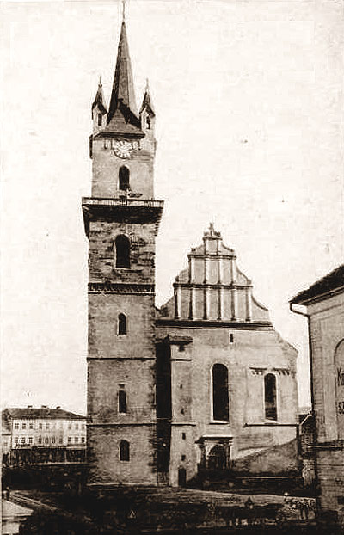
- the 13th century Church of minorits
- "Sugalete" - commercial archway stores.
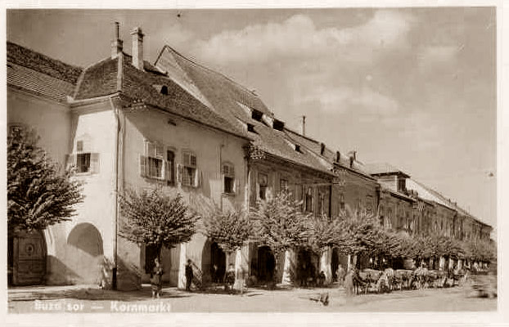
- The silversmith’s House built in the 16th century
- The old fortress walls and Cooper’s Tower - one of the city's defense towers is still intact.
In 1968 Bistrita became the capital city of Bistrita Nasaud county.

