Informations about Rome

Introduction

As capital of the Roman Empire, the Papal States and Italy, Rome truly is the "Eternal City". One of the world's most elegant capitals the layers of history and the city's sheer excess of beauty can prove overwhelming to the unsuspecting visitor.

This is a city best explored on foot, with every corner offering an overlooked treasure or unforgettable panorama. Roman columns soar up aimlessly next to medieval basilicas, the sound of water splashing in fountains fills the air in front of Renaissance palaces and exuberant Romans jostle through multi-coloured markets and winding cobbled streets.

Breathe the air of the Caesars in the Roman forum, stroll through the menacing Colosseum, marvel at the splendours of the Vatican Palace - and you will wonder if this can be the capital of a modern industrial nation or whether you have stepped back into the pages of history. But around these relics of history Rome is still evolving. It's at the cutting edge of fashion and cuisine and is one of the most popular shopping destinations on Earth.

See & Do

Rome is a work of art in itself and you'll never tire of wandering its streets and plazas, discovering new and ever greater architectural gems with every turn. Seeing the many treasures the city contains would take a lifetime, but there are several highlights that remain essential on a trip to the Eternal City.

The Roma Archeologia Card costs EUR20 and is valid for 7-days. It allows admission into all Roman National Museum sites as well as the Colosseum, Palatine, Bells of Caracalle, Tomb of Cecilia Metella and Villa of the Quintiti. You can purchase it at all the above sites with the exception of the Tomb of Cecilia and Villa of the Quintiti, as well as at the Rome Tourist Office Visitor's Centre at Via Parigi, 5.

Galleria Borghese

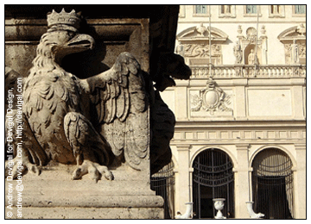
Even if it was empty, the stunning Casino Borghese, home to the Galleria and Museo Borghese, would be a highlight of a trip to Rome. With its stupendous collection of sculptures and paintings, it is foremost among the city's "must-sees" for any art lover. Highlights of the collection include Canova's eerily lifelike statue of Paolina Bonaparte, Bernini's sculpture of Apollo and Daphne, Caravaggio's "Boy with a Basket of Fruit" and Titian's "Sacred and Profane Love".

Piazzale Scipione Borghese. Open: Tue-Sun 09h00-19h00. Admission: EUR8.50 including reservation fee. Tickets must be booked in advance and your visit will be scheduled to a two-hour time slot. You collect tickets at least 30mins before your allocated slot or forfait the booking fee. Tel: +39 06-855-5952 (information and bookings).

Capitoline Museum and the Campidoglio

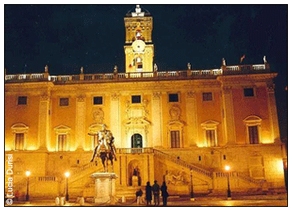
In a city of piazzas the Campidoglio is undoubtedly one of the most beautiful. Designed by Michelangelo the square is reached by a long stairway from Piazza Aracoeli and is bounded on three sides by palazzi whose harmony is unparalleled.

The two restored palazzi to either side (Palazzo Nuovo and Palazzo dei Conservatori) provide a breathtaking setting for the city's collection of ancient sculptures and paintings known as the Capitoline Museum, first established in the late-15th century when the then Pope Sixtus IV donated a collection of artworks to the city. This collection included a magnificent bronze of the she-wolf suckling Romulus and Remus, the founders of Rome - initially the sculptures were displayed on the façade of the Palazzo dei Conservatori, but as more atefacts were unearthed in various excavations around the capital the collection soon outgrew this public display space. Swelled by even more works in the 16th century thanks to Pope Pius V's refusal to allow pagan images in the Vatican, the Capitoline moved part of its now sizeable range of statuary and artefacts into the Palazzo Nuovo.

Additions to the collection, including the creation of the Capitoline Picture Gallery at the bequest of Pope Benedict XIV and the creation of new wings and display galleries to connect the two main buildings have greatly enlarged the museum, and it is undoubtedly one of the best places to see artefacts specifically pertaining to the capital, rather than to Italy as a whole.

Piazza del Campidoglio 1. Open: Tue-Sun 09h00-20h00. Admission: EUR6.20, adults; EUR4.20, children. Additional charges may be payable for special exhibitions. Tel: +39 06-3996-7800 .

The Colosseum

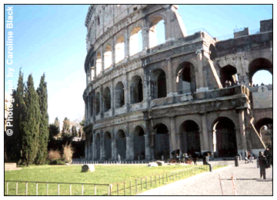
No visit to the city would be complete without a visit to the Colosseum, the symbol of Rome and the amphitheatre that lends its name to all others. The structure dates to the first century AD and it was here that the legendary gladiator fights and grand spectacles were held. A gallery on the second level offers a visual display and information on the bloody entertainment that took place within the amphitheatre's encircled space. The best view is from the Colle Oppio above the Colosseo metro station. Across Piazza Colosseo you can see the remains of the "gladiator school".

Piazza del Colosseo, via dei Fori Imperiali (Metro: Colosseo). Open: daily 09h00-19h30. Admission: EUR10. Audio guide: EUR4. Tel: +39 06-3996-7700.

Roman Forum
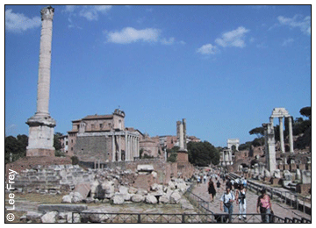
The political heart of the empire, this area covers a thousand years of Roman history. Here you can visit the Senate House (on the steps of which Julius Caesar was assassinated), the temple of Castor and Pollux, the temple to Saturn, and the House of the Vestal Virgins. Despite its city centre location there is a timeless tranquillity to the forum as you stroll among the ruins of Rome's past glory.

Foro Romano. Entrances are located in via dei Fori Imperiali (Metro stop: Colosseo), Largo Romolo e Remo and Piazza di St. Maria Nova. Open: daily 09h00 until one hour before sunset. Admission: free.

The Pantheon
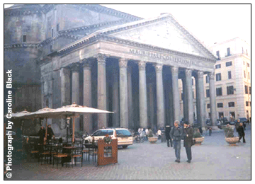
Dating from the 2nd century AD this is the most impressive and best-preserved Roman building in the capital. It dominates the small square in which it is located and at night the façade is lit up making an inspiring sight.

The dome of the Pantheon is the largest in the city, larger even than that of St Peter's. Converted in the Middle Ages into the church of St Mary and Martyrs, which explains its remarkable state of preservation, it is the final resting-place of Italian royalty as well as Raphael.

Piazza della Rotonda. There is no public transport direct to the Pantheon, but it is easily reached on foot from Largo Argentino. Open: Mon-Sat 08h30-19h30; Sun 09h00-18h00. Admission: free. Tel: +39 06-6830-0230.

Vatican Museum

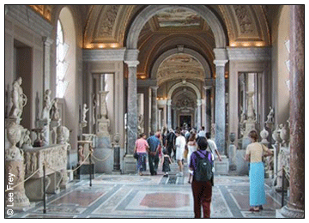
A tour of the Vatican's vast museum, filled with sculptures, books, paintings, furnishings and tapestries can easily take a full day. This enormous collection is housed in the fabulously decorated salons and loggias of the palace. The gallery of frescoed maps of the world and the rooms painted by Raphael are unforgettable.

The museum is well laid out allowing the visitor to choose a route to suit their particular interests and time. For many the highlight of a visit is the lovely Sistine chapel with its awe-inspiring frescoes of The Creation and The Last Judgement.

Open: Mon-Fri 08h45-16h45 (Mar-Oct); 08h45-12h20 (Nov-Feb); Sat and the last Sunday of each month 08h45-13h45. Admission: EUR12; free on the last Sunday of each month. Tel: +39 06-6988-4947.

St Peter's Basilica
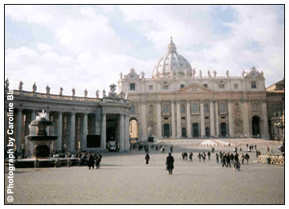
Built as the centre of Roman Catholicism, the aim of St Peter's was to impress upon the visitor the glory and might of the church. With Bernini's piazza to its front, a dome designed by Michelangelo and a façade by Moderno, the basilica certainly achieves its objective.

Among the treasures inside are Bernini's "St Peter's Chair", the statue of St Peter by Cambio and the immensely touching "Pieta" by Michelangelo. You should note that, should you wish to climb to the top of the dome, there are nearly 500 steps. The lift only goes a third of the way, so it's still an arduous climb.

Basilica San Pietro, Piazza del Risorgimento. Open: daily 07h00-19h00 (Apr-Sep); 07h00-18h00 (Oct-Mar) except some Wed mornings. Different opening times can apply to the dome and other attractions. Admission: basilica: free; dome: EUR5 with lift/EUR4 by stairs; Treasury Museum: EUR5. It is also possible to pre-arrange visits to the Necropolis.

Piazza Navona and Bernini's Fountain
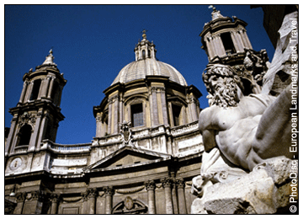
The huge oval Piazza Navona is home to Bernini's "Fontanoa dei Quattro Fiumi", or "Fountain of the Four Rivers". This noble project was designed to encapsulate the spirit of four of the world's greatest rivers, the Ganges, the Nile, the Plate and the Danube in one splendid structure. The result is a spectacular centrepiece to one of the great squares of the city.

The square itself is a fantastic place to take a coffee in one of the cafés and watch the world go by to the sound of water splashing in Bernini's masterpiece. The piazza actually used to be an arena in Roman times, and hosted "games". Some of the remains from this grim past can still be seen below ground level.

Trevi Fountain

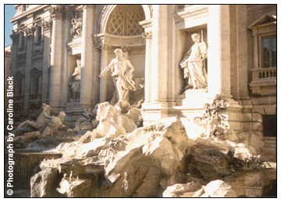
Designed in 1732 by Nicola Salvi, this is one of the city's most famous landmarks. Located in the piazza of the same name the fountain is a magical spectacle, despite the crowds of visitors. It is best seen during an after dinner stroll when the crowds have died away. Custom has it that if you throw a coin over your shoulder into the fountain you will one day return to Rome.

The fountain is hidden away in the city centre. From via del Corso turn into via Muratte which leads to the fountain or from the bottom of via Nazionale turn into via della Pilotta and follow the road to the fountain.

Piazza Spagna

Another Roman landmark, the square and the Spanish Steps that lead from it get their name from the Spanish Embassy that is located in the square.

The piazza is a great place to sit and do some serious people-watching. And when you get bored of watching the locals and foreign tourists scurrying around, climb the steps and enjoy one of the best views over Rome's rooftops. For the literary-minded the English poet John Keats lived in the house to the right of the steps.

Piazza di Santa Maria in Trastevere
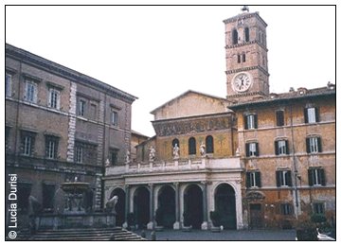
This delightful cobbled square includes a 17th-century fountain and the church of Santa Maria in Trastevere. According to religious legend a well of oil sprang from the square when Christ was born. The miraculous oil ran down to the Tiber river along what is now known as via della Fonte dell'Olio - or "fount of oil" street. It is thought that the first Christian church on the site was erected sometime between 220AD and 330AD, making this the oldest church in the city.

The current building was first erected circa 1140 and has undergone several refits and rebuilds since. It is particularly famous for its 13th-century mosaics on the front façade, which depict the parable of the wise and the unwise maidens. The interior mosaics are also excellent, dating from various times over the last 700 years or so.

Roman National Museum - Palazzo Altemps
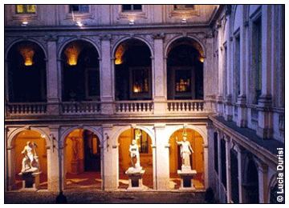
This is just part of the state-owned collection of art on display in the city, but the 16th-century Palazzo Altemps has been quite beautifully restored and is well worth visiting in its own right.

The collection itself is an eclectic mix of high art. Items of interest include a statue of Ares once spruced up by Bernini and a Julius Caesar-commissioned copy of "The Dying Gaul" from an original on the Acropolis at Pergamon, Greece. Another highlight is the collection's huge sarcophagus - its graphic depictions of Roman soldiers massacring barbarian hordes make an interesting variation from the religious iconography that dominates most of Rome's galleries.

Museo Nazionale Romano. Palazzo Altemps, Piazza Sant'Apollinare 46. Open: Tue-Sun 09h00-19h45. Admission: EUR5. Tel: +39 06-3996-7700.

Galleria Spada

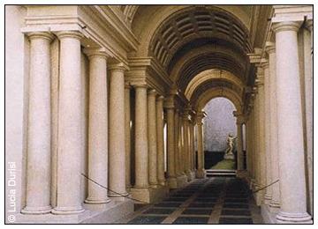
Set in a fantastic 16th-century palace the Galleria Spada is not the most extensive collection of art in the city but does contain some extremely impressive exhibits.

Incongrously, several Flemish pieces are included in the collection including a distinctively Dutch Van Breughel landscape, with windmill naturally. More in line with the Italian aspect of the gallery is Barbieri's 1631 canvas, "La Morte di Didone" and Pietro Testa's "Massacre of the Innocents". Cerquozzi's action-packed 17th-century street scene "The Revolt of Masaniello" depicting a citizen's revolt that took place in Naples in 1647, is also eye-catching.

