Leonardo da Vinci

Florentine artist

Birth April 15, 1452
Death May 2, 1519
Place of Birth Vinci, Italy
Principal Residence Florence
Known for Initiating the Italian High Renaissance with paintings that set a new standard for composition and expression of complex emotion
Possessing a sprawling intellect that touched astoundingly diverse areas of knowledge, but suffering from a tendency to assume too many projects in various fields, and failing to complete most
Milestones 1466 Began his career as an apprentice to Florentine artist Andrea del Verrochio
1470 Contributed a kneeling angel to Verrochio's Baptism of Christ. Leonardo's angel is generally considered superior to Verrochio's central figures.
1481 Began painting Adoration of the Magi, an unfinished work that reveals his technique of beginning with a dark painting surface and adding elements of light, unlike most painters of his time who started with outlined figures on a white surface
1485 While serving the duke of Milan as a military advisor, painted The Virgin of the Rocks, which demonstrated his use of sfumato, a technique he developed for blending tones to create a soft glow and sense of atmosphere
1495-1497 At Santa Maria delle Grazie in Milan, painted The Last Supper, a dramatic depiction of the moment Jesus announced that he would be betrayed
1503 Began but did not finish Battle of Anghiari, a work that broke with conventions of battle painting and depicted the violent fury of battle rather than the historical narrative
1503-1506 Painted the Mona Lisa, which he kept with him for the remainder of his life
1506 Was summoned to Milan by Charles d'Amboise, where he designed a military monument that was never built, and devoted his energies to anatomical studies
1510?-1513? Drew a self-portrait, perhaps the most famous of the many drawings he produced
1514-1516 Resided in the Vatican and focused his attention on scientific experimentation
1516 Moved to France to enter the service of King Francis I, and spent much of his remaining years conversing with the king and observing the properties of water
Did You Know The subtlety of expression and glow of faces depicted by Leonardo is attributed in part to his practice of painting by the soft light of dusk with a linen sheet drawn overhead to further diffuse the illumination.
The Last Supper, which began to deteriorate in Leonardo's lifetime, suffered further damage when 17th-century monks cut a door through the lower portion, and was nearly destroyed by Allied bombing in World War II.
Leonardo established modern techniques of scientific illustration with highly accurate renderings such as Embryo in the Womb (1510?).
Knowledge of Leonardo's Battle of Anghiari, which was destroyed in the 17th century, is based on later artists' rendering of the work, most notably a drawing by Flemish painter Peter Paul Rubens.
Leonardo performed autopsies on corpses to improve his knowledge of physiology, and ridiculed lesser artists' depictions of human flesh, saying they looked like "sacks of nuts."

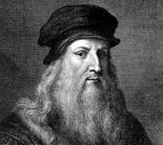

Culver Pictures
Leonardo da Vinci
Leonardo da Vinci was known not only as a masterful painter but as an architect, sculptor, engineer, and scientist. His pursuit of knowledge was relentless and his discoveries left lasting changes in the fields of art and science. With his sophisticated skills and love for learning, Leonardo was the quintessential Renaissance man. He painted The Last Supper between 1495 and 1497.

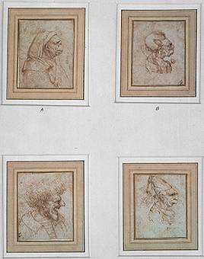

Bridgeman Art Library, London/New York
Four Caricatures
Leonardo da Vinci, an Italian Renaissance artist, was a master draftsman. These four caricatures, drawn in brown ink, reveal the effortless quality of Leonardo’s drawing skill. He was fascinated by faces, and produced countless drawings of them, using a range of models from haggard elderly people to angelic children.
.

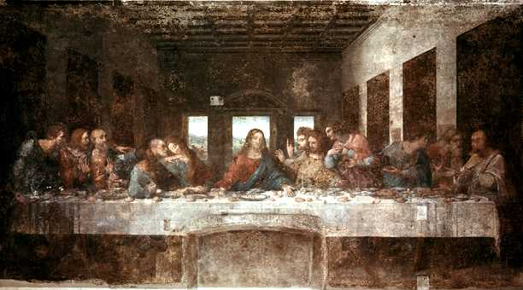

Bridgeman Art Library, London/New York
The Last Supper
One of the most famous religious paintings of all time, Leonardo da Vinci’s The Last Supper (about 1495-1497) decorates the walls at Santa Maria delle Grazie in Milan, Italy. This mural depicts the moment immediately following Christ’s dramatic announcement to his disciples that “One of you shall betray me.” Unfortunately, much of the mural has deteriorated because Leonardo painted with an oil-tempera mixture that did not stick well to the wall. A 15th and early 16th century Italian artist and scientist, Leonardo ranks as one of the great creative figures of the European Renaissance (1300-1600).

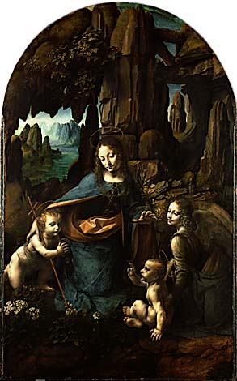

Bridgeman Art Library, London/New York
The Virgin of the Rocks
The Virgin of the Rocks by Leonardo da Vinci was actually painted twice. The first version, done in 1485, was commissioned to be an altarpiece but was evidently rejected. That painting now hangs in the Louvre, Paris. This version was commissioned about ten years later, but wasn’t completed until about 1506. The cross and halos were added later by someone else. The painting hangs in the National Gallery, London.

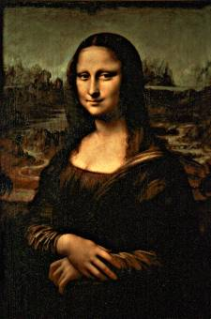

Bridgeman Art Library, London/New York
Mona Lisa
Mona Lisa (1503-1506, Louvre, Paris), Leonardo da Vinci’s world-famous portrait, was the artist’s favorite painting; in fact, it went everywhere with him. Although there have been many theories about the origin of the inexplicable smile on the woman’s face, it was probably just the result of Leonardo’s interest in natural chiaroscuro (the effect of light and shadow on the subject).

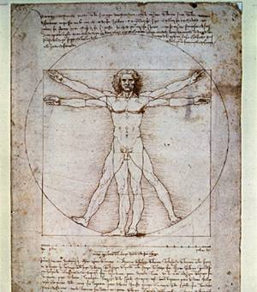

Scala/Art Resource, NY
Vitruvian Man
Italian artist Leonardo da Vinci’s Vitruvian Man, from around 1492, shows a man within a circle and a square—an illustration of the proportional canon of ancient Roman architect Vitruvius. Leonardo and many other Renaissance artists were interested in mathematical and scientific measurement. This work is in the Accademia di Belle Arti in Venice, Italy.
Microsoft ® Encarta ® Encyclopedia 2002. © 1993-2001 Microsoft Corporation. All rights reserved.

