Harry Potter is the name of the famous book for children, written by J.K. Rowling.
It’s about a teenager magician, whose parents were killed by an evil sorcerer, called Valdemort.
Until the age of eleven, he lived with his muggle relatives, aunt Petunia, uncle Vernon and their fat boy, Dudley, who were completely against any sort of abnormality. Now, after being recovered from their hands by Hagrid, the gamekeeper at Hogwarts School of Witchcraft and Wizardry, Harry has to accommodate to his new life as one of the greatest magicians in history, although he is but a child.
He also has lots of magician friends like Ron Weasely and Hermione Granger, or Albus Dumbledore and Professor McGonagall, but on the other side he has some enemies too, like Draco Malfroy, Professor Snape and of course, Valdemort himself.
What makes this book really interesting is the way the story is told, the way all the action is blended with magic and well known myths and legends. This project has the purpose of naming and describing some of the magical creatures found in this amazing tale.

Creatures:

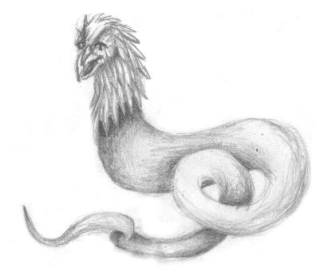
Basilisk: an ancient giant creature with the head of a bird and the scaly body of a snake and the power to turn creatures into stone. Harry battled this creature in “ The Chamber of Secrets”.

The Blast-Ended Skrewt is a stange hybrid creature bred by Hagrid at Hogwarts in the fall of 1994 by crossing manticores and fire-crabs. Newly-hatched skrewts looked like pale, slimy, deformed, shell-less lobsters. They had no heads but had legs sticking out at odd angles. The creatures were about six inches long and smelled strongly of rotten fish. Sparks flew out from their ends every so often which propelled them forward a few inches. Some skrewts had stings--Hagrid suspected that these were the males--and the females had suckers on their bellies to suck blood.

After two months, the skrewts were about three feet long and extremely ill-tempered. When kept together, they attacked and killed each other. They developed gray, shiny armour and began to look like a cross between giant scorpions and elongated crabs. They still expelled fire from one end, although since they had no heads it was difficult to determine which end that was. This blast of flame shot the skrewt in the opposite direction several yards.

By December, the skrewts were six feet long. They held their stings arched over their backs and were extremely dangerous and repulsive.

By June, they were ten feet long and had become incredibly dangerous, fearsome creatures. They looked like gigantic scorpions with stings curled over their backs. Their armour deflected magic spells and it used its firey blast to hurl itself at its foe. It's single undefended spot is its fleshy, armor-less underside. Hagrid placed a full-grown skrewt in the maze for the Third Task of the Triwizard Tournament. Harry defeated it with a luckily-aimed Impediment Curse in its belly.

Hagrid started in September with several hundred skrewts. By the following June, there were almost none left -- all we know of is the one that was in the maze. This isn't surprising since they have no mouths and apparently don't eat, added to the fact that they pretty much killed each other off. All in all, it would seem that Hagrid's experiment in breeding magical creatures wasn't much of a success. We might guess that the final remaining specimen, once it recovered from the curse, was released into the forbidden forest, where all wild things are released in the end.

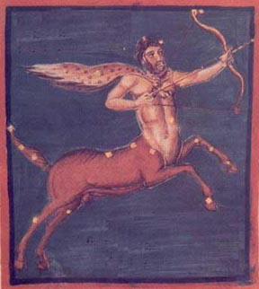
Centaurs are very mysterious creatures. They avoid Muggles and Wizards alike. Centaurs watch and read the signs in the stars and planets and they do not take sides in the events unfolding around them, which they have forseen. They prefer simply to observe. The Centaurs have chosen to be considered beasts by the Ministry and do not take part in governing at all.
A number of Centaurs live in the Forbidden Forest, including Ronan, Bane and Firenze. Firenze has made the bold decision to ally himself with humans against the evil that he saw stalking the forest in the person of Quirrell/Voldemort. This put Firenze at odds with Bane and Ronan, who felt that it was the duty of a Centaur to remain a neutral observer. Firenze, in spite of the feelings of the other Centaurs, rescued Harry from Quirrell/Voldemort in the forest on May 26, 1992.
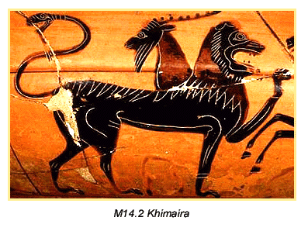
Chimaera: Greek: lion's head, goat's body, dragon's tail. Vicious and bloodthirsty. Chimaera eggs are classified as Class A Non-Tradable Goods. Dai Lleweleyn, the famous Quidditch player, was killed by a Chimaera while on holiday in Greece.

The Clabbert is an arboreal creature resembles a cross between a monkey and a frog. Its smooth skin is mottled green. The Clabbert has short horns and a wide grinning mouth. Its long arms and webbed hands and feet allow it to move gracefully through the trees. On the Clabbert's forehead is a large spot which flashes red when the Clabbert senses the approach of danger, included Muggles.

Chameleon ghouls - known to pretend to be suits of armour.

The Diricawl is a plump, flightless bird escapes danger by vanishing in a burst of feathers. Muggles knew this bird as the "dodo" and believe that it is extinct, being unaware of its ability to vanish at will.

Dementors -- Remus Lupin gives this excellent description of a dementor:
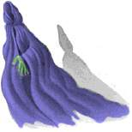
"Dementors are among the foulest creatures that walk this earth. They infest the darkest, filthiest places, they glory in decay and despair, they drain peace, hope, and happiness out of the air around them. Even Muggles feel their presence, though they can't see them. Get too near a dementor and every good feeling, every happy memory will be sucked out of you. If it can, the dementor will feed on you long enough to reduce you to something like itself...soul-less and evil. You will be left with nothing but the worst experiences of your life."

They feed on positive human emotions; a large crowd is like a feast to them. They drain a wizard of his powers if left with them too long. They are the guards at Azkaban and make that place horrible indeed. There are certain defenses one can use against dementors, specifically the Patronus Charm. A dementor's breath sounds rattling and like it's trying to suck more than air out of the room. It's hands are "glistening, grayish, slimy-looking, and scabbed." It exudes cold

The dementor's last and worst weapon is called the Dementor's Kiss. They pull off their hood and clamp their jaws on the mouth of the victim and suck out his soul, leaving him an empty shell, alive but completely, irretrievably "gone."

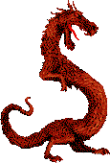
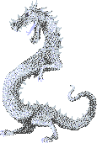

Dragons are the one of the most amazing magical creatures in the world. Dragons are terrifying and awe-inspiring as they take wing and breathe fire. Muggles remember them only as beasts from mythology, which is a credit to the ongoing efforts of the Ministries of Magic in many countries who work tirelessly to keep these huge beasts hidden. Wizards who work with them are called Dragon Keepers (Charlie Weasley is a Dragon Keeper in Romania).

Breeds of Dragons
There are ten breeds of dragons in the world:

Antipodean Opaleye
native to: New Zealand (and Australia)
habitat: valleys
size: medium
appearance: iridescent, pearly scales
eyes: glittering, multicolored, with no pupils
flame: vivid red
food: sheep
eggs: pale grey

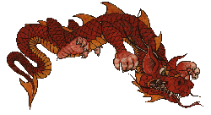
Chinese Fireball (Liondragon)
native to: China
appearance: scarlet with a fringe of golden spikes around its face
eyes: protruding
flame: mushroom-shaped
food: pigs, humans
eggs: vivid crimson speckled with gold

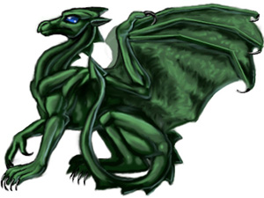
Common Welsh Green
native to: Wales
habitat: nests in higher mountains
appearance: green
flame: narrow jest
food: sheep
eggs: earthy brown speckled with green

Hebridean Black
native to: Hebrides
length: up to 30 feet
appearance: dark, rough scales, ridges along back, tail is spiked
eyes: bright purple
food: deer

Hungarian Horntail
native to: Hungary
appearance: black scales, bronze horns, spiked tail
eyes: yellow, vertical pupils
roar: yowling, screeching scream (GF19)
flame: up to fifty feet
food: goats, sheep, humans
eggs: cement-colored with very hard shells

Norwegian Ridgeback
native to: Norway
appearance: black scales, bronze horns, black ridges on its back
fangs: venomous (SS)
food: any large mammals, including water animals
eggs: black

Peruvian Vipertooth
native to: Peru
appearance: smooth, copper-colored, short horns
fangs: venomous
size: small (15 feet)
food: goats, cows, especially humans

Romanian Longhorn
native to: Romania
color: dark green scales, long glittering golden horn

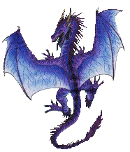
Swedish Short-Snout
native to: Sweden
habitat: wild, uninhabited mountain areas
appearance: silvery-blue
flame: brilliant blue

Ukrainian Ironbelly
native to: Ukraine
appearance: metallic grey, long talons
size: largest breed of dragon, up to six tons
eyes: deep red

Useful materials from dragons:

Gloves, boots, shields
Swedish Short-Snout skin is particular sought-after

blood
there are twelve uses, as discovered by Albus Dumbledore (SS)

liver
17 sickles an ounce in Diagon Alley

heart
heartstring used in wands

horn
powdered
Romanian Longhorn horns are a Class B Tradeable material

eggs
defined as Class A Non-Tradeable Good
Chinese Fireball eggshells are highly prized as potion ingredients
Hagrid acquired a Norwegian Ridgeback egg from someone in a pub and hatched it in his hut. His wooden hut.

dung
for sale by the barrel in Knockturn Alley
dragon dung compost used in Herbology

Other facts about Dragons
Dragon breeding was outlawed by the Warlocks' Convention of 1709

Dragon reservations:
Romania: research center, many types of dragons live there
Charlie Weasley is a Dragon Keeper here
Hebrides: the MacFusty clan traditionally cares for their native dragons
Wales: in the higher mountains
Sweden: between Arjeplog and Kopparberg, the annual broom race goes right through it

The Erkling is a small elf-like creature native to Germany. It's high-pitched laugh is particularly entrancing to children, which the Erklings like to eat. Erkling killings have decreased dramatically over the last few hundred years as the German Ministry of Magic has put in place strict controls over the creatures.
"Rowling has transposed a few letters in the name of the Erl King...of German legend. Otherwise, her description holds true. It is an evil creature in the Black Forest of Germany that tries to snatch children."

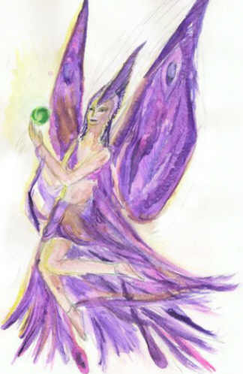
Fairies are tiny creatures which look like perfectly formed humans with insect wings. Fairies have very limited intelligence. They are extremely vain and quarrelsome. They like nothing better than to serve as decoration. Fairies have their own weak form of magic which they use primarily to avoid being eaten by predators. Fairies cannot speak, but communicate with each other using a form of buzzing.

The Fire-Crab looks like a tortoise with a jeweled shell which can shoot fire out of it's rear end. It is constantly in danger of being killed for its shell, which unscrupulous wizards will use as cauldrons. The Fire-Crab is native to Fiji, where there is a coastal reserve set aside for its protection.
Hagrid bred Blast-Ended Screwts from Fire-Crabs and Manticores.

Flobberworm- a ten-inch, toothless brown worm which eats vegetation, especially lettuce. The mucus it exudes is used to thicken potions. Hagrid, after losing his nerve with the Hippogriff debacle, had his third year students raise these for a semester, which was completely pointless as they prefer to be left alone and to do nothing

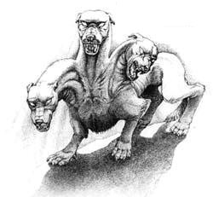
Fluffy is a huge, three-headed dog (Cerberus) which Hagrid owned. Hagrid got him from a Greek fellow in a bar. Fluffy was extremely dangerous, but could be subdued by playing music. This would put Fluffy into a magical sleep, but the second the music stopped, Fluffy would wake up. Hagrid placed Fluffy in the third floor corridor over the trap door which led into the chambers of the Philosopher's Stone. When trying to keep Quirrell from getting through the trap door on Halloween night, 1991, Snape was bitten on the leg. Later, Quirrell used a harp to play Fluffy to sleep long enough to slip through the trap door. Harry played a wooden flute, that Hagrid had given him for Christimas, to follow Quirrell. After the Stone was destroyed and Fluffy was no longer needed for guard duty, Hagrid released the giant dog into the Forbidden Forest.

Hagrid got Fluffy from a "Greek chappie" in a pub, which is significant because the three-deaded guardian dog is a reference to Greek mythology (where it was named Cerberus and guarded the Underworld). Unfortunately, this reference was inexplicably changed in the film.
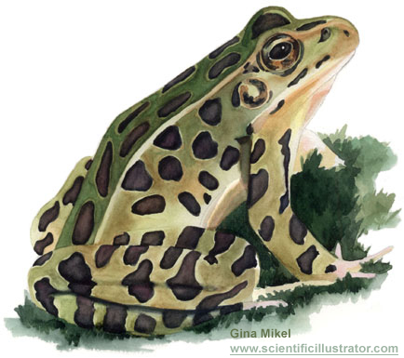
Frogs: Ron has a big one in a tank in his room (was filled with frog spawn before). They also live in the Weasley's garden pond. For a detention, Neville had to disembowel a whole barrel full of frogs.

Ghosts are an unusual type of magical creature. In some ways, they're not creatures at all, but rather characters just like Harry, Ron, Dumbledore, and all the other living people in the books. But they aren't quite the same, since they've all had the misfortune to die unexpectedly and are now semi-transparent, non-corporeal beings.

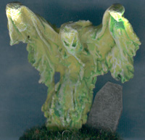
Ghosts can pass through solid objects. They do not eat, but in many other ways they seem to enjoy a full life. They interact with "live 'uns," as Sir Patrick said, referring to Harry, Ron, and Hermione. There are differences, however. It seems that their sensibilities are somewhat altered since their deaths, since their idea of music--an orchestra of thirty musical saws--is bizarre and dreadful to the ears of the living. Also, they do seem to be in some way tied to a place, some (Myrtle, for example) more than others. They don't all get along exactly well, either. The Bloody Baron is avoided by most ghosts, and the Hogwarts ghosts don't go into the Shrieking Shack because they say a "rough crowd" lives there (although this is likely a story they've invented to help support the official lore of the place).

While ghosts as a rule don't affect the physical world--people walk right through them, for example--there are some exceptions. Myrtle can splash water out of the toilet she haunts when she wants to cause a ruckus to demonstrate how miserable she is.

The Ministry of Magic has some authority over ghostly behavior. When Myrtle was stalking Olive Hornby in retaliation for the way Olive tormented her in life, the Ministry was called in and Myrtle was forced to return to Hogwarts and haunt the place of her death, the first-floor girls' restroom.

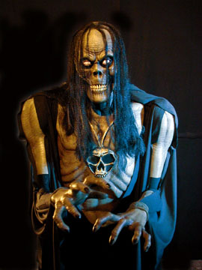
Ghouls are slimy, buck-toothed, ugly creatures which live in attics or barns of wizards. They are dim-witted and are content to throw things around now and then. Ghouls are relatively harmless creatures who live on spiders and moths. A ghoul lives in the attic of the Burrow, just above Ron's room. The ghoul makes noises a lot.

Giants now live mostly in remote mountain areas, but there was a time when they were a force to be reckoned within the Wizarding World. The Giants allied themselves with Voldemort in the 1970s and were responsible for many of the worst incidents of killing and torturing, especially of Muggles. A great many of the Giants were killed by Aurors and the rest fled.
Hagrid's mother was a Giant named Fridwulfa. Olympe Maxime is also part Giant.
Full-blooded giants are about twenty feet tall.

The Gnome is a common garden pest resembling a potato with legs. They live in Gnome-holes underground, where they dig up the roots and generally cause a mess; they're also a dead give-away that a home belongs to a Wizard when there are Gnomes about. Every so often, a garden must be "de-Gnomed," which involves grasping the Gnomes by the ankles, swinging them around a few times to disorient them, then tossing them out of the garden. Gnomes are rather dim, so when they realize a de-Gnoming is going on, they all come rushing up out of their holes to see what's going on, making them a lot easier to catch. Crookshanks loved chasing Gnomes around the Weasley's garden and the Gnomes seemed just as much to love being chased.

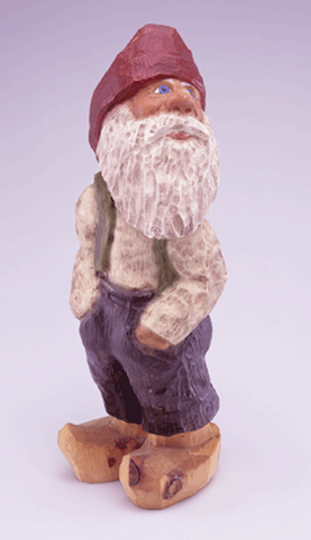
Goblin:
- quite short
- swarthy, clever faces
- pointed beard
- long fingers and feet
- very clever, can battle wizards
- Gringotts is run by Goblins
- many Goblin rebellions and uprisings took place in the 1600s

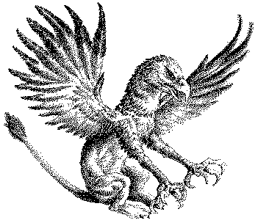
Griffin: Strange creature with the front body of an eagle and hindquarters of a lion. Griffins are used to guard treasure.
There is a statue of a griffin in a corridor in Hogwarts, near the girls' bathroom where Harry, Ron, and Hermione faced a Mountain Troll.The knocker on the door of Dumbledore's office is shaped like a Griffin. Godric Gryffindor, the founder of Gryffindor house, may have gotten his name from this beast.

A Grindylow is a pale green creature which lives in the weed beds on the bottom of lakes in Britain. It is also known as a water demon. Grindylows have long, brittle fingers which they use to grip their prey, sharp little horns, and green teeth. Lupin taught his third year students about them.
Grindylows in the lake near Hogwarts attacked the Triwizard champions during the second task.

The Gytrash is a huge, spectral hound which lives in the forest.
The Gytrash, in the form of a huge dog, horse, or mule, haunts solitary places; it is found in the folklore of Northern England.

House-elves are small humanoid creatures who inhabit large houses belonging to wealthy Wizarding families. They are "bound" to the family of the house, which means they do all manner of menial tasks for them until they die. House-elves are apparently very happy with this arrangement and consider it a matter of pride that they serve faithfully and do not betray their families.

There are over a hundred house-elves at Hogwarts; there they lay the fires, do the laundry, light the lamps, and do countless other such tasks. The House-Elves are also the chefs of the castle and they create wonderful meals in the huge kitchens.

A house-elf is a short creature with large bat-like ears and enormous eyes. It is difficult to tell the difference between male and female house-elves, although the female generally has a higher, squeakier voice. Both male and female house-elves do not wear clothing (and would consider it shameful to do so) but cover themselves in towels, tea cosies, or pillowcases. If their owner gives them an article of clothing, it breaks the "enslavement" and the house-elf is free. For most house-elves, this would be the ultimate insult and they would be shamed forever.

However, a house-elf named Dobby, who served the Malfoy family, took a more enlightened view. He desperately wanted to be free and eventually Harry Potter managed to trick Lucius Malfoy into giving Dobby an old sock. Dobby has since come to work at Hogwarts, where he actually receives payment for his labours.

Dobby has huge, green, tennis ball-sized eyes and a long thin nose like a pencil. He is quite short, like all House-Elves, coming only up to Harry's navel. He is devoted to Harry Potter and also to Ron Weasley, who he refers to as Harry's "Wheezy." Dobby is particularly fond of socks and has begun using his earnings to buy yarn and knit them himself.

Winky, a female house-elf who until recently worked for the Crouch family, has enormous brown eyes and a nose like a tomato. She has also come to work at Hogwarts, but she is in total disgrace and has taken to sitting on a stool by the fireplace and getting drunk on butterbeer. For years, Winky took care of Barty Crouch Jr., who was held in the Crouch residence under the Imperius Curse. Barty Crouch Sr. fired her when she was found holding a wand at the Quidditch World Cup. Winky's mother and grandmother were also Crouch family House-Elves.

House-elves have a very powerful magic all their own, magic which requires none of the types of focusing tools (wands or words) that Wizard magic requires. Dobby used his magic to enchant a Bludger, to close the magic portal that leads to Platform Nine-and-Three-Quarters, to interfere with Owl Post and steal someone's letters, and to knock Lucius Malfoy down a flight of stairs. He also can disappear at will, which would seem to be a form of Apparition, but a form which can be done within Hogwarts, where, as Hermione constantly reminds Harry and Ron, normal Wizarding Apparition is simply not possible. All of these are very powerful charms.

Unfortunately, as long as they're enslaved, they aren't likely to be using this magic for anything but their routine work. Hermione Granger is working to bring enlightened thinking to the house-elves at Hogwarts, so far with very little success. It would be interesting indeed if she would succeed in convincing these creatures to stand up for themselves and perhaps even fight against Voldemort.

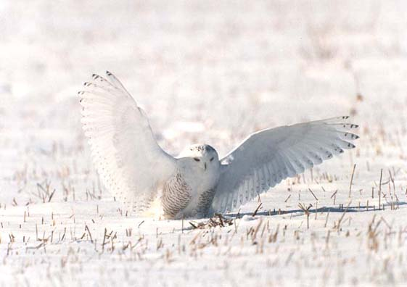
Owls are the primary means of personal communication in the wizarding world. Messages are tied to the leg of the owl or it carries the item in its claws or beak. Owls also carry parcels, sometimes several owls together if the package is large. Through magic, owls can always find the recipient, although the trip is not always an easy one. Occasionally other birds have been used to carry letters
Owl Post: hundreds of owls deliver mail every morning during breakfast at Hogwarts
Post Office – Hogsmeade
- rows and rows of owls of all sizes, colour coded - you choose how fast you want your message delivered

Hedwig - Harry's snowy owl, amber eyes, unusually intelligent
Erroll - Weasley family's owl, old and decrepit
Hermes - Percy's screech owl
Pigwidgeon - Ron's owl (tiny, over-exuberant )

The Phoenix is a magical bird about the size of a swan. The Phoenix has crimson feathers on its body and a long, golden tail as long as a peacock's. It's claws and beak are gleaming gold and its eyes are black. (These colours happen to be the colours of Gryffindor House, interestingly enough.) The Phoenix can disappear and reappear at will, in a burst of flames. Phoenix tears heal wounds. It can lift great weight with its tail; when Harry grasped Fawkes' tail in the Chamber of Secrets, he felt as if he were becoming weightless. The song of the Phoenix gives strength and hope to those it sings for.

Fawkes is the pet Phoenix of Albus Dumbledore. The wands of both Harry and Voldemort contain feathers from Fawkes' tail.

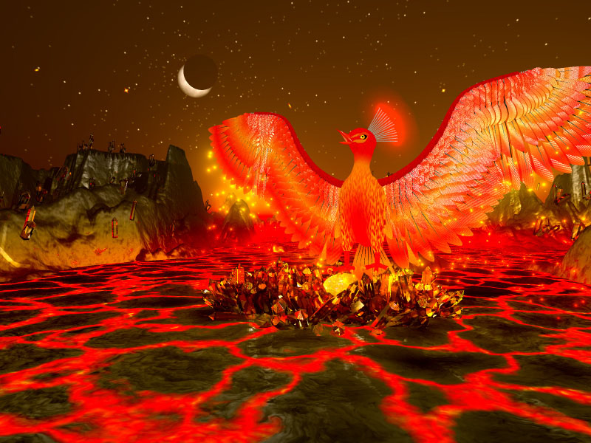
When a Phoenix is approaching its Burning Day, it resembles a half-plucked turkey and makes gagging noises. Its eyes become very dull and its feathers fall out. Then suddenly it will burst into flames and turn to a pile of ashes on the floor. From this pile of ashes rises a newborn Phoenix, small and ugly. In a matter of days it becomes a fully-grown, beautiful Phoenix.

Unicorns:
- silver unicorn horns cost twenty-one Galleons each at the apothecary in Diagon Alley
- Mr. Ollivander uses unicorn tail hairs in some of his wands (including Cedric Diggory's and Ron Weasley's).
- Unicorn blood is silver in colour and shines under moonlight
- Unicorns are powerful magical creatures. It's not easy to catch them
- long slender legs, pearly-white mane
- horn and tail hair used in Potions
- so brightly white it makes snow look gray
- unicorn hoofs are golden.
- unicorns prefer a woman's touch
- unicorn foals are pure gold
- they turn silver when they're about two years old. They grow horns at around four. At about seven years old, they're fully grown and turn pure white.

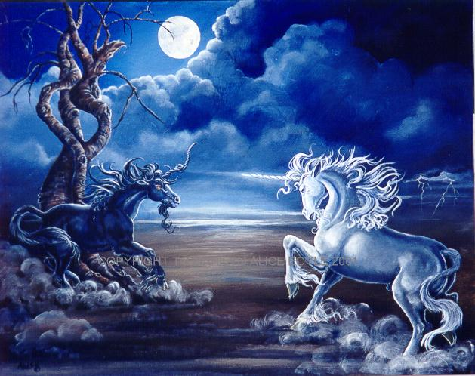
" It is a monstrous thing, to slay a unicorn. Only one who has nothing to lose, and everything to gain, would commit such a crime. The blood of a unicorn will keep you alive, even if you are an inch from death, but at a terrible price. You have slain something pure and defenceless to save yourself, and you will have but a half-life, a cursed life, from the moment the blood touches your lips." Firenze the Centaur



Bibliografie: Internet, Volumele Cartii “Harry Potter”, Filmele “Harry Potter”
Redactori: - Trogmaer Tudor ( Ben )
-Georgescu Catalin (Chris)
-Exarcu Mircea ( John )

