Michelangelo

EARLY LIFE (1475-1504)

The life of the great artist began on the 6th of March, 1475. He was burn in Casentino, Caprese. His parents were Lodovico di Leonardo Simioni and Francesca di Neri di Miniato del Sera.

Michelangelo’s first teacher was Francesco da Urbino. He had to teach young Michelangelo grammar, but Michelangelo was not very fond of it. He often ran away from school to the church, for drawing icons. Michelangelo’s father saw that his son had more practical skills then academic achievements. He saw the talent of a great artist in his son. So, in 1488, with the help of Francesco Granacci, Lodovico sent Michelangelo as an apprentice in Domenico Ghirlandaio’s studio.
In 1489, Bertodolo di Giovanni, sculptor and colector of ancient things, helped Michelangelo to get into Lorenzo di Medici’’s Garden. Medici’s Garden was a place, near San Marco, where the most talented young men were gathering.
But in the 8th of April 1492, Lorenzo di Medici, the Magnificent, died. Michelangelo lost his protector and he had to work alone just for a while, because Piero, Magnificent’s son, took him to the Medici’s Palace. But Michelangelo didn’t stay there for long. He ran away to Venetia, just before Piero’s thrown away, in 1494. Then, Michelangelo moved to Bologna. He worked for Lorenzo di Piefrancesco dei Medici Popolani. Later, in his way of recovering a statue sculpted by himself, Michelangelo went to Rome. He sat there 5 years: from 1496 to 1501.
From that period there are two famous sculptures: Bachus, made for Jacopo Galli and Pietà from San Pietro.

For unknown reasons, Michelangelo returned to Fluorinate. He sat there from 1501 to 1505. He found everything changed. But a great thing happened to him: he met Leonardo da Vinci. Michelangelo had the opportunity to be in touch with da Vinci’s work and da Vinci himself. Leonardo, who was 23 years older, encouraged Michelangelo. They did not become friends. But important was that Michelangelo agreed the fact that Leonardo was still better than he was and tried to learn from him, and Leonardo understood that Michelangelo’s talent was real and very well used.
During the time spent in Fluorinate Michelangelo sculpted a lot of statues. The first ‘job’ was coming from Cardinal Francesco Piccolomini (future Pope Pirus II), Jacopo Galli’s friend. Michelangelo had to make 15 statues for the Cathedral from Siena, in 4 years.
Michelangelo’s behavior was at least weird. He did not respect the engagement. At the end of the period he had only 4 statues. Michelangelo made another sculpture, Madonna from Brunger, for the Cathedral from Siena, but he changed his mind: he sold it in 1506. He sculpted a lot of others ‘Maddens’. They were very beautiful pieces, unlike the ones from Siena. Michelangelo’s statues gave the impression of life.
At this time, Michelangelo met Donatello and Leonardo. And from now on, Donatello and Leonardo, beside the ancient influence, inspired Michelangelo’ s technique.
Michelangelo’s strange behavior found a reason: he was trapped, body and soul, by the giant block of marble, which would become David.
In 1463 Agostino di Duccio sculpted a ‘Hercules’. The next year his masters required him another huge statue, David. For a stupid reason di Duccio refused and messed all. In 1501 Michelangelo received an offer: to continue (the unstarted) work of Agositno di Duccio. He accepted immediately. ‘David’ was ready in 1504 and it had been appreciated by Leonardo da Vinci, Botticelli and many others. It was placed in the middle of Fluorinate.
Some time later, Michelangelo had been called to paint “Battle of Casincea”, together with Leonardo, which was painting “Battle of Anghiari”. Both of the paintings should be exhibited in the big court of Palazzo Vecchio.

MID YEARS (1505-1534)

Michelangelo riched the highest step of his glory, when he was called to Rome, for decorating pope’s Iuliu 2nd's grave.
Michelangelo accepted right away, because, finally he had the opportunity to fulfil his dream: to make a huge work, to put all his talent in there. But, unfortunately, with all the good pieces of advice of Giuliano Sangallo, the pope listened to envious artists, like Bramate, and concealed the contract.
Michelangelo got very furious. His patience was too hard tried. He left Rome without any word. The pope felt sorry for offending such an artist and looked for him. The reconciliation took place in Bologna, 1506. Michelangelo made a statue of Iuliu II, there, in Bologna, but it would be destroyed in 1511. Finally Michelangelo returned to Rome, where, his friend Giuliano Sagnallo convinced all that Michelangelo is the man. Only Michelangelo could paint the ‘Valut of the Sixtine Chapel’. The envious artists also believed that Michelangelo should paint the Valut. The thought that Michelangelo would not accept (he was a sculptor) and offence the pope. If Michelangelo would accept, they were sure that he would never be capable of such great work. They were all wrong. Although against his will, Michelangelo accepted. He started in May, 1508. He worked without any help, far away from the outside world.
There was some information, which said that at first Michelangelo had to paint only a little part of the Valut. But Iuliu II was irritated by Michelangelo’s pressing. The great artist told him over and over that the Valut was empty and pour, and he would never let it like that. Thence Iuliu II said his famous words: “Do what you want!”. And Michelangelo did what he wanted. On the 31st of October, 1512, the ‘Valut of the Sixtin Chapel’ was open. Thousands of people crossed themselves in front of a miracle.
The Valut meant very much. Michelangelo’s genius was recognized by all. But the glory was nothing for Michelangelo. He had a lonely life and the only joy he could have was to make pope Iuliu II’s grave. But life had a new blow: the pope died, on the 21st of February 1513. There were a lot of discussions for the grave and new contracts between Michelangelo and Iuliu II’s will performances. During all this time Michelangelo sculpted magnificent works, like: ‘Revolted slave’, ‘Moses’, ‘Die slave’ etc. during all those years, everything was confuse: Michelangelo accepted some works and then renounced at them, Florenta fell under the Medici’s family command again, a plague epidemic, wrong decisions and so on…

FINAL DAYS (1536-1564)

All those determinated Michelangelo to move, forever this time, to Rome, in 1534. But Michelangelo’s technique was not the same. It lost its ancient influences, to the pain and melancholy advantage. Whitnesses to his transformation are ‘The Night’ and ‘The Aurora’, from the Medici’s Chapel.
One year later, in 1535, the pope Paul III, asked Michelangelo to lead the works for San Pietro Cathedral. Some time later, Paul III careced Michelangelo to paint ‘The Judegement Day’ on the sacred wall of the Valut. Michelangelo accepted, once more against his will, but sure that he was the only one who could finish what he started. After showing the begins of life on Earth, Michelangelo painted the end of the world: Judegement day (1541).
Everybody loved the Valut. ‘The Judgement Day’ was also a big success but it was also frightful. It was showing the new call of God, the day when everyone equal and naked in front of the Providence.
Between 1542-1550 the sculptor Michelangelo continued his painting career making two wall paintings in the Pauline Chapel. In 1548 he finished after many years and many obstacles, the grave of Iuliu II.
The time went by and Michelangelo was not tired. He worked as an architect and he proved his wizens. But something happened to him: he realized that new generation of sculptors, painters, architects, and poets, were on the road. He realized that the language he spoke had ancient influences and that the future was coming very fast, and he was not young anymore. Even if popes like Iuliu III, Paul IV, Pirus IV tried to get him on their side, Michelangelo felt that his time passed away. Michelangelo left the stage of life on the 18th of February 1564.
All his life, Michelangelo worked at Pietà. He did not finish it and some said that it was destined to his own grave.

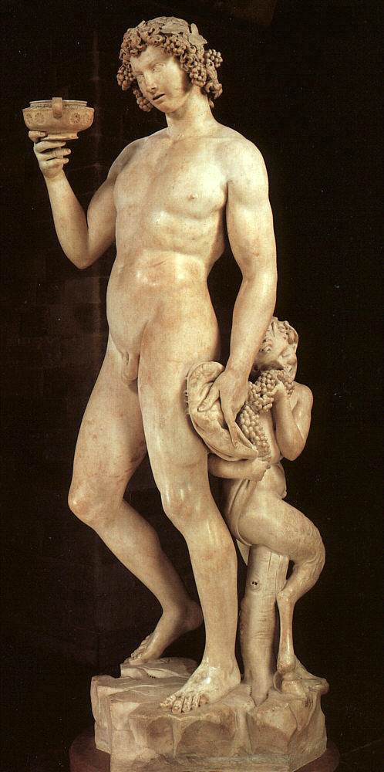

Bachus was a great statue, made by marble, 203-ft. height. Unlike the others statues of Michelangelo, Bachus’s concept seems to be ronde-bosse: it can be watched from all parts; even more: it makes you sourround it to see it from different angles.
In the first sight, one can belive that Bachus is an ancient statue. Its ancient character is not given only by the expression; but also by the way it was made. Michelangelo slept over the usually sharp-tongued manier, which was used by his contemporary. Bachus was alive. Its eyes, its muscles, all of it was scattering a special impression.

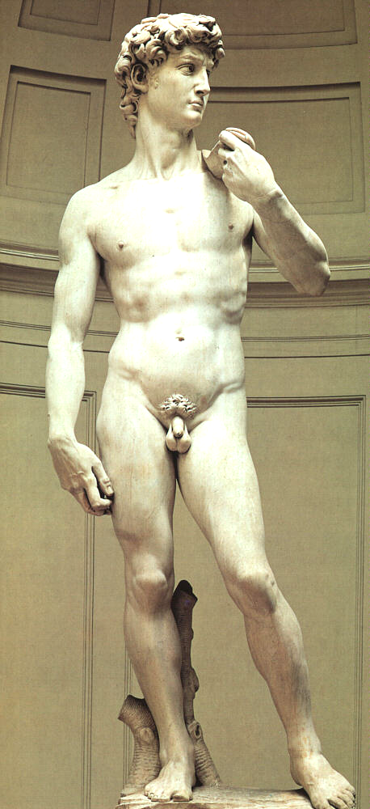

‘David’ was the reason of Michelangelo’restless. In ‘David’ Michelangelo put all his talent, and the result was a miracole. The main style was ronde-bosse again; it could be whached from different angles.
Michelangelo’s ‘David’ was the first presented in his hole splendor: a young face, the ideal man’s head, a perfect naked body. It had more then ancient influience; it had life. The look of his eyes, the tension of the arms,everything placed young ‘David’ before the battle with Goliat. So his impression had a rey of purity .

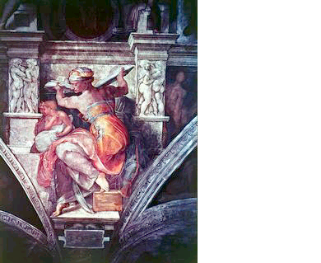

The ‘Sixtin Chapel’ was placed in the North of Saint Peter’s basilica. It was build by the pope Sixt IV della Rover between 1473-1477. It was a great building and a lot of famousness artists left there a piece of them. Michelangelo played the most important role in the Chapel’s decoration. The Saint Virgin protected the Chapel.

The other great work commissioned from Michelangelo by Iuliu the frescoing of the ceiling of the Sistine Chapel was equally daunting, but was brought to sublime fruition. The contract was signed on 10 May 1508 and the finished ceiling was unveiled on 31 October 1512. Michelangelo, who always regarded himself as a sculptor first and foremost, was reluctant to undertake the work. But he made of it his most heroic achievement, not only for its quality as a work of art, but also in terms of the endurance and stamina he showed in completing so quickly and virtually unaided such a huge and physically uncomfortable task. There is still much debate about the exact interpretation of the scores of figures that adorn the ceiling, but the main panels represent scenes from Genesis, from the Creation to the Drunkenness of Noah, forming the background to the frescos on the life of Moses and of Christ on the walls below by a number of 15th-century artists. Prophets and Sibyls who foretold Christ's birth are at the sides of the ceiling, and at each corner of the central scenes are figures of beautiful nude youths (usually called the Ignudi), whose exact significance is uncertain. They have been thought to represent the Neoplatonic ideal of humanity, and as Kenneth Clark wrote, `Their physical beauty is an image of divine perfection; their alert and vigorous movements an expression of divine energy. From the moment of its completion the Ceiling has always been regarded as one of the supreme masterpieces of pictorial art (the recent cleaning has revealed anew the beauty of the colouring). Michelangelo was, at the age of 37, recognized as the greatest artist of his day, a position he retained unchallenged until his death.

