My favorite PETS
DOGS

Category’s : BOXER

Boxer, breed of working dog, developed in Germany during the second half of the 19th and early part of the 20th centuries from a number of breeds, principally the bulldog and terrier types. The ancestors of the breed were originally used for dogfighting and bull baiting; in later years, because of the courage, strength, and agility of the boxer, it was selected for police work in Germany and was used as a guide for the blind. Always faithful, intelligent, and alert, the boxer makes a splendid pet. Among its physical characteristics are a massive head; an undershot jaw; a muzzle with a characteristic black mask; ears that are rather long and set high; dark-brown eyes; a broad, black nose; a strong, round, and muscular neck; a deep chest; and well-muscled hindquarters. The dog has a short, glossy, smooth coat that is any of various shades of fawn or brindle in colour, sometimes with white markings. The male is from 56 to 61 cm (22 to 24 in) tall at the shoulders and weighs about 30 kg (66 lb); the female is from 53 to 58 cm (21 to 23 in) tall and weighs about 28 kg (62 lb).
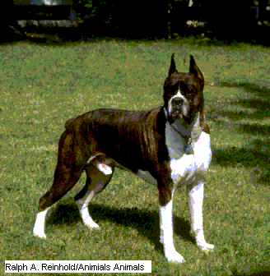

BULLDOG
Bulldog, breed of dog, often used to represent the character of Britain and the British. It was developed in England in the 13th century for courage and ferocity needed in the sport of bull baiting. After bull baiting became illegal in 1835, the dog was selectively bred to eliminate viciousness. The bulldog has a heavy, thickset, low-slung body; a massive head; wide shoulders; short, stout, and straight forelegs; long hind legs; and a fine-textured coat of short, straight hair. It is also characterized by small, thin ears, located high on the head; a large, broad nose; and a deep, broad, and full chest. The lower jaw projects, enabling the dog to take a grip that is difficult to break. The tail is short, straight, or screw, but not curled, and is hung low. The colour of the dog may be red brindle, other brindles, or solid white. Mature male dogs weigh about 25 kg (55 lb); females, about 21 kg (45 lb). North American bulldogs are slightly lighter.
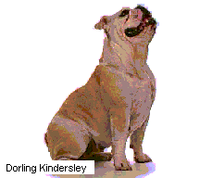

German Shepherd Dog
German Shepherd Dog, breed of working dog, which originated in northern Europe several centuries ago, hence their alternative (but unofficial) name Alsatian. The dogs were originally used to protect flocks of sheep and are still used for this purpose. More recently they have been trained to assist police forces in capturing criminals and to guide the blind. German shepherds are also used as guard dogs by the military. The dog is above medium size, standing 61 to 66 cm (24 to 26 in) tall at the shoulder. Males may weigh up to 41 kg (90 lb); females are usually much lighter. It has a long, muscular body and gives an impression of power and ruggedness. The dog has a long head; a wedge-shaped muzzle; dark-brown eyes of medium size placed somewhat obliquely; medium-sized ears, set high; short, compact feet with hard pads and dark nails; and a bushy tail. The dog has a double coat, consisting of an outer coat with straight hairs of medium length and a thick woolly undercoat. There are also long-coated varieties. The colour may be any of many varieties between light grey and jet black; the main colours are brindle, black and tan, tan, brown, and black. A white coat is not acceptable in the breed standard. The German shepherd is noted for loyalty, intelligence, and courage.
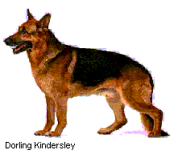

ROTTWEILER

Rottweiler, breed of working dog, probably descended from a herding dog used by the Roman armies to drive their cattle and to guard their camps. From the early Middle Ages until the mid-19th century, drover dogs of this type were used in southern Germany. They were especially connected with the market town of Rottweil, hence their name. The breed was revived early in the 20th century and used for police work. Rottweilers are fairly large, strongly built, and intelligent, making excellent guard dogs. The short, coarse, flat hair is black, with tan to dark brown markings. The tail is short and carried horizontally. Males stand about 61 to 69 cm (24 to 27 in), females about 56 to 62.5 cm (22 to 25 in).
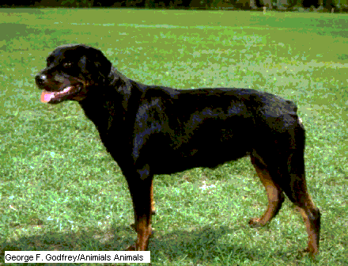

DOBERMANN PINSCHER
Dobermann Pinscher, breed of working dog that originated in Apolda, Germany, where it was first bred in about 1890 from the German shepherd dog, the Rottweiler, the black and tan terrier, and the German pinscher. The Doberman (or Dobermann) pinscher is named after its first breeder, Louis Dobermann, a watchman, who developed the dog to help him with his guard duties. It was employed at first as a watchdog and later was trained to act as a police dog and a war dog. Characteristics of the breed are a powerful musculature; a wedge-shaped head; dark eyes ranging from brown to black in colour and having an alert, courageous expression; a well-muscled neck; and a smooth, hard, close-lying coat that is black, red, fawn, or blue in colour. The male dog is about 65 to 70 cm (26 to 28 in) tall at the shoulder and weighs from 32 to 34 kg (70 to 75 lb). Females are slightly smaller.
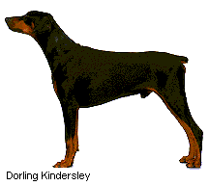
MAN VIOREL
MUREŞAN IOAN

