Oxford Street

Oxford Street is one and a half miles end to end. Most shops open 10am until 6 or 7pm. Some open Sunday 12 to 6pm with late nights on Thursday. Oxford Street is best known for Selfridges and the other big department stores which are all found in the section from Marble Arch to Oxford Circus, along with most of the big-name multinationals. It's more of the same as you continue towards Tottenham Court Road, but generally on a smaller scale. Oxford Street claims to be the busiest street in Europe.
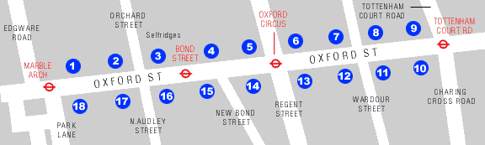

Contens:

Oxford street- Busy doesn't come close to describing it
St Christopher's Place- For a more leisurely shop
Carnaby Street- Another side street enjoying a revival
List of our 5 stars hotels-The list of our top 5 hotels

Busy doesn't come close to describing Oxford Street, a mecca for shopping-mad tourists and Londoners alike. Made famous as the home of designer boutiques in the 60s,
Oxford St
Along this two-mile stretch, right from Tottenham Court Road tube to Marble Arch there are tons of chain stores and cut price shops, many aimed at tourists. Most of the shops are of the high street variety; you'll find Next, River Island, Dixons and Top Shop along here. There's also a few large department stores such as Debenhams and John Lewis and the largest of them all, Selfridges.
As well as stocking every shade of lipstick, hue of tights, and range of ties under the sun Selfridges offers a free advisory personal shopping services fro customers. So if you aren't sure whether neon pink is really you, or you can't decide if the latest kinky boots can be worn by middle-aged mums, the suitably stylish assistants will give you an honest answer to all your fashion dilemmas.
After an initial consultation, clothes, are selected according to your taste and budget. And for the ultimate pampering, make-up and massage facilities are also available. For an appointment call 020 7318 3536.
Another Oxford Street institution is the Marble Arch Marks & Spencer. This flagship store stocks many items you won't find in any other branch because new lines are introduced here, and, if prove popular enough, are then sold on nationwide. The arrival of new lines is greeted with such greedy anticipation that if you hesitate you'll miss out. Rails and rails of popular designs can sell out in less time than it takes the shop assistants to pop them on their hangers.
St Christopher's Place
But for a more leisurely shop away from the chaotic crowds and cut-throat shoppers, St Christopher's Place offers a slice of laid-back continental charm right in the heart of the capital's hustle and bustle.
"The Place" as it's known locally, is tucked between a shoe shop and jewellers on Oxford Street, opposite Bond Street Tube station. This small precinct with its stylish mix of one-off stores and designer outlets is much more intimate than the big modern West One shopping centre on the other side of Oxford Street.
Under Two Flags sells meticulously crafted model toy soldiers and scale figures. The Egyptian House is crammed full of weird and wonderful home decor for the more discerning stylies. Designer wear on show includes Nicole Farhi, Moschino, Dries Van Voten and Martine Sitbone. Antonia Pollack jewellery, Robert Clergerie shoes and Storm fashion accessories ensure you'll leave the place looking absolutely fabulous from head to toe - provided you're also prepared to depart with an empty wallet that is.
Carnaby Street
Another side street enjoying a revival (thanks to the designers' current obsession with the sixties) is Carnaby Street.
Until the 1950s Carnaby Street was dominated by sweat-shop tailors who made the suits for Saville Row. But in the mid-1950s Bill Green opened a shop called Vince selling outrageous clothes for the growing gay population. A string of trendy boutiques followed and by the 1960s Carnaby Street became the heart of funky street fashion.
Today it is largely populated by tourists and tacky souvenir shops, though there are a few hip clothes shops in between. But Newburgh Street, which cuts across Carnaby Street, has become home to a number of innovative designers such as John Richmond, Pam Hogg and Jean Paul Gaultier.
So whether you want wild style or conservative chic Oxford Street and its many cooler back
Lumina, 89 New Bond Street is one of the most significant office and retail developments to come available in the West End for many years.
Occupying a commanding corner position at the junction of New Bond Street and Oxford Street, just west of Oxford Circus, the property is in the heart of the West End. The area is an established office location with local occupiers including Diageo, Japan Airlines, Total Oil, Condé Nast and Ericsson. It is also ideally located for the area’s unrivalled amenities, including exclusive shopping together with numerous bars and restaurants.
89 New Bond Street offers perhaps the highest level of nearby amenity of any building in London. The building is located on the corner of New Bond Street and Oxford Street, two of the most presigious shopping addresses in London with famous names such as Cartier, Gucci, Joseph and Louis Vitton mixing seamlessly with the day-to-day essentials such as Tesco, Selfridges and John Lewis. All the high street banks are represented within easy walking distance and the smart and casual restaurants and sandwich bars are in abundance.
The property is also within walking distance of some of London's most fashionable hotels including Clairages, the Ritz, the London Hilton and the Grosvenor House Hotel all of which offer conference and leisure facilities. Car parking is also easy, with numerous Westminster or NCP car parks in the vicinity backed up by meter parking.

List of our 5 stars hotels

Le Meridien Piccadilly * * * * *  A luxurious five star hotel in arguably the best location in London, being a short walk from Theatreland and principal shopping areas. Bedrooms are exquisitely furnished as are the public area. Relax Champneys Health Club with its swimming pool, gymnasiums, squash court and Turkish bath. | 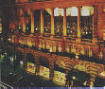

The Langham Hilton * * * * *  On of London's finest hotels located at the north end of Regent Street. Very convenient for theatregoes and for shopping on Oxford street and new Bond street. All Bedrooms are individually decorated in different styles and thoughtfully and comfortably equipped. The langham Health Club offers a full range of fitness equipment as well as sauna, solarium and steam room. | 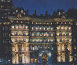

Britannia Hotel * * * * *  A charming and discreet five-star hotel located in the heart of fashionable Mayfair. Accommodation is remarkably spacious and supremely comfortable with the added benefits of air conditioning. A choice of restaurants and bars caters for every taste. Theaterland and the shopping areas of oxford street, Bond Street and Knightsbridge are a short walk away. | 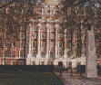

The Waldorf Meridien * * * * *  A traditional English five-star hotel in a ideal location for theatregoers. Bedrooms are beautifully furnished with authentic Edwardian. The palm Court lounge is a famous feature of the hotel where tea dance are held on Saturdays and Sundays. | 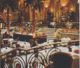

If you want a real feel for the diversity of London life, Oxford Street is a must visit location. The variety of stores range from little shops selling boots and shirts and jeans to massive department stores such as the magnificent Selfridges, Marks & Spencer and the John Lewis Partnership (a partnership where the founder set down the principle that all profits would be shared out evenly amongst the staff - a tradition which continues today).
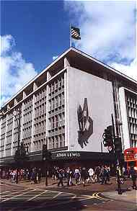
The John Lewis Partnership
The Street has enormous historical interest. There are no pubs (bars) on the street, in part thanks to the public executions carried out at Tyburn (the present day Marble Arch is the historical location of this historic place of public execution - there's a small plaque on a traffic island at the junction with Edgware Road which marks the exact spot). So why no pubs? Well, the story goes that as the condemned were dragged to their execution, they were allowed to claim a drink in every pub along the route. The route was Oxford Street which had no pubs, so in effect it wasn't such a particularly great gesture. By a strange coincidence there are still no pubs today - but step a few yards off the main drag and you'll be spoilt for choice, so maybe there is something in the story after all.
Oxford Street is well served by public transport, with the Central line forming the backbone of this network. There are four stations along the route - from Marble Arch in the west, through Bond Street and Oxford Street itself down to Tottenham Court Road. Tottenham Court Road itself is the place to head if you want to replace your Walkman or buy electrical goods of any kind... but the more upmarket stores will be found to the west of Oxford Circus. These including the wonderful and grand Selfridges...which apart from anything else has the biggest cosmetics hall in Europe! The store itself is open seven days a week, 10.00am to 7.00pm Monday through to Wednesday, and 10.00am until 8.00pm Thursday to Friday. Saturday sees it opening from 9.30am to 7.00pm and Sunday from noon until 6.00pm. Oxford Circus is also the home of London's Nike Town.
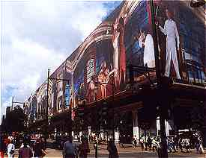
Selfridges having a facelift
The area also has plenty of food outlets - mostly fast food and the bigger 'chain' outlets. The food is expensive and generally indifferent. The same is the case with most pub pub food. You are best advised to try one of the restaurants in the department stores or head for Soho where you'll find better grub from a wider choice of restaurants. The freshly squeezed orange juice in John Lewis is actually squeezed to order and tastes divine.It's worth visiting the Lewis store for the orange juice alone, let alone the fantastic shopping opportunities.
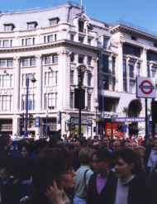
The hustle & bustle of Oxford Circus

streets are sure to have something to suit.

