Profile of the setting

The land chosen by Hardy for his novel to develop is Wessex, a large agriculture region which designates the south-western counties of England, principally Dorset and which is also the author’s native place. The Vale of Blackmoor “is a vale whose acquaintance is best made by viewing it from the summits of the hills that surround it...”(ch. V)
It is common-knowledge that nature and the landscapes are playing a very important role in Hardy’s novel, as they project the feelings of the characters on a background of eternity and generality.
In order to understand why Thomas Hardy had chosen Stonehenge to all the places in the world, one must know a little about the history of this magnificent monument.
The ancient monument lies on the Plains of Salisbury, or “The Great Plains” (as Hardy identified them on his map) and dates from the Neolithic (late Stone Age) and Bronze Age. It is the most celebrated of the megalithic monuments in England and the most important prehistoric structure in Europe. Stonehenge consists of four concentric ranges of stones. Within this outermost range is a circle of smaller bluestones enclosing a horseshoe-shaped arrangement of bluestones capped with lintels. Within these trilithons (an assemblage of two uprights capped by a lintel) stands a slab of micaceous sandstone known as the Altar Stone.
The entire assemblage is surrounded by a circular ditch 104 m (340 ft) in diameter. On its inner side the ditch rises into a bank within which is a ring of 56 pits known as Aubrey holes (after their discoverer, the antiquarian John Aubrey) and used at a later stage as cremation burial pits. On the north-eastern side, the bank and ditch are intersected by the Avenue, a processional causeway 23 m wide and nearly 3 km long, bordered by a ditch. Near the entrance to the Avenue is the Slaughter Stone, stone that may originally have stood upright. Almost opposite, and set within the Avenue, is the Heel Stone, which may have played a part in sightings of the sunrise at the summer solstice.
We can now understand why Hardy had chosen Stonehenge as the setting for the most powerful scene of “Tess of the D’Urbervilles”.
It seems that Stonehenge was the only right setting for such a dramatic scene.
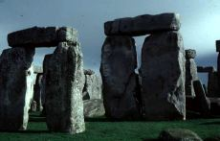 Stonehenge, England 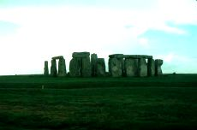

The primordial elements of nature are to support and to echo Tess’s tragedy.
The Stonehenge fragment begins with Hardy’s detailed description of the monoliths. We can almost see Tess passing her fingers along the vertical surface of the stones.
Angel himself names this edifice a “very Temple of Winds” because the wind blowing among its blocks of stone made a sort of a buzz. (“What monstrous place is this?” said Angel. “It hums”, she said. Harken”). He listens. The wind, playing upon the edifice produced a blooming tune, like the note of some gigantic one-stringed harp...(chapter LVIII)
Tess’s and Angel’s symbolical phrases are meant to express its darkness, coldness, wildness and greatness. “You mean that pagan temple? Yes. It’s older than the ages, even than the d’Urbervilles.” Than follows the description of the Great Plain and that of the Stone of Sacrifice and the Sun stone.
The Altar Stone, lying within the horseshoe-shaped arrangement on which Tess is resting peacefully, gives her a feeling of comfort. She said that she felt like home and that she liked it very much there. When Tess falls asleep everything is dark, the night wind dies out.
The author than gradually prepares the reader for her awakening: the light is growing, the light is strong, the sunbeams “shine full” on the heroine’s face, the stones are “glistening green gray”. Hardy is using alliteration to amplify the feeling of anxiety. Notice the parallelism between the character’s feelings and the nature itself. From dusk to dawn, the whole nature (light, wind, water, stone) accompanies Tess.
The Stonehenge scene illustrates once again the idea that in Hardy’s novels, the nature projects the tragedy of mankind on the primordial axes, it doesn’t help them through the moment.

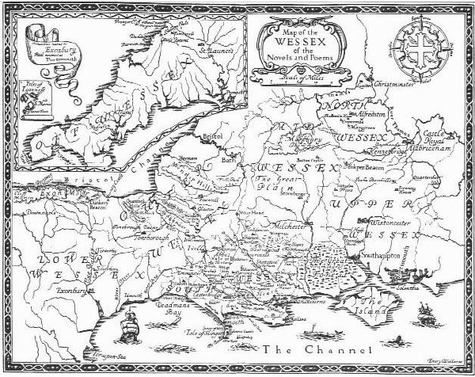.

Thomas Hardy’s map.

Bibliography: - the internet.)
- Thomas Hardy, Tess of the d’Urbervilles”.

