STOCKHOLM - THE CITY ON WATER

Welcome to Stockholm! The city is bursting with life and bustling with activity all year round, offering visitors a rich variety of events and activities, culture, shoping, restaurants and great nightlife. Why not visit some of the city’s around 70museums and sights, 100 galleries, 80 cinemas, 50 theatres or 700 bars.
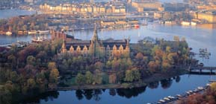
Spread over 14 islands and surrounded by water so clean you can fish or bathe right in the heart of the city, Stockholm is reallyis Beauty on Water. Stockholm is also gateaway to the 24,000 of the archipelago and to Lake Mälaren with its castles, picturesque small towns and beautifull countryside.
Historycal monumentes:
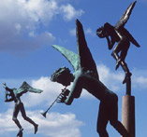
Most of churches are open to the public and offer Swedishlanguage services at 11.00 on Sunday morning, with many also organising a packed programme of concertes. Some churches also hold services in English and other languages.
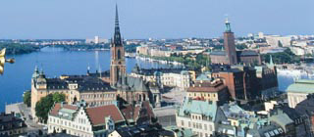
Stockholm Cathedral is situated in the old town and it had 700 years old and steeped in history: it was here that the first ever service in Swedish was held, herethat the first international church meeting was held in 1925, and here that King Carl XVI Gustaf married Silvia Sommerlath in 1976. It is also here that you can see the famous 15th century statue of St George and the dragon.
The Riddarholm is situated on Riddarholmen and was built around the end of 13th century and was the burial place of Swedish monarchs and nobility between 1920 and 1950. The walls are lined with coats of arms of the Knights of the Order of the Seraphim, Sweden’s highest decoration. The deth of a knight is marked with his or her coat of arms being hung in the church and the church bell tolling the Seraphim salute in the burial day itself.
A WALK AROUND STOCKHOLM
Startin at Sweden house in Hamnagatan, head through Kungsträdgården park towards the waterfront. In medieval times the park was the royal kitchen garden but later became a favourite place for the royal family to spend time together. Today it is a popular meeting place for Stockholmers, particulary in the summer.
The Royal Opera House is to be found at Gustav Adolfs Torg and faces the Sofia Albertina Palace which is home of the Ministry of foreign Affairs. Cross the Norrbro bridge to the royal palace. To the right is one of Sweden’s two parlamentary buildings. The Royal Palace, with its 608 rooms, is Europe’s largest royal palace still used for its purpose and, although the King and Queen work here, it is open to the public. Turn left onto Slottskajen.
THE OLD TOWN
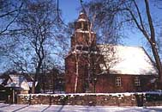
Turn right at the corner of the palacee and walk up the hill. To the right is the Royal Armoury, to the left is the Royal Coin Cabinet and stright ahead is the Cathedral, the oldest church in Stockholm and home of the famous sculpture of St George and the dragon.
The changing of the guard takes place in outer courtyard of the palace at 12.15 on Mondays to Saturdays during the rest of the year. The ceremony takes place at 13.15 on Sundays and public holidays all year.
Although there are many rune stones and other traces of the Vikings to be found in the capital, Stockholms official documented history doesn’t begin until the 13th century. The city was originally sited on the srategically important islands of Stadholmen and expanded rapidly.
VASA MUSEUM
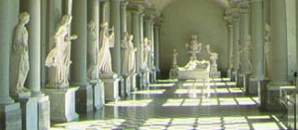
VASA – the pride of the Swedish fleet – sank on her maiden voyage in 1628.
After she was salvaged in 1961, the adventure began which is still in process. Before the eyes of the public, the wreck has been transformed into a ship with a complet lower rigging. The bold architecture of Vasa Museum houses nine exhibitions, computers for adventures of your own, multislide presentations of this century.
In the summer, the museum is open 9.30 am – 7 pm. The rest of the year the opening hours are 10 am – 7 pm. The museum is closed from 23 to 25 December, on 31 December, 1 January and 1 May.
SKANSEN – THE HIGH POINT OF STOCKHOLM
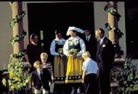
Skansen is setting for encounters in time and space,encouters between generations and with Swedish history. The houses and farmsteads of the countryside and the Town Quarters are inhabited by people in period costume, and living home ocupations and crafts are on display all the year around.
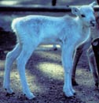
Here, in the word’s first open-air museum in the middle of a big city, you can study the Swedish flora in gardens, Herb Garden and Rose Garden. The farmsteands have their livestock, which include traditional Swedish breeds, but you will also find enclosures for wild animals like the elk, wolf, bear, links and seal. In the Skansen Aquarium you will find exotic animals from all over the world.
All big festivals on the year are celebrated at Skansen, and there are Autumn and Winter Markets here as well. In summer there are concerts, variety performances and folk dance diplays. And Skansen, with its Punch and Judy show, roundabouts, children’s circus and children’s zoo, is a paradise for the children.
At Skansen you will find nice restaurants and cafeterias. And craft and souvenir shop. Skansen is open every day of the year except Christmas Eve. Skansen is in the Djurgården district, near the centre of Stockholm. A number 44 or 47 bus or ferry from Slussen will get you here. In summer and certain weekends there is also a tram service.

