The Works Of Alexandre Gustave Eiffel:

- The Universal Store “Bon Marche” in Paris, France.
- The Observatory from Nyssa, France – situated in the Maritime Alps, The Observatory from Nyssa was, when Eiffel finished the construction in 1885, the biggest dome of its kind in the world; Eiffel produced the iron structure of the cupola, with the diameter of 22.5 m, which rotates on a ring without friction, which allows 110 tones to be moved by hand.
- The Garabit Bridge, France – this viaduct from the Central Massive occupies the second position after the Eiffel Tower in the gallery of technical Eiffel creations; at its inauguration in 1884, it was the highest arch-bridge in the world, rising at 120 m over the Truyère River; the arch of 165 m sustains a railway passage of 564 m.
- The Eiffel Tower, Paris, France – the masterpiece of the genius, the most famous tower in the world, built to celebrate the centenary of the French Revolution was constructed between 1887 and 1889 from forged iron. Although shortly after it was finished, it was strongly criticized, the tower became the national symbol twice taller than any other constructions built before. The tower weights 9,547 tones and it contains 18,000 components assembled with 2.5 millions rivets. It required 230 workers, 100 for the manufacturing of the structures and 130 for the assembling. The total height is 302 m, and in the hot days it reaches even 320 m because of the dilatation.

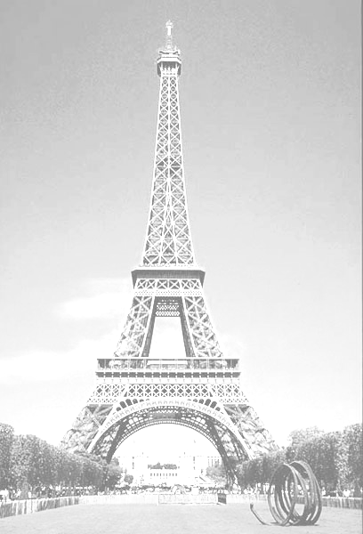
Alexandre Gustave Eiffel, the biggest architect of all time, was born in December 15, 1832 in the city of Dijon. After graduating the Chemistry University in Paris, he worked for a company which produced railway equipment, which encouraged him to give up chemistry for civil engineering. When he was almost 25 years old he was charged with the construction of a bridge over the river Garonne, at Bordeaux. He adopted a new strategy for the guiding of the pillars and the success gained for finishing one of the biggest iron structures of that time gave him a world reputation hard to get.
Next he became independent consulting engineer and soon founded in Paris a factory of iron workings. His rising reputation brought him contracts in Peru, Algeria and Indochina and also some viaducts and railway bridges in Europe.
His craftsmanship has manifested in every aspect of the engineering: a harbor in Chile; churches in Peru and Filipinas; gas factories, some steelworks and a dam in France; the gates of harbor lock in Russia and for the Panama Channel.
Eiffel died at the age of 91, on December 27, 1923 in his villa on street Rabelais in Paris.

