THE JUDGEMENT DAY
September 11th 2001

The day of September 11th 2001 will remain as a dark day in history. All people know about this day and what happened at this date. On this day, the terrorism reached its highest point since the beginnings till now and maybe similar events will be greater. (God forbid!). All the other terrorist events didn’t create such a wave of fear, revolt and hate. However, sometimes we ask ourselves if a human being is capable of doing such a thing. Faith was, it is, and it will be a goal for which people will kill each other, but one thing is to sacrifice your life in an honourable way, and another thing is to kill yourself pulling after you 4000 innocent lives: ”Great things demand great sacrifices”.

Being objective, I remember perfectly what I saw on TV that morning. I turned on the TV and I saw images with one of the two towers burning intensely. That image was unimaginable. Suddenly, two things came to my mind: 1.”Could this be the beginning of the end?” And 2.”Could this be the start of The World War Three?”. I’m quite sure that my thought was a general one and every man on the Earth asked himself the same questions. And indeed, on that day World War Three started, but a war different from what we know. This is a silent war, in which you fight against an invisible enemy, almost undetectable, who is hiding very well. That day The World War Three started, a war against terrorism and tyranny.
Anyway, something final happened on the clear sky of the Occident. Something important and, maybe, not very clear, but perceived by the global community as a fact meant to mark an irrevocable moment, the start of an epoch-making change. For all of us, the image of the two Boeings crashing the Twin Towers was enough to understand that the Apocalypse, as it was imagined, could finally erupt on the face of the Earth.
But, beyond this tragedy and the horror of loosing thousands of lives, there is hiding something else: the final combat, ”dies irae”, The Judgement Day, between two global systems which, for a long time only watched each other from distance till they came to this final and direct confrontation. This is not about the Christian world on one side and the Islamic world on the other side, here is about the World of richness, individualism, progress, and efficiency on a side and The World of poverty, misery and blind faith on the other side. These two different worlds had to meet, finally to confront themselves and destroy each other as sandcastles. It is important to see that they are based on different conceptions concerning life: in the previous century it seemed that the western world broke any connections with the spirit and its purposes were only material…In the so-called “the third world”, the man is still in contact with his spiritual roots and traditions, and in the confrontation with the Occident, it seems that this world is losing itself in the tornado of despair…
Now, let’s start describing how everything took place…
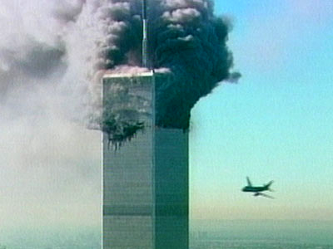

Premises: A week before September 11th 2001, Egyptian information services sends a message saying to CIA that Bin Laden might have planned a terrorist attack on American territory. This message was not considered very important by the American authorities…
7:58 a.m. – United Airlines Flight 175 leaves Boston for Los Angeles carrying 56 passengers, two pilots and 7 flight attendants…
7:59 a.m. – American Airlines Flight 11 departs from Boston for Los Angeles, carrying 81 passengers, 2 pilots and 9 flight attendants. This Boeing 767 is also hijacked and diverted to New York…
8:01 a.m. – United Airlines Flight 93, a Boeing 757 carrying 38 passengers, 2 pilots and 5 flight attendants, leaves Newmark, New Jersey for San Francisco…
8:10 a.m. – American Airlines Flight 77 departs Washington’s Dulles International Airport for Los Angeles, carrying 58 passengers, 2 pilots and 4 flight attendants. The Boeing 757 is hijacked after take off…
New York - time: 8:46 a.m.- hell is unleashed. The second hijacked plane, American Airlines Flight 11, with all the peoples on board, crashes violently into the north tower of World Trade Center. The eyewitnesses have a great shock and despair becomes general. People caught at the superior floors understand that these are the last moments of their life. The help asked in despair doesn’t come: white clothes are waved, screams are heard, objects thrown – but vainly, for them there is nothing to be done. Really desperate, some of them throw themselves out of the window, the impact being fatal. These people accepted their fate and decided to finish faster with this torture. Others died waiting for something…something that was only an illusion…the illusion of a second chance. But God takes care of His people and some of them, managed to find some stairs that were not badly damaged by the impact. We can say, without any doubt that these people were born for the second time…
The nightmare images seemed not to have happened in reality, but in a movie very well directed.
And this is just the beginning because after a few minutes the second hijacked plane reached its target: the south tower of the World Trade Center. At 9:03 a.m., at only 17 minutes from the first attack, the first hijacked plane, United Airlines Flight 175 with all the people on board, crashes into the south tower of World Trade Center, in front of the terrified eye-witnesses and TV cameras. In the first place, people thought that this was the tank water plane meant to stop the fire in the building. But it didn’t resemble at all a tank water plane, rather a big flying grave. Now, the Twin Towers became two huge torches covering a great part of New York’s sky with their infernal smoke. The TV cameras and civilians took pictures of a “landscape” that they surely wouldn’t see again.
U.S Federal Aviation Administration shut down all New York area airports. At 9:21, all bridges and tunnels leading into New York are closed.
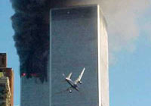
At 9:43 a.m., at 40 minutes from the second attack and an hour later from the first, the last hijacked plane, American Airlines Flight 77 with people on board, crashes over a section of the Pentagon.

The White House is on alert. At 10:05 - the new president, George W. Bush with the entire White House staff are immediately evacuated and put in the presidential airplane, Air Force One, where he is safer than staying on ground. All flights, commercial, tourist, passenger, are cancelled and the US’s sky is supervised by airplanes with the order of knocking down any kind of flying object. Everything takes place as a chain reaction, but this chain has unimaginable consequences that will change the course of history.
At 10:05, at only one hour from the attack, the south tower falls with big noise. The south tower is the last crashed and the first falling down. After five minutes, at 10:10, the third hijacked airplane, United Airlines Flight 93, crashes in a wooded area in Pennsylvania, Somerset Country, the only victims being the passengers and the hijackers. It seems that the passengers fought and preferred to sacrifice their life instead of fulfilling the diabolical plan. The destination of this plane is unknown. Hundreds of firemen, police officers and military units are brought to pull out the survivors from the demolished south tower and from the north tower that hasn’t collapsed yet.
Half-hour later after the attack, all the Wall Street stock exchange is in shock. The American $ is loosing important percentages, its value being 30% smaller. President George W. Bush called these events “acts of war” and he transmitted to the Army and secret services to “find those responsible and bring them to justice”. He asked the US Congress to vote 20 billion $ for reconstruction, reorganization and the affected by the tragedy.
At short time after the south tower crashed, at 10:28 the north tower crashed too. The falling of these giants was symbolic for the falling of America and not only…these giants seemed invincible and untouchable but they were crushed like some flies.
A perfect system has proved to be very imperfect. The heart of America was deeply bleeding and it is not known if this wound is ever going to heal or at least to become a big scar.
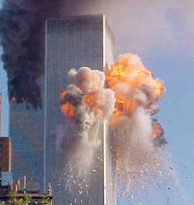
Besides the Twin Towers, because of the shock and dust, another 7 buildings collapsed and many more were very badly damaged. The material losses were estimated to billions of dollars, the human losses-around 2000.
Photos taken from satellites hurried to show the face of the devil appearing in the wave of
smoke; coincidence or not?…we will never know. Many people hurried to associate this
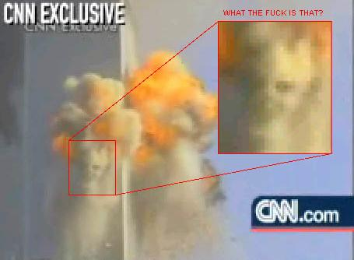
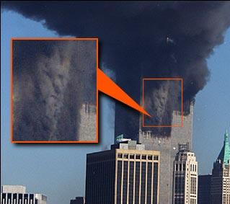
event with some fragments from the Holy Bible.
Others associated the event with some of Nostradamus’s prophesies…God knows the truth…
It is certain that September 11th 2001 will remain a memorable day in humankind’s history. Unimaginable forces that we are not able to understand were unleashed on that day, not only a hand of Afghan rebels.
Immediately after the attack, in that chaos, thousands of FBI, NSA, CIA agents were on alert and a lot of responsibility for what happened is put on their shoulder.
The fast investigations made by the secret services gave only a name…Secretary of State Collin Powel confirmed the first results of the investigations: ”Osama bin Laden is the prime suspect”. The news spread as a flash of lighting over the world and for a long time the name of this man was on all people’s lips. Bin Laden denied any implication, but when he heard the news that the Twin Towers had fallen, he knelt with enthusiasm saying: “Allah be glorified”. After a few days there were no doubts: the real author of the attack is Osama bin Laden.
The truth is that Bin Laden, if it is he who ordered the attacks, obtained the effect he wanted to obtain. The Twin Towers, the Pentagon, besides The White House, represented a symbol for America, a symbol that was destroyed….
Slowly, the chaos makes room for order and with very hard work and in time, people go again to their normal life…The trash resulted started to be cleaned in the fourth day from the attack…Under the remains sometimes different bodies were found which were covered in the US’s flag and any activity slowed down for 15 minutes, in sign of respect for the dead. About 9 months were necessary finish cleaning the spot and then the reconstruction started.
A couple of weeks after the attack the authorities started to collect money for the affected ones. Many commercials were broadcast on TV to raise funds, in Washington, all stars met and gave concerts in order to collect money to help those who lost members of their family or their home during the attack. Thousands of candles and flowers are put on the streets and in churches in the memory of those who lost their lives in the attack. After a couple of months, a monument was built for the ones who sacrificed their life and the
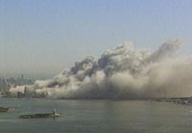
airplane crushed in Pennsylvania…these were declared national heroes. Another monument was built in New York for the ones who died in the Twin Towers attack.

President Bush started the war against terrorism and named it “the first war of the 21st century”; ”America will lead the world to victory”.
People always make fun of something important either evil or good. At some time after the events, appeared different kind of jokes about Bin Laden, Bush, The Twin Towers, etc. It’s good that people didn’t lose their sense of humour. One of these jokes is presented in the image below. It’s quite funny…
This event had also long lasting consequences. It is logical, the air transport went down dramatically…According to statistics, in September 2001, international air transports registered a fall of 15%. IATA (International Air Transport Association) declared that the air traffic didn’t decrease since the Gulf War. In September, the loading degree was 69%, that means a quarter from the total of chairs were empty. The most affected ones were American Airlines, the air traffic being reduced with 30%. US Airways announced losses of 800 million $ and after some time declared bankruptcy. After the bankruptcy of Swissair and Sabena, a fourth company announced its fall: Canada 3000.Other American companies were threatened with the bankruptcy: United Airlines and American Airlines (both of them directly involved in September 11th attack).

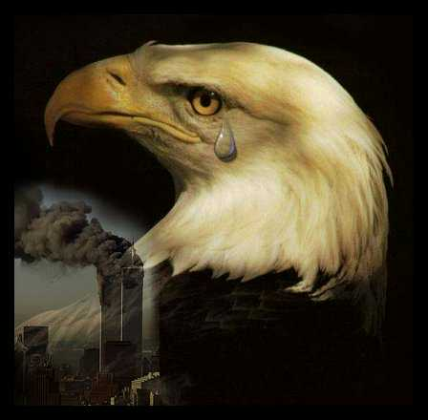
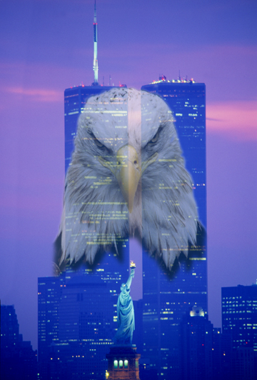
As a conclusion I want to mention that this is the most dramatic terrorist attack that has ever happened…around 4000 people died including those from the hijacked planes… material losses of billions, human losses: priceless… September 11th 2001 will be seen in the future as a day of radical changes, a day of a NEW BEGINNING…

