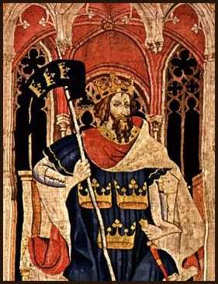

by DOBROMIR DRAGOS-CATALIN

rom the very beginnings of the English language there have been legends of great heroes. From the first settlements of Britain come stories rooted in ancient Celtic and Germanic imagination. Out of these stories, certain figures enjoy pre-eminence as the strongest, the bravest and the best. King Arthur is one such hero, known perhaps over all other mythical medieval figures as a chivalrous knight, a powerful warrior and a just and intelligent leader.
In an age of treachery and darkness, one king brought peace and prosperity to his land, defended it from every danger, and expanded it to an empire that would rival Rome itself. His wise counselor taught him the ways of justice and to value truth. At his command a loyal band of fearless, gentle knights protected the helpless, struggled against evil, and faced unimagined peril in the search for the holiest of relics. Though his queen and his best knight would betray him, though his own son would defeat him, though the shining kingdom he had forged would fall into ruin, still he set the standard by which all other leaders would be judged for centuries.
King Uther Pendragon loved Igraine, the wife of the Duke of Cornwall. So he made war on Cornwall and in that war Igraine's husband was killed, though not until after King Uther slept with Igraine by means of magic. Arthur was conceived, and later Uther and Igraine were married. The child was raised by a knight called Sir Ector. Britain did not have a king and was divided. The future king was to draw a magnificent sword from a stone to prove himself the heir to the throne (the sword Caliburn or Excalibur is sometimes said to have been given to Arthur by the lady of the lake).
Many people tried and many strong men travelled from afar to try to claim the great prize. No one succeeded…until one day a young boy drew the sword from the stone with little effort. The boy's name was Arthur and he was named king. The independent kings of Britain fought with Arthur but were defeated. Arthur then became king of all of Britain. 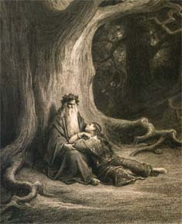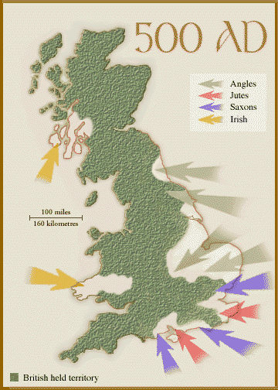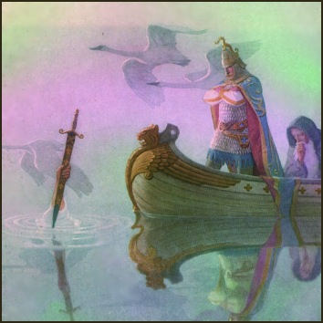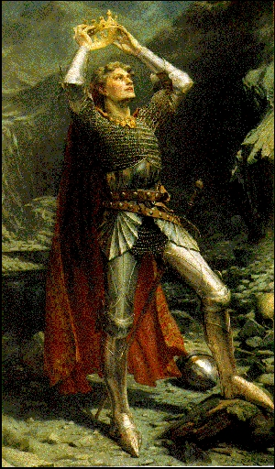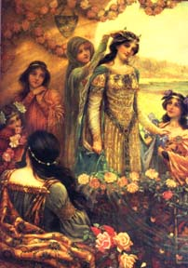
After he became king, Arthur began to try to mend this country in ruins. He did this under the watchful eye of Merlin, his trusted aid and court magician. Arthur went on to build Camelot and, here, he founded the Knights of the Round Table, the most honourable of warriors. King Arthur married Guinevere, the daughter of King Leodegrance, who gave Arthur as a wedding gift a hundred knights. With Guinevere as his wife, Arthur continued to aid the country in its prosperity. He went on a quest to discover
the infamous precious chalice, the Holy Grail.
Morgan Le Fay, the enchantress half-sister of Arthur, used black magic to steal Excalibur. Her paramour, Sir Accolon fought Arthur using Excalibur and nearly won the fight when the swords were accidentally exchanged and Arthur won. King Lucius of Rome demanded tribute payments from Arthur, but Arthur refused to pay. All the knights of the realm promised him aid, and in the war that followed Arthur conquered Germany and Italy and was crowned Emperor of Rome. An old hermit prophesied that a vacant seat at the Round Table would be filled by a knight who would win the Holy Grail. This knight turned out to be Sir Galahad, actually Sir Lancelot's son (he was tricked into sleeping with the maid Elaine). On the quest for the Holy Grail Lancelot was stricken when he tried to enter the chamber where the grail was kept. He was laid low for 24 days as penance for his years of sin, sins like, for instance, sleeping with the King's wife.Galahad, however, saw the miracle of the Grail and became king of some middle-eastern city, where he died in holiness.

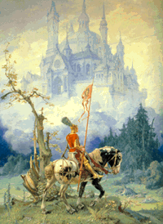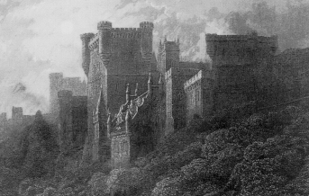
When the questing knights returned to Camelot, Lancelot forgot the lesson he learned in the Grail chamber and began consorting again with Guinevere. One spring, while traveling with her attendant, Queen Guinevere was captured by a traitorous knight, Sir Meliagrance. Lancelot rescued her. Enemies of Lancelot told the King of Lancelot's love for Guinevere. A party championing the king's cause fought with Lancelot. All those he fought died except the king's illegitimate son, Mordred. Guinevere was sentenced to be burned, but Lancelot rescued her and they went of to the Castle Joyous Guard to be together. Arthur then besieged the castle, but the Pope intervened and commanded a truce. Lancelot and his followers went to France where he held lands. Arthur then invaded France, but while he was away, his son Mordred mounted an uprising with the aid of the dark sorceress Morganna. He seized the throne of Britain and tried to force Guinevere to become his queen. She escaped to the Tower of London. Arthur heard about Mordred's usurpation and returned to England.
Battles ensued; it was a great civil war. During a temporary truce, a snake caused a knight to draw his sword and this action brought on another battle in which Mordred was killed and Arthur mortally wounded. On his deathbed Arthur told Sir Bedivere to cast Excalibur back into the lake from which the sword had come, but he twice pretended to have done it. Arthur insisted, and when Bedivere finally complied, a hand reached up out of the water and caught the sword. King Arthur died and was carried on a barge to the fabled land of Avalon. (Some writers say Arthur never actually died and he will come again.) Guinevere became a nun, and Lancelot became a hermit. Sir Constantine of Cornwall was chosen to succeed Arthur.

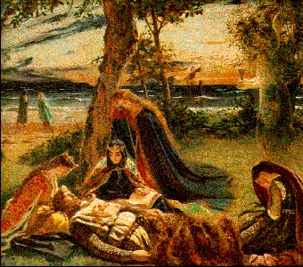
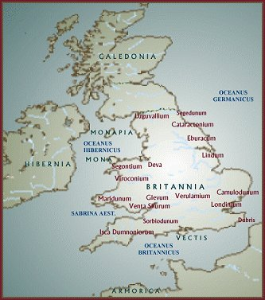

The spectre of King Arthur haunts the middle ages so completely that he cannot, and should not, be ignored. For hundreds of knights and kings, for thousands of writers, artists, for millions of ordinary people, Arthur was--and is-- what a king should be. For more than 1500 years, King Arthur enjoyed a respected, even exalted place in history. In this way Arthur becomes more than a literary figure, a myth, or the object of an impossible historical quest. He becomes our ally in the search for the past.
As king he has free-will to act on situations. Some may lead others to death; however, King Arthur’s wise character takes precautions. King Arthur dreams that Sir Gawain comes to tell him to delay the battle scheduled for the next day. Sir Gawain warns that otherwise he will be killed. Instead of putting lives at risk, King Arthur, decides to make a treaty with Sir Mordred. After the treaty is finalized and both sides agreed not to fight, they meet in a field. King Arthur knows that Sir Mordred still could be planning to fight and makes a wise decision to warn his men. The men agreed that if a sword is drawn that they fight till the end of the battle.
King Arthur is a loyal character who is always watching out to protect his knights and his people. During the meeting with Sir Mordred a snake bites one of Sir Mordred’s knights. When that knight draws his sword to kill the snake the fighting begins; it continues until all men are dead except two of King Arthur’s men and Sir Mordred. King Arthur was upset to see all of his men dead and knew now that he could die because of his dream.King Arthur takes his sword and kills Sir Mordred for his knights. Respect is a characteristic of King Arthur that was earned by his loyalty and wise actions. King Arthur does get hurt, falls to his side and can not move, so, Sir Lucan, another knight that survived, picks him up with deathly wounds to his stomach. Then Sir Lucan tries to help King Arthur, Sir Lucan falls and dies from his battle wounds. King Arthur realizes how respected he was by Sir Lucan trying to save King Arthur before himself. This also shows the respect that King Arthur’s men had for him. The loyalty and wise decisions that King Arthur portrayed to his men also reflected back to King Arthur as being a respected King by his entire kingdom
King Arthur was a man with great power and he believed in himself. Not only did he believe in himself but he also believed in his knights. King Arthur was able to show his knights his admiration for them by the loyalty and wise decisions he made on their behalf. In return the knights and King Arthur’s Kingdom respected this gracious leader.

