TITANIC
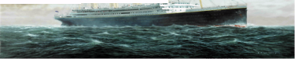
THE ARTIFACT EXHIBITION

VOCABULARY
DID YOU KNOW?

Aft—Toward the back of the Ship
Bow—The front of the Ship
Bridge—The forward command center of the Ship.
Bulkhead—A large vertical partition separating sections of the ship.
Collapsible—A lifeboat with canvass sides.
Crow's Nest —A lookout platform on the Ship's mast.
Davits—Cranes that lowered Titanic's lifeboats.
Debris Field—The area on the seabed surrounding the wreck.
Forward—Toward the front of the Ship.
Hold—A storage area for cargo and baggage.
Hull—The outer skin of the Ship.
Maiden voyage—A vessel's first voyage.
Port—The left side of the Ship looking toward the bow.
Rivets—Steel bolts that held the hull plates together.
Starboard—The right side of the vessel looking toward the bow.
Stern—The rear of the vessel.
Submersible—The small vessel that can dive to the ocean floor.
It cost $7.5 million to build the Titanic in 1912 and carried a $5 million insurance policy. It would cost approximately $400 million to build the Ship today.
While serving on the Titanic, Chief Officer Henry T. Wilde wrote to his sister: "I still don't like this Ship. I have a queer feeling about it."
A first-class ticket for a parlor suite cost $4,350, which would be roughly $50,000 today.
Adhering to the rule of the sea: women and children first, a man listed as passenger Hoffman handed his two young sons over to strangers to insure their survival. He perished. The man was actually Michel Navratil who had kidnapped his sons during divorce proceedings. The children were eventually reunited with their mother in New York when she read of their plight in a newspaper that had dubbed them "The Titanic Orphans."
Only one first-class child perished: Loraine Allison, age 2, from Canada.
The Ship was as long as four city blocks and as wide as a four-lane highway.

QUICK FACTS
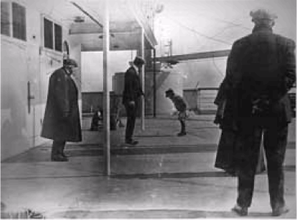
- MAIDEN VOYAGE BEGINS APRIL 10, 1912
- SINKING OCCURS APRIL 14-15, 1912
- PASSENGERS/CREW SAVED—705
- PASSENGERS/CREW LOST 1,523
- RESCUE SHIP CARPATHIA
- CHILDREN ON BOARD 114
- CHILDREN LOST 54
- DOGS ON BOARD 12

In the photograph above, taken by Father Frank Browne, six-year-old Robert Douglas Spedden of New York is spinning his top on A-deck while his father, Frederic, looks on. Robert survived the sinking in lifeboat 3 with his toy bear. Later his mother would write a book about the family experiences called "Polar the Titanic Bear."

THE PASSENGERS
The Titanic is more than an epic of steam and steel. It is the story of her passengers, from first-class millionaires to third-class immigrants, who displayed incredible acts of courage, self-sacrifice, and heroism, and who endured extraordinary loss.
- The most famous couple making the crossing was Mr. and Mrs. John Jacob Astor IV. They were returning to
New York after a honeymoon abroad. Madeline survived but John Jacob perished as did their Airedale, Kitty,
boarded in the ship's kennels. As the wealthiest man on board, Astor's death made headlines around the world.
- Major Archibald Butt, military aide to President William Taft, in true soldierly fashion, helped others to the
lifeboats but failed to save himself. A memorial fountain dedicated to his bravery stands near the White House
in Washington, D.C.
- Benjamin Guggenheim and his valet changed into formal attire as the end approached. The millionaire was
reported to have said, "We've dressed in our best and are prepared to go down like gentlemen."
- Second-class passenger, Annie Clemmer Funk perished after selflessly relinquishing the last place in a lifeboat
to a mother whose children had already been seated in the boat. Annie was returning home from missionary
work in India to be at the bedside of her own ailing mother.
- Rosa Abbott was a single mother traveling in third-class with her two sons, Rossmore and Eugene. The Abbott
boys were not allowed into the lifeboats because, at ages sixteen and fourteen, they were considered men.
Rosa refused to leave without them and all three were swept away from the deck by a wall of water as the ship
took its final plunge. Rosa was the only woman pulled into a lifeboat from the sea. Her boys were never found.
THE TITANIC WRECK SITE

The wreck site of the Titanic is 963 miles northeast of New York and 453 miles southeast of the Newfoundland coastline. Titanic lies 2.5 miles beneath the ocean's surface where the pressure is 6,000 pounds per square inch. The recovery teams reach the site via MIR, a $25 million submersible equipped with mechanical arms. Each submersible weighs 18 tons and is made of titanium and high grade rolled steel. The submersibles carry three people with one-foot thick plastic portholes. They can deploy a Remote-Controlled Vehicle (ROV) on a 110-foot tether which is flown inside the wreck to record images. It takes over 2 hours to reach the wreck site. Each dive lasts 12-15 hours with an additional 2 hours to return to the surface.
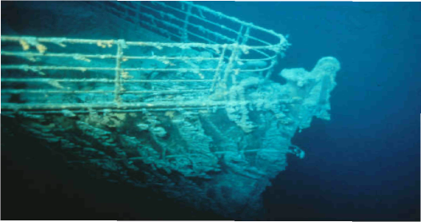

CONSERVING ARTIFACTS

Conservation begins as soon as an artifact is exposed to the air. Scientists follow a careful process to remove rust and salt deposits from each artifact.
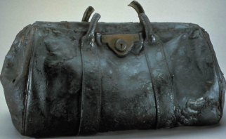
- The artifact is cleaned with a soft brush and placed in a
foam-lined tube of water to be shipped to the laboratory.
- At the lab, the artifact is washed in de-ionized water to
leach out contaminating surface salts.
- Electric currents are used to remove salts from paper,
leather and wood. These materials are treated with
chemical agents to remove rust and to fumigate the artifacts
in case mold has begun to form.
- As artifacts made of wood and leather begin to dry, they
receive injections of water-soluble wax to fill in the spaces
left by the water.
- Paper artifacts are freeze-dried to remove all water and
treated to protect against mold then resized and restored to
their shape.
- All recovered artifacts are carefully maintained in a
temperature-controlled climate, protected from humidity
and kept away from sunlight.

WHAT DID CHILDREN DO FOR FUN ON THE TITANIC?
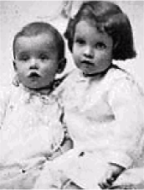

Children in First Class could:
- Go to the gymnasium. The gymnasium was reserved for children between the hours of 1:00 and 3:00 P.M.
every day. The gym instructor, T. W. McCawley, enjoyed showing children how to use the equipment.
- Ride a mechanical horse or camel in the gymnasium
- Use the stationary bike or rowing machine.
- Watch the passengers' dogs being walked by a steward every morning and afternoon on the poop deck.
- Play shuffleboard or deck quoits, a game similar to horseshoes played on the deck of a ship with rope
rings thrown at a wooden score board for points.
- Attend a concert in the first-class lounge in the evenings.
Six-year old Douglas Spedden of Tuxedo Park, New York, played with his spinning top on the boat deck.
Children in Second Class could:
- Skip and play games like "horse racing" on deck.
- Read books in the library.
Ruth Becker pushed her brother, Richard, around the decks in a White Star Line stroller.
Children in Third Class could:
- Play games on the poop deck.
- Run up and down the stairs exploring the parts of the ship open to them.
- Look down into the boiler room and wave at the stokers shoveling coal.
Frank Goldsmith remembered swinging on huge baggage cranes in the well deck and getting his hands covered with oily grease.

