Brasov is the favourite tourist destination in Romania. Only 13 km far from Brasov, up in the mountains you can find a unique winter resort: Poiana Brasov. 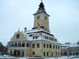
Winter sports, mainly skiing and snowboarding, bring in the winter season thousands of tourists coming from all over Europe. Sleigh rides, ski jets or ice-skating are only few of the things you can enjoy visiting Poiana Brasov. 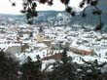
In summer there are tennis courts, swimming pools, boat rides, mountain climbing, horse riding and many other great sports activities. 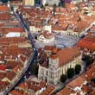
Thanks to a great number of hotels, chalets and villas, restaurants, and clubs your stay in Brasov will be an enjoyable and comfortable one. Being an old medieval city, Brasov gives you the opportunity to visit a lot of old historical monuments and museums. 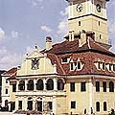 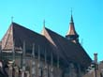

Brasov is everything that Bucharest isn't: a placid, gentle, civilised city of 350,000 people nestled in the Carpathian mountains. A fabulous base for exploring the surrounding countryside, the air is clean, the people friendly, and the prices a pittance of those in the capital. You'll love Brasov.
