1. WHAT IS AN OPTION CONTRACT?
An option contract is a contract between a buyer and a seller. The option is connected to something, such as a listed stock, an exchange index, futures contracts, or real estate. Options have one feature that sets them apart from all other existing financial instruments: the holder of an option has the right, but not the obligation, to buy or sell an underlying asset at a predetermined price during a specified period. Thus, the option holder will exercise his or her option (i.e. take up the rights granted by the option) only if it is profitable to do so. The maximum possible loss to the holder of an option is limited, but the potential profit is unlimited.
Every stock option is designated by:
- name of the associated stock
- strike price
- expiration date
- the premium paid for the option, plus broker’s commission.
Using the example of a three-month option to buy a house for $100,000, the holder of the option has the right to purchase the house for $100,000 at any time during the next three months. The option price, or premium, can be mutually agreed upon by buyer and seller, and may for instance be $ 5,000 in this example. Should house prices increase above $100,000 during this time, the option holder can obviously exercise his or her option and, if they have risen above $105,000, he can buy and resell the house for a net profit. Should he no longer require the house, he can at least resell it at the higher price. However, should house prices fall to say, $90,000, he can now "abandon" the option and buy the house at the current market value of $90,000 (i.e. for a total cost of $95,000).
An option can therefore be considered as a type of insurance against unfavorable price movements and, as in the insurance industry, the amount paid for an option is called the premium.
The date on which an option becomes void if not exercised is called the expiration date, while the date on which an option is exercised is called the declaration date or exercise date. The price at which an option may be exercised is called the strike price.
2. TYPES OF OPTION CONTRACTS
Call and put option contracts
There are two basic types of options - a call option, which grants the holder the right to buy, and a put option, which grants the holder the right to sell.
Thus, the purchaser of a three-month 100 oz. gold call option with a strike price of $315.00 per oz. has the right to buy 100 ounces of gold at $315.00 per ounce at any time during the next three months. Likewise, the purchaser of one ABC March 100 put option will have the right to sell 100 shares of ABC at $100 at any time prior to the March expiration date.
Call and put options can each be bought or sold. Buying a call option contract is often referred to as a long call and selling a call option as a short call. Likewise, one refers to a long put (buying a put option) and a short put (selling a put option). Note that the option seller has an obligation if the option is exercised, while the buyer has a right to exercise.
American and European option contracts
There are two basic types of options, the American option and the European one. An American (or American-style) option is an option contract that can be exercised and settled at any time between the date of purchase and the expiration date. Most exchange-traded options are American-Style. All stock options are American style. A European (or European-style) option is an option contract that can only be exercised and settled on the expiration date. Futures contracts (i.e., options on commodities) are generally European-style options.
Option contracts on specific and notional assets
Like forward and futures contracts, option contracts are derivative financial instruments. They are all based on an underlying asset, which may be specific (such as commodities or financial assets) or notional (such as an equity index).

3. OPTIONS AND THEIR USES
Some of the basic uses of call and put options will be discussed in this section.
In combination with the underlying cash market instrument(s) and/or other option contracts, options can simulate virtually any other financial instrument.
3.1 Basic option strategies
3.1.1 Long call (buying a call option contract)
The purchaser of a call acquires the right, but not the obligation, to purchase a fixed quantity of the underlying asset at a specified price during the life of the option. For instance, the purchaser of a 100 oz. gold American call option with a strike price of $320/oz. and a final declaration date of 31 December 1998 has bought the right to buy 100 oz. of gold at $320/oz. at any time up to the end of December 1998. In return for this right the purchaser pays a premium to the seller or (writer) of the option, say $5/oz. (or $500 in total). The risk/return profile of this position is illustrated in graph 1.
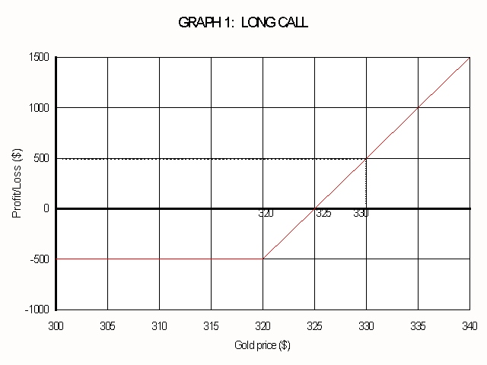
The maximum risk to the option holder is limited to the premium paid, in this case $500. If the price of gold falls, then the option holder will not exercise, and his or her maximum loss will be the premium of $500. However, if the price rises above $320, then the option will be exercisable but, as can be seen from the graph, the position does not come into profit until the gold price reaches the strike price plus the premium paid ($320 + $5). The potential profit is unlimited - the higher the gold price rises, the more profit the call option will show. If the price of gold rises to, say, $330, the option holder could realize his or her profit by simultaneously exercising the option and selling 100 oz. of gold in the physical or cash market at $330/oz. His or her net profit would be $500 (i.e. 100 x (330-320-5).
3.1.2 Short call (selling a call option contract)
The writer (or seller) of a call option will obviously have an opposite risk/return profile to the previous example. An uncovered writer is one who sells an option without taking or holding the opposite position in the cash market. By contrast the investor who is holding, say, 100 oz. of gold and then writes a call option against it, is said to be writing a covered call (if he writes an option without holding the underlying asset, then he is said to be writing a naked or uncovered call).
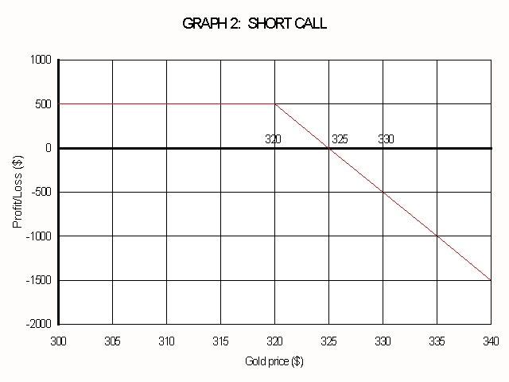
The writer receives the premium, in return for which he assumes a potential obligation. If the option is exercised, he is obliged to sell the asset to the holder of the option at the exercise price. Using the example above, if the call option was exercised, he would be obliged to sell 100 ounces of gold to the option holder at $320/oz. On the exercise date the uncovered writer's potential profit is limited to the premium paid to him or her, and his or her potential loss is unlimited (see graph 2). His or her initial and potential maximum gain is the premium received regardless of how low the price of gold falls. At a level equivalent to the strike price plus the premium the writer breaks even and, should the gold price rise above this level, the holder's gain becomes the writer's loss.
3.1.3 Long put (buying a put option contract)
Buying a put, i.e. buying the right to sell, has a risk/return profile that is the mirror image of buying a call. Like the call buyer, the put purchaser's risk is limited to the premium paid, and his or her profit potential is "unlimited". (Strictly speaking the profit is limited to the value of the underlying asset - see graph 3.)
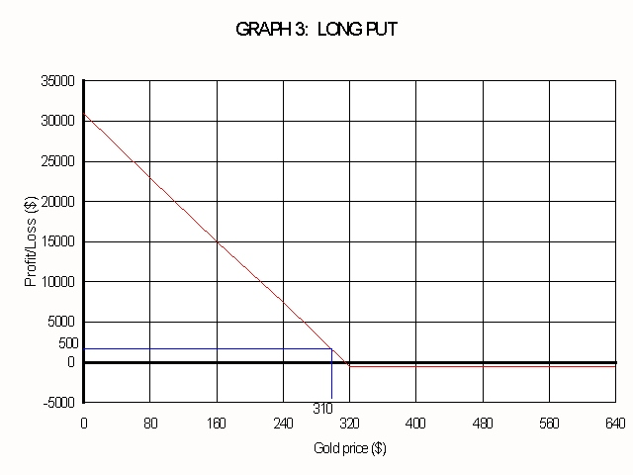
The risk/premium profile of the buyer of a 100 oz. gold put option with a strike price of $320 and a premium payable of $5 per oz., or $500 in total, is illustrated in graph 3. The break-even point will be the strike price less the premium paid or $315 in this example. If the gold price falls to $310/oz. the option buyer could realize a profit of $500 by simultaneously buying 100 oz. of gold in the physical market at $310/oz. and exercising his or her option to sell 100 oz. of gold at $320/oz. to the option writer.
3.1.4 Short put (selling a put option contract)
In the same way that the risk/premium profiles of the buyers of puts and calls are similar (but reversed), so are those of the sellers of puts and calls. The profit potential of the seller of a put option is limited to the premium received, and the potential losses are "unlimited" (or more precisely, losses are limited to the value of the underlying asset).
Using the same example, the writer of a 100 oz. gold put option with a strike price of $320 who receives a premium of $5 per oz., will have a risk/return profile as depicted in graph 4.
The writer will break even at the strike price less the premium, or at $315 in this example. Any movement in the price below this level will result in losses but, if the price remains above this level, the writer will make a profit up to a maximum of the premium received.
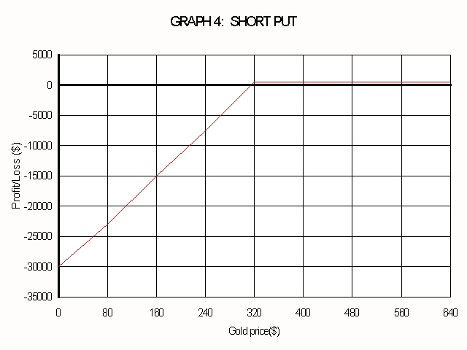
3.1.5 Writing options
People also sell options without having owned them before. This is called "writing" options and explains (somewhat) the source of options, since neither the company (behind the stock that's behind the option) nor the options exchange issues options. If you have written a call (you are short a call), you have the obligation to sell shares at the strike price any time before the expiration date if you get called.
Example: The Wall Street Journal might list an IBM Oct 90 Call at $2.00. Translation: this is a call option. The company associated with it is IBM. The strike price is 90. In other words, if you own this option, you can buy IBM at US$90.00, even if it is then trading on the NYSE at $100.00. If you want to buy the option, it will cost you $2.00 (times the number of shares) plus broker’s commissions. If you want to sell the option (either because you bought it earlier, or would like to write the option), you will get $2.00 (times the number of shares) less commissions. The option in this example expires on the Saturday following the third Friday of October in the year it was purchased.
In general, options are written on blocks of 100s of shares. So when you buy "1" IBM Oct 90 Call at $2.00 you actually are buying a contract to buy 100 shares of IBM at $90 per share ($9,000) on or before the expiration date in October. So you have to multiply the price of the option by 100 in nearly all cases. You will pay $200 plus commission to buy this call.
If you wish to exercise your option you call your broker and say you want to exercise your option. Your broker will make the necessary requests so that a person who wrote a call option will sell you 100 shares of IBM for $9,000 plus commission. What actually happens is the Chicago Board Options Exchange matches to a broker, and the broker assigns to a specific account.
If you instead wish to sell (sell=write) that call option, you instruct your broker that you wish to write 1 Call IBM Oct 90s, and the very next day your account will be credited with $200 less commission. If IBM does not reach $90 before the call expires, you (the option writer) get to keep that $200 (less commission). If the stock does reach above $90, you will probably be "called." If you are called you must deliver the stock. Your broker will sell IBM stock for $9000 (and charge commission). If you owned the stock, that's OK; your shares will simply be sold. If you did not own the stock your broker will buy the stock at market price and immediately sell it at $9000. You pay commissions each way.
If you write a Call option and own the stock that's called "Covered Call Writing." If you don't own the stock it's called "Naked Call Writing." It is quite risky to write naked calls, since the price of the stock could zoom up and you would have to buy it at the market price. In fact, some firms will disallow naked calls altogether for some or all customers. That is, they may require a certain level of experience (or a big pile of cash).

4. PRICING OF AN OPTION CONTRACT
The price (or premium) of an option can be divided into two parts:
- intrinsic value
- time value.
4.1 Intrinsic value
Intrinsic value is the amount by which the current spot market price exceeds the strike price in the case of a call option or the amount by which the strike price exceeds the current spot market price in the case of a put option. Options are classified into three categories depending on the relation between the exercise (strike) price and the current market price of the asset:
- “in-the-money” are those options that have intrinsic value. For instance, a call option with a strike price lower than the current spot price or a put option with a strike price higher than the current spot price.
- “at-the-money” are those options with a strike price equal to the current spot price.
- “out-of-the-money” are those options that have no intrinsic value. For instance, a call option with a strike price higher than the current spot price or a put option with a strike price lower than the current spot price.
4.2 Time value
The time value of an option is that portion of the premium that is in excess of the intrinsic value. The amount of time value depends on the time remaining until expiration. At expiry date the time value must be zero.
The shorter the time to expiration, the less the time value (assuming all other factors remain unchanged), because the chances of the asset price changing materially before the expiration date become less. However, the time value does not erode on a straight line basis. It decreases much more rapidly during the last few weeks of an option's life as the chances of a material price change diminish progressively. At the beginning of a long-term option's life (three months or longer) the effect of time erosion is usually minimal, but during the last four to six weeks it becomes precipitous. Therefore, as seen in graph 5, the decay of time value forms a negative exponential curve.
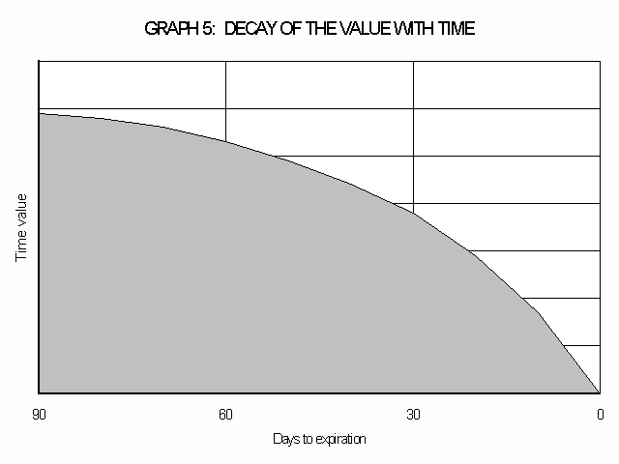
Graph 6 shows the effect of time decay on the total option premium in an alternative way. The solid line depicts the familiar risk/return profile of a long call at expiration date. Prior to this expiration date the shape of the risk/return profile may be very different. For instance, suppose a call option contract was purchased four months prior to expiry date at a strike price equal to the ruling cash-market price. If that call option was sold the next day, no material loss would be incurred if the cash-market price has also remained unchanged. So the risk/return profile of a long call, say, four months prior to expiration is rather like the dotted line in graph 6. As the dotted line must move into the shape of the solid line as the time to expiration becomes shorter, the option holder knows that he will lose the full option premium if the cash-market price remains at the strike price until expiry date.
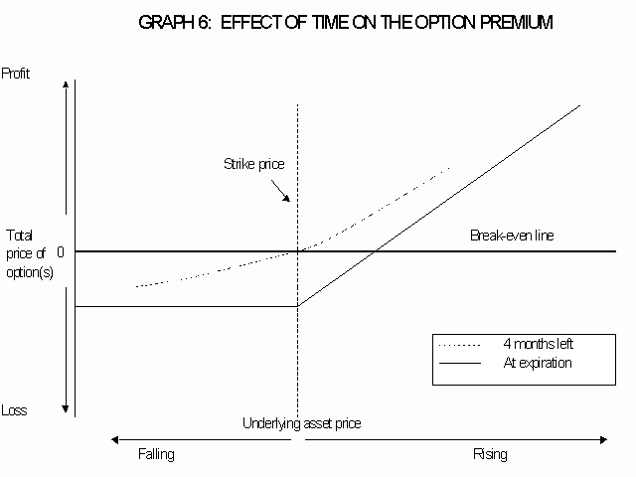
4.3 Determinants of the option premium
4.3.1 The underlying asset price
With all other variables constant, the greater the price of the underlying asset relative to the strike price of a call option is , the greater is the value of that call option, as there is a greater chance of the call option expiring in-the-money. The converse holds for put options.
4.3.2 Exercise price
The amount of intrinsic value implied in an option premium will also affect its time value. Consider the following extremes:
- a deep in-the-money option (one with a great deal of intrinsic value) is almost certain to be exercised and therefore takes on the characteristics of a forward contract. It is unlikely that the characteristic of no obligation will ever be called upon (i.e. the option is unlikely to be abandoned), and therefore the writer of the option can hedge himself or herself accordingly, with very little concomitant risk. Consequently the amount of time value involved is very small or zero. Occasionally options will trade below their intrinsic value and are then said to be trading at a discount.
- a deep out-of-the-money option (one of which the strike price is far above the spot price in the case of a call or far below in the case of a put) has only a very small chance of being exercised, and so the time value is correspondingly low (in exactly the same way that the cost of insurance against unlikely events is also low).
- however, the time value implied in an at-the-money option is at its highest. The holder does not have to pay for the intrinsic value (and therefore increase the amount of money at risk), but any favorable movement in prices will result in the option gaining intrinsic value.
The relationship between time value and the relative exercise price is shown in graph 7, while the relation between time value and intrinsic value is shown in graph 8.
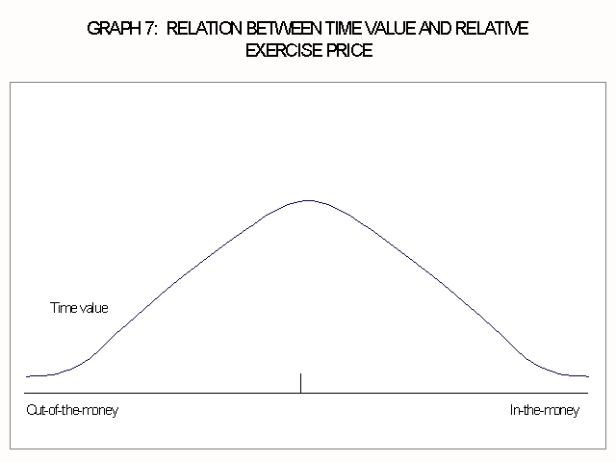
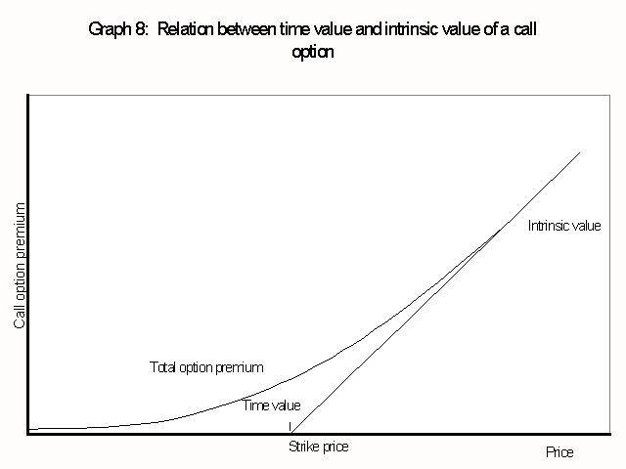
4.3.3 Relative interest rates
A call option on an underlying asset that costs money to hold, holds an additional benefit for the purchaser, since he can hold an option and lock in his or her buying price without actually having to hold the underlying asset. The option premium reflects this advantage.
4.3.4 Length of declaration period
Because an American option gives greater flexibility to the option holder than a European option, it is more expensive than the European option - at least when a normal yield curve is prevailing.
4.3.5 Volatility
Volatility is the only factor affecting the option pricing that is not directly observable - yet it has a significant effect on the option's premium. A volatile market will produce higher premiums than a stable market, because the risk to one party to an option contract, and consequently the potential return to the other party, is much higher than in a stable market. The premium will reflect this risk.
As expected, price volatility cannot be predicted accurately, it is often approximated by the most recent historical price volatility of the underlying instrument. A common method of estimating volatility is to use the standard deviation of daily (or weekly) historical price changes over a period of, say, three months.
Another approach that is often used is to solve the option valuation model in reverse, i.e. to provide the option price and other parameters and calculate the so-called implied volatility.
5. OPTIONS MARKETS
There are basically two types of markets in which options can be traded:
- the over-the-counter market
- formalized exchanges.
5.1 The over-the-counter option market
The significant feature of OTC options is that there is an inherent credit risk, since each contract is an agreement between two parties, and each is at risk in that the counterparty may not fulfill the terms of the contract. As a result of this credit risk and the absence of contract uniformity, liquidity is lacking in OTC options markets. Standardized options have greater liquidity because the contract specifications are uniform, but the writer of such an option may not be acceptable to some option buyers - so there is not complete contract fungibility.
The advantages of this over-the-counter system for hedgers are that:
- the expiry date can be negotiated to suit a particular hedging strategy, so that no extra time value has to be purchased;
- the strike price can be set at any level;
- normally no margin is paid by the grantor.
However, over-the-counter markets are often illiquid, which is an important disadvantage, since writers are not prepared to write large volumes if they are unable to "lay off" at least part of the risk. As in all over-the-counter markets, it can be difficult to resell the option before the expiry date, if this is desired.
5.2 Exchange traded options
The biggest advantage of a formalized exchange is the liquidity created in the market for such securities by uniform contract specification plus the existence of a central clearing house that guarantees the fulfillment of the terms and conditions of options contracts. Options on futures contracts and equity indices are currently the most liquid in the world. This liquidity is a result of a standardization of contract terms with specific strike prices, expiry dates, and contract sizes, which all lower the information costs in these markets. Some option exchanges use market makers, who make bid and offer prices on each series of options at all times, with the maximum spread allowed between those bid and offer prices limited on some exchanges.
Occasionally warrants are issued by listed companies as part of a capital raising exercise and these are listed and traded on the stock exchanges in the same manner as normal equity shares. Warrants are generally longer dated than normal options and give the holder the right to subscribe for shares at a specified price or prices on a specified date or dates. The main difference between options and warrants is that warrants will result in the company issuing new shares to cover the exercised warrants.
A disadvantage of hedging on a formalized exchange is that the expiry date may not coincide with the final date of the hedge. Therefore, at times it may be necessary to purchase a more expensive longer-dated option. But then the option price is nearly always competitive, compared with other hedging instruments (such as forward, futures, and swap contracts), while in most cases the liquidity on formalized exchanges is so good that the option can be easily "closed out" when no longer required.
A comparative analysis between the over-the-counter (OTC) and listed options markets is shown in table 1.
TABLE 1: A COMPARISON BETWEEN THE OTC AND LISTED OPTIONS MARKETS
 | OTC options | Listed options
1. Geographical | In most developed economies | Mainly in major industrial countries
2. Market place | Screen market or telephonically | Central exchange floor telephonically or screen market
3. Method of transaction | Telephonically between buyers and sellers. | Open outcry on exchange among many buyers and sellers
4. Integrity of system | Based on integrity of players - not guaranteed | Handled by clearing house
5. Accessibility | Open to any buyer but writers must have acceptable standing in market | Open to all
6. Participants | Large corporations banks brokers with relatively small interest from general public | Large corporations banks brokers - public participation encouraged
7. Regulation | Not regulated | Regulated by government body and appointed commissioners
8. Contract sizes | Normally not standardized | Standardized
9. Trade ability | Secondary trade at times inhibited by credit rating of writer | Secondary trade able
10. Delivery date | To suit needs of buyer | Standardized
11. Frequency of delivery | All exercised options settled by delivery | Less than 5% settled by delivery
12. Price fluctuations | No limit | No limit
13. Security deposit | No margin | Initial plus variation margin
14. Term | 1 day to 2 years | 1 day to 9 months
15. Types of instruments | Commodities, currencies, fixed-interest securities, notional assets and individual equities | Commodities, currencies, fixed-interest securities, notional assets and individual equities
A formalized exchange can work on two principles, namely:
- "open-outcry" on a trading floor
- electronic screen dealing.
6. OPTIONS MARKET PARTICIPANTS
The typical participants in the options market are to a great extent the same institutions and people as those operating in the futures market

