World War 1

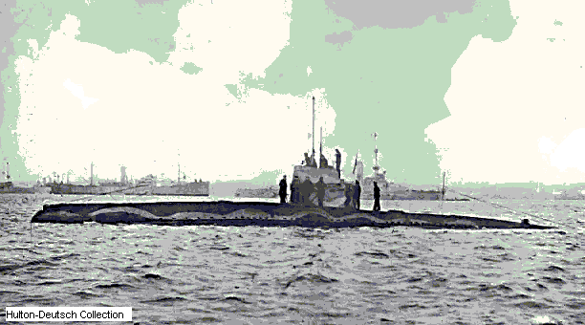
World War was a military conflict wich lasted from 1914 to 1918, that began as a local European war between Austria-Hungary and Serbia on July 28, 1914; was transformed into a general European struggle by declaration of war against Russia on August 1, 1914; and eventually became a global war involving 32 nations. Twenty-eight of these nations, known as the Allies and the Associated Powers, and including Great Britain, France, Russia, Italy, and the United States, opposed the coalition known as the Central Powers, consisting of Germany, Austria-Hungary, Turkey, and Bulgaria. The immediate cause of the war between Austria-Hungary and Serbia was the assassination on June 28, 1914, at Sarajevo in Bosnia (then part of the Austro-Hungarian Empire; now in Bosnia and Herzegovina), of Archduke Francis Ferdinand, heir-presumptive to the Austrian and Hungarian thrones, by Gavrilo Princip, a Serb nationalist. The fundamental causes of the conflict, however, were rooted deeply in the European history of the previous century, particularly in the political and economic policies that prevailed on the Continent after 1871, the year that marked the emergence of Germany as a great world power.
Causes of the War .The underlying causes of World War I were the spirit of intense nationalism that permeated Europe throughout the 19th and into the 20th century, the political and economic rivalry among the nations, and the establishment and maintenance in Europe after 1871 of large armaments and of two hostile military alliances. World War I provided a great stimulus to the production and military use of aircraft, including the airplane and airship, or dirigible balloon, and the tethered balloon. Aircraft were used for two principal purposes: observation and bombing. For observation of stationary battlefronts extensive use was made by both belligerents of small tethered balloons; for scouting at sea, dirigible balloons were extensively used, and airplanes were used for scouting coastal waters. In connection with military operations on land, airplanes were used to observe the disposition of the troops and defenses of the enemy and for bombing the enemy's lines or troops in action. A special feature of the war was the raids conducted by means of dirigibles or airplanes on important enemy centers far removed from the battlefront.The first German airplane raid on Paris took place on August 30, 1914; and the first German air raid on England was on Dover on December 21, 1914. During 1915 and 1916 the German type of dirigible known as the zeppelin raided eastern England and London 60 times.

